6. 3D Room
HERE LIES THE ENTRY FOR AN IMAGINED THING
This is a thing imagined by Ameiah, aged 10, on Wednesday April 21
The full name of this thing is: 3D ROOM
It can be found in: My 3D Room is from a movie I really love called Teen Titans.
It is known that: I've always wanted to be in the 3D room. So I can go and see stuff in 3D like real life but somewhere were I would like to go. But in real life I can't
This thing has three important features: Computer, Door, and Me

An image of 3D ROOM can be found here:
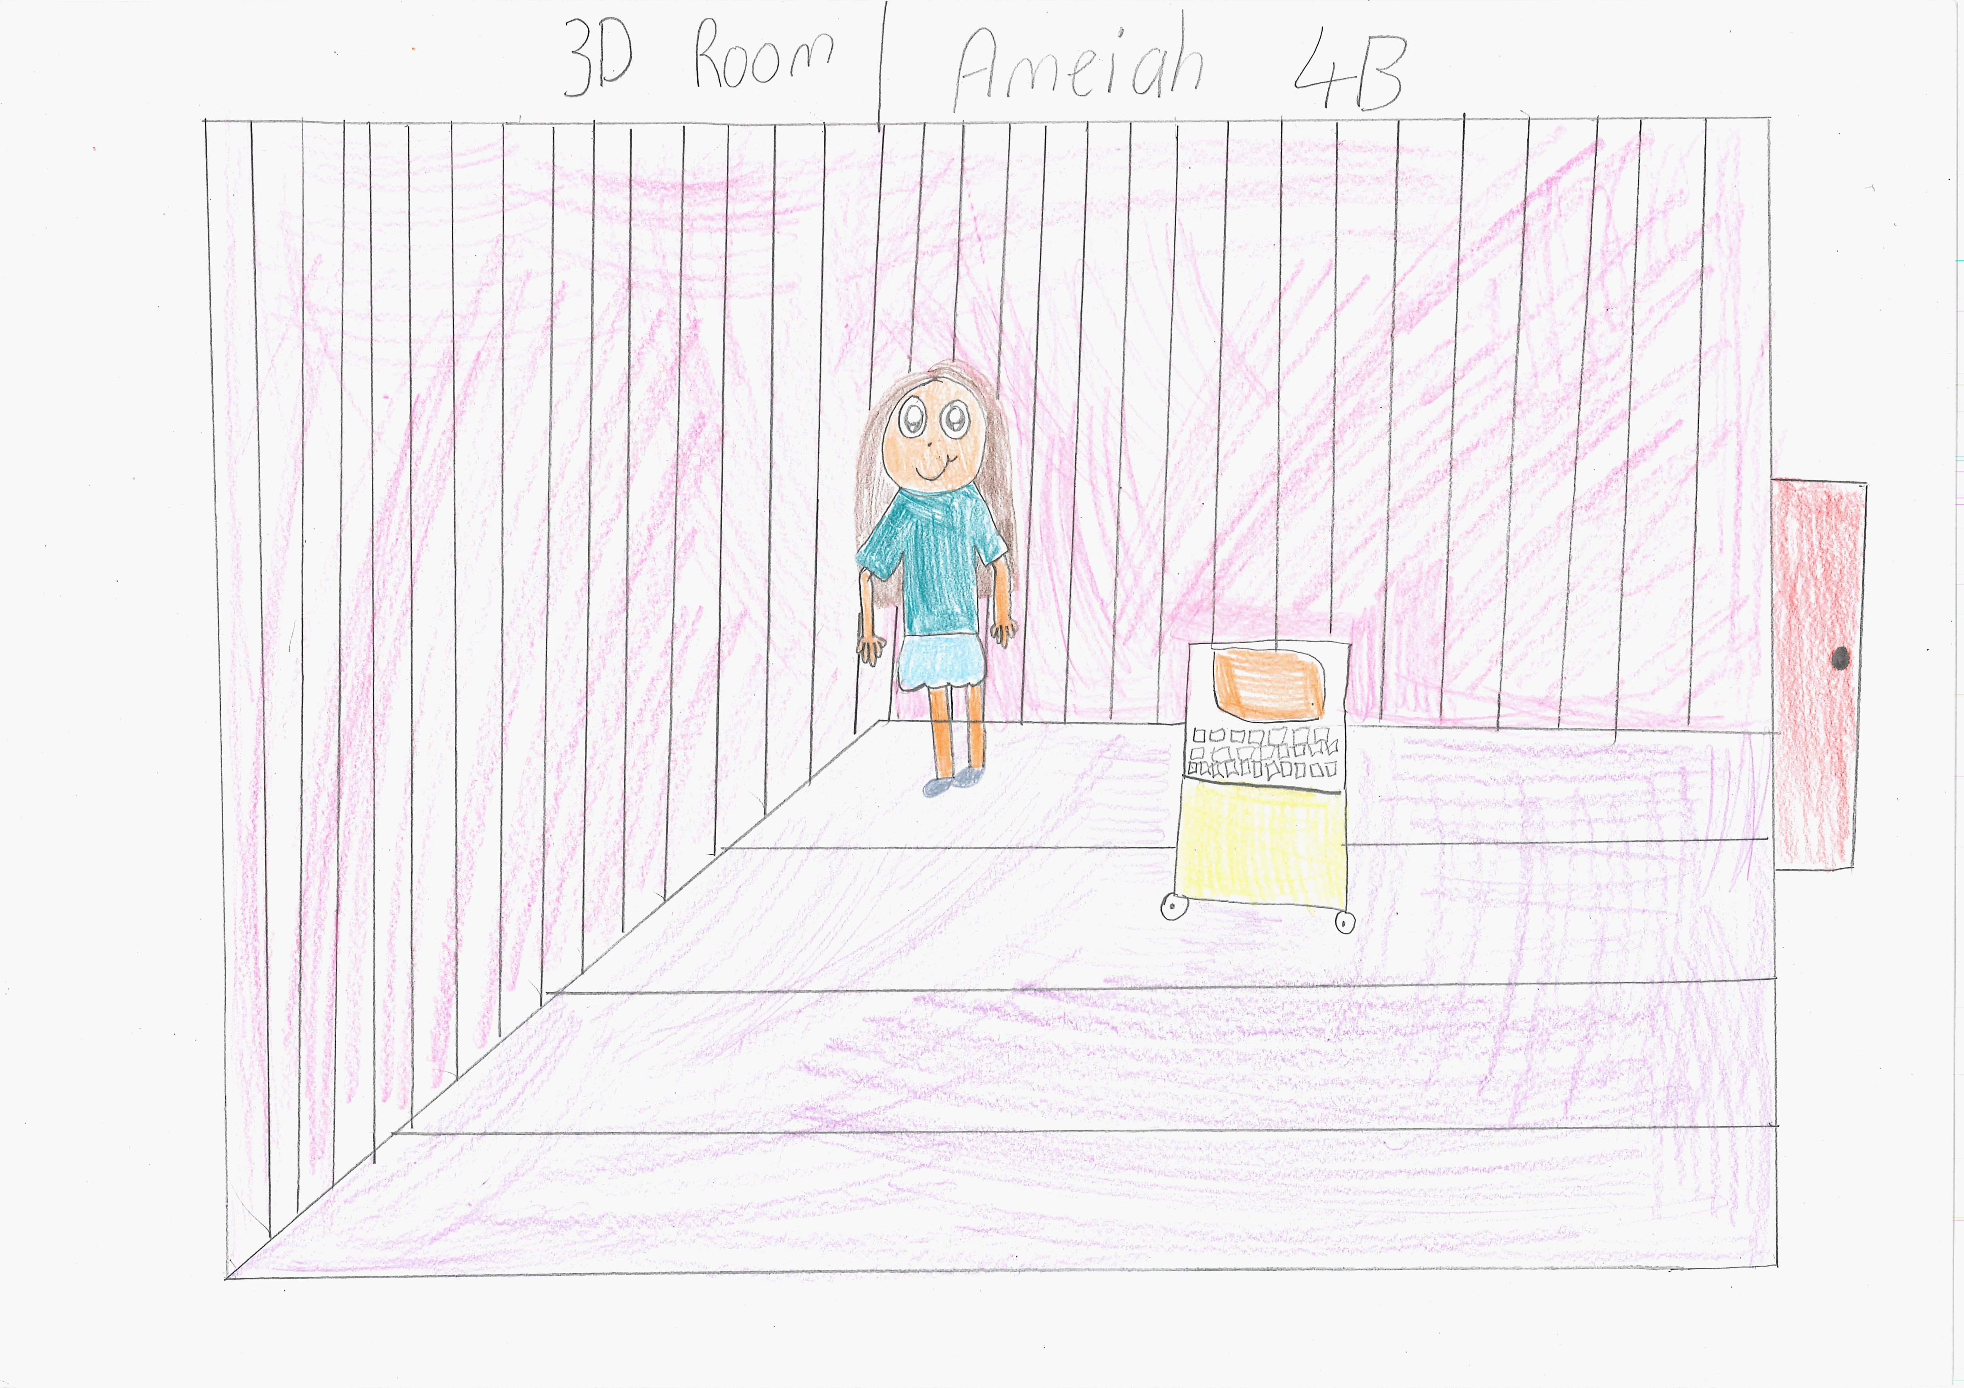400

A recording 3D ROOM can be found here:
400

This is the unique QR code for this Imagined Thing. Right click it to save then share it, so you and others can find your way back to here to this point of The Well.

IT IS KNOWN! HUZZAH FOR THE GREAT & GRAND RUMPUS!

