58. The thingy mijig
HERE LIES THE ENTRY FOR AN IMAGINED THING
This is a thing imagined by Mariam, aged 8, on Wednesday May 12
The full name of this thing is: The thingy mijig
It can be found in: a science lab
It is known that: Once upon a time this thing was made in a science lab and he was friends with the scientist and the scientest called the thin a thingy mijig. the scientest dies and the cops were trying to get thingy mijig in jail because they thought he was a bad guy, but he moved on and found a friend and better lif. thingy mijig fake his death so the police can stop tracking him the end.

An image of The thingy mijig can be found here:
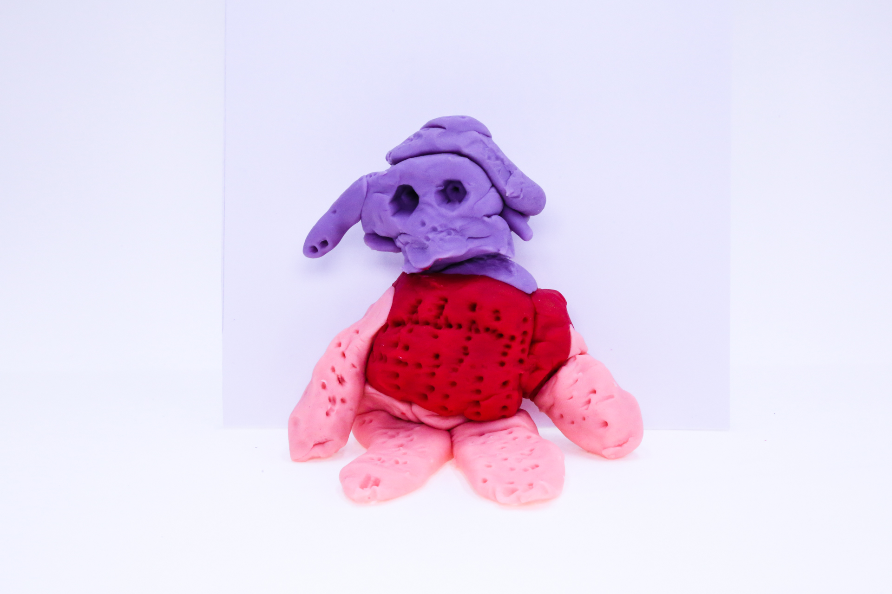400
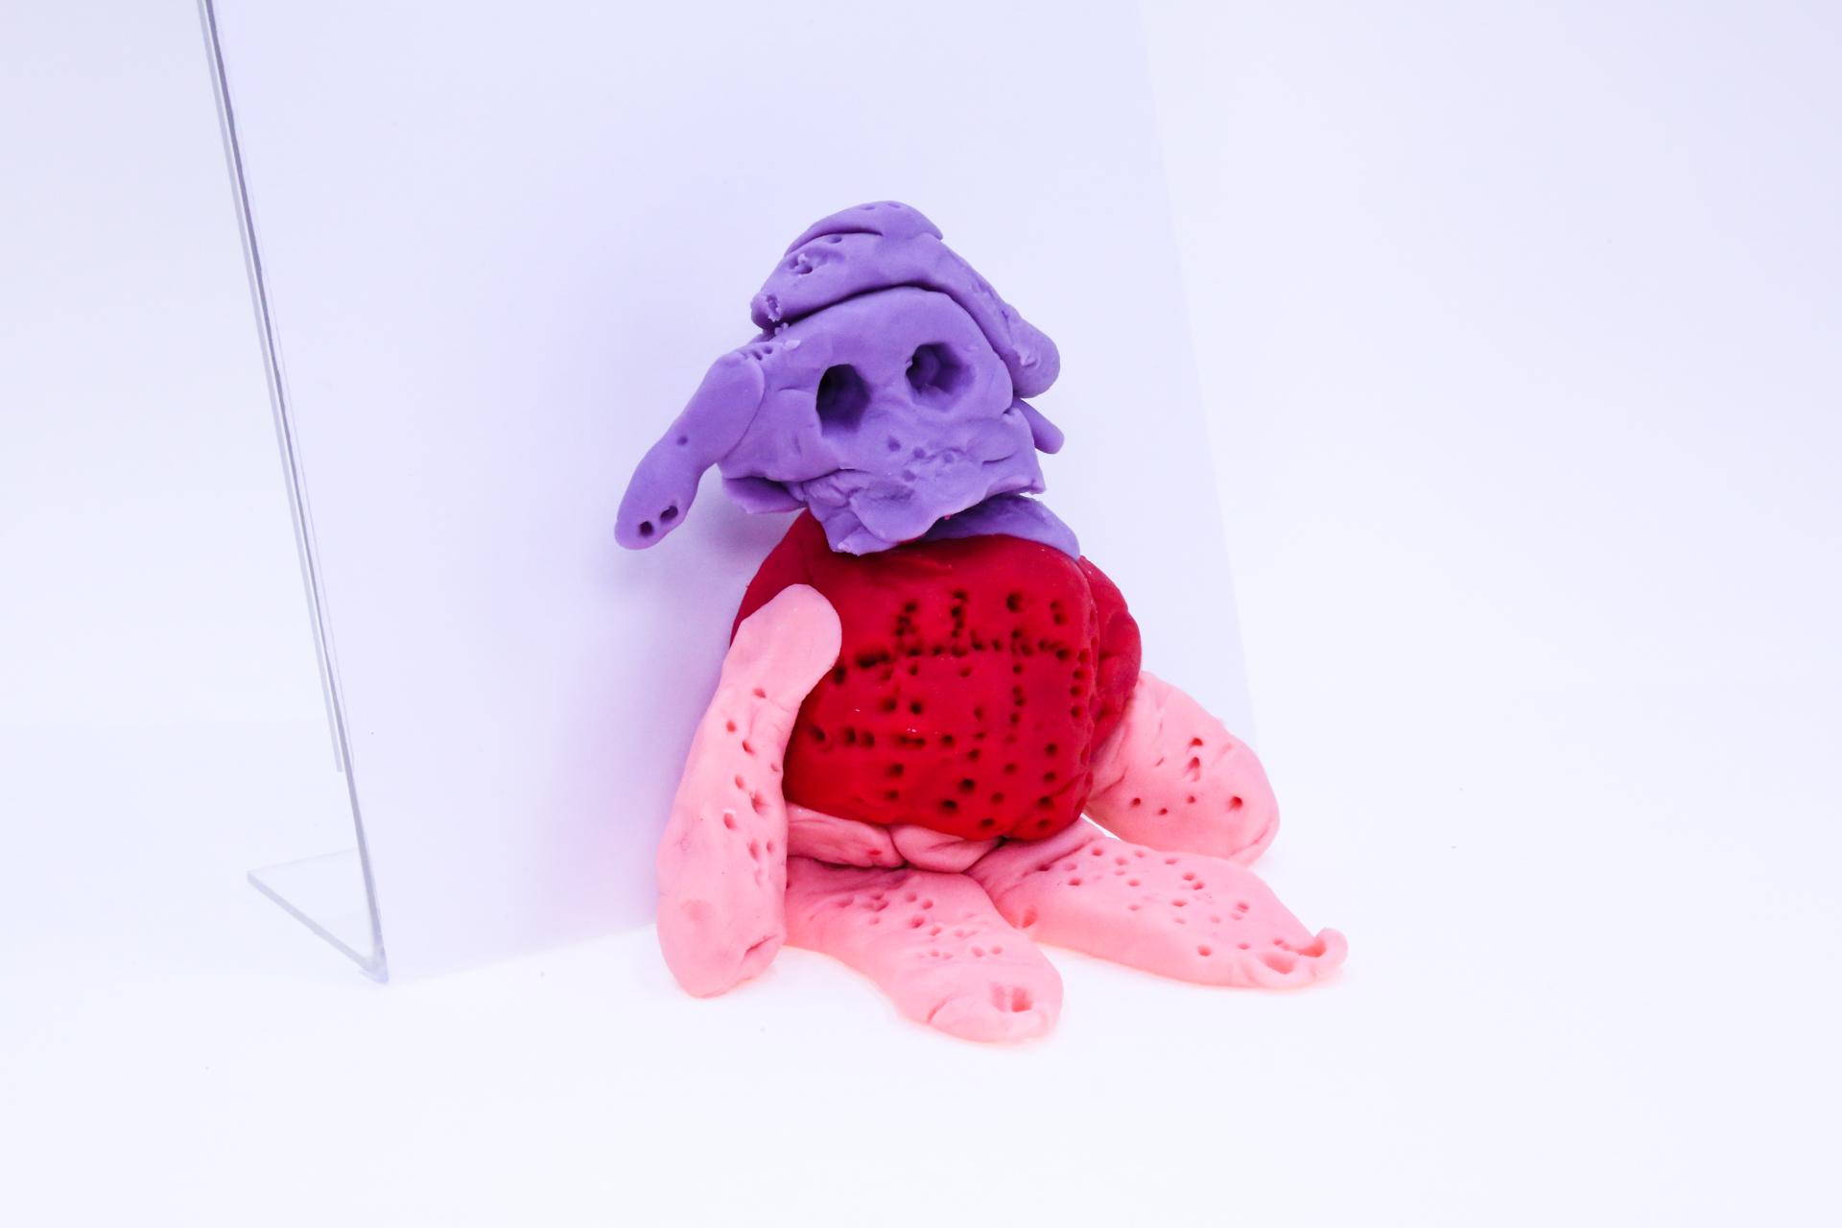400
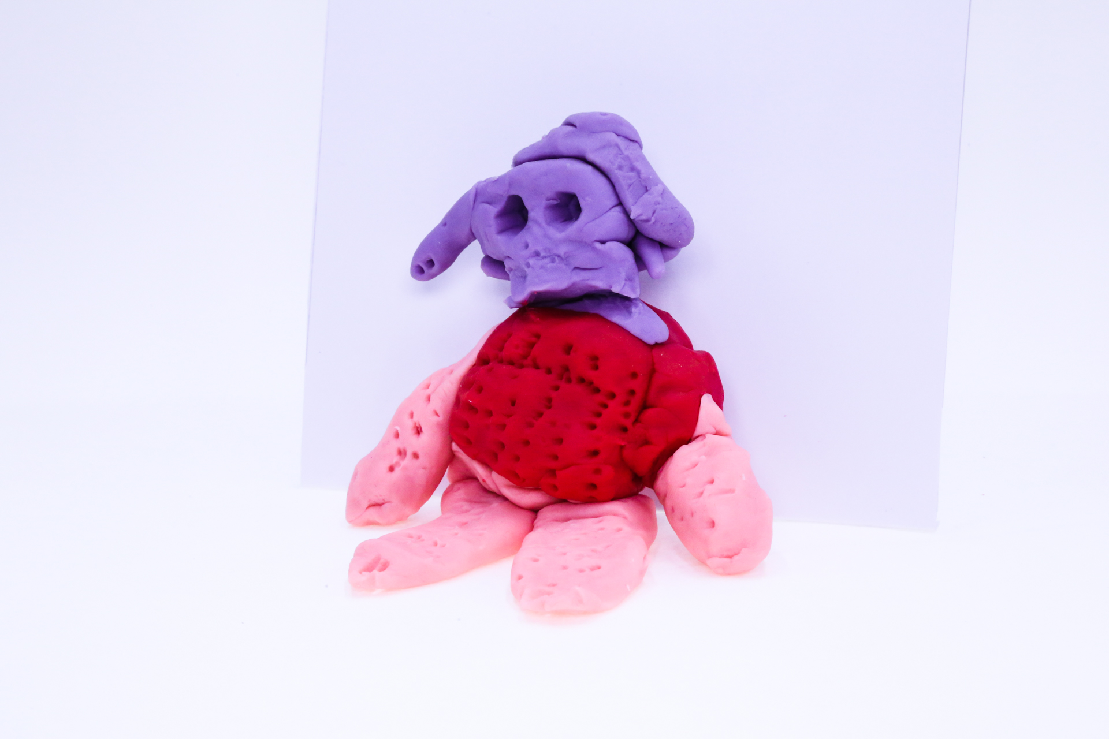400
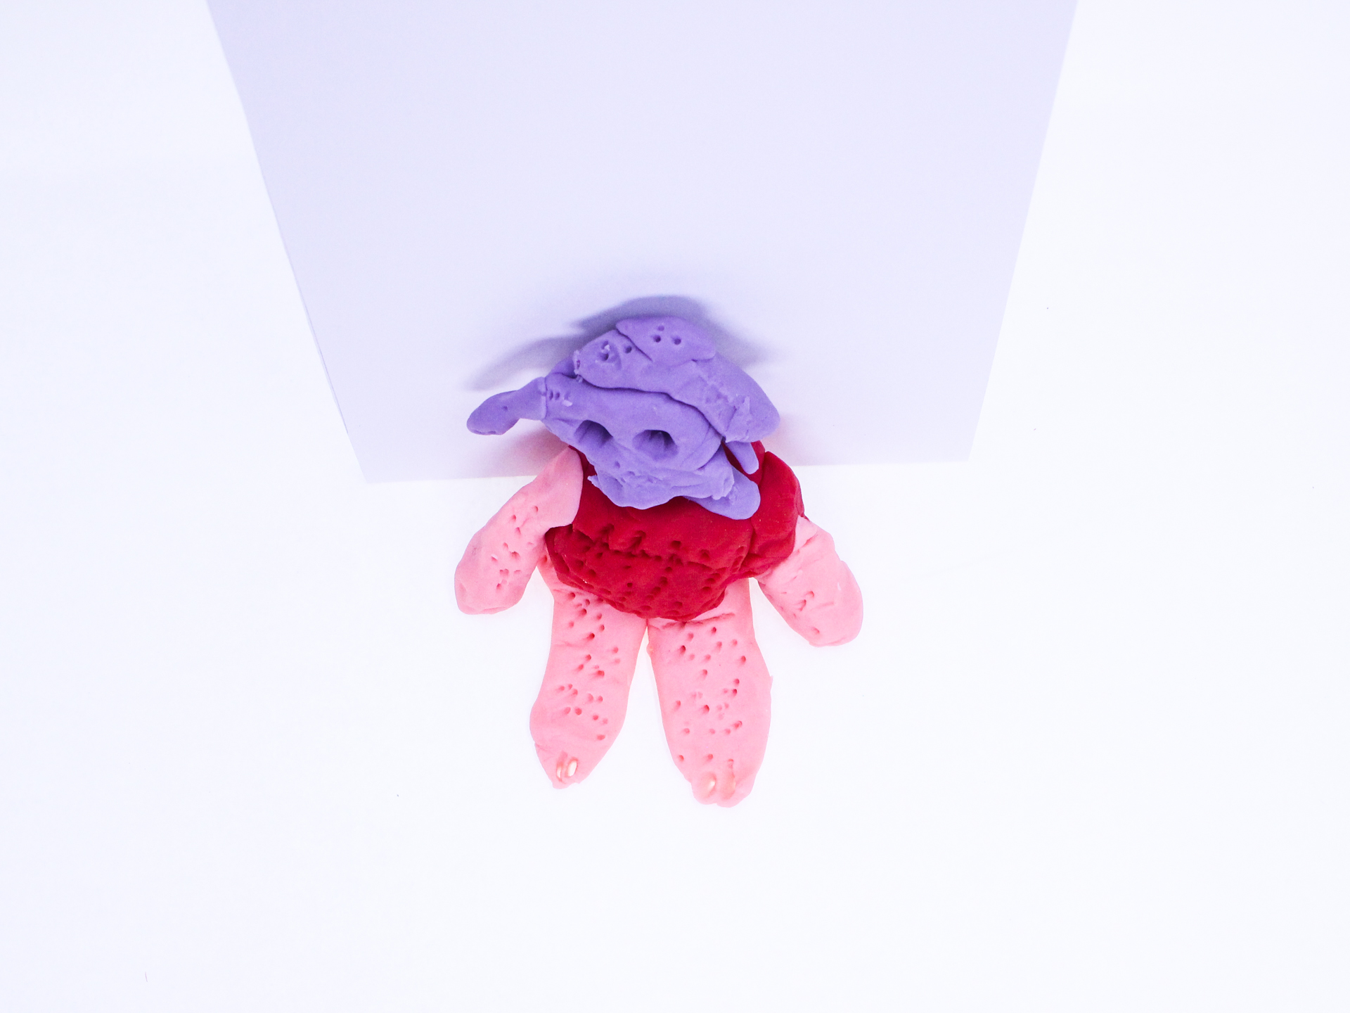400

A recording about the The thingy mijig can be found here:
400

This is the unique QR code for this Imagined Thing. Right click it to save then share it, so you and others can find your way back to here to this point of The Well.

IT IS KNOWN! HUZZAH FOR THE GREAT & GRAND RUMPUS!

