55. Spikey
HERE LIES THE ENTRY FOR AN IMAGINED THING
This is a thing imagined by Noah, aged 8, on Wednesday May 12
The full name of this thing is: Spikey
It can be found in: A really dark cave
It is known that: One bright sunny day a really scary dragon names spikey he was really angy so one day he cam to a village. He was biteing people eating people even blowing down houses he was so angry because he had no friends. So he stopped and made friends.
This thing has three important features: real looking (see sketch drawing), cool, and details

An image of Spikey can be found here:
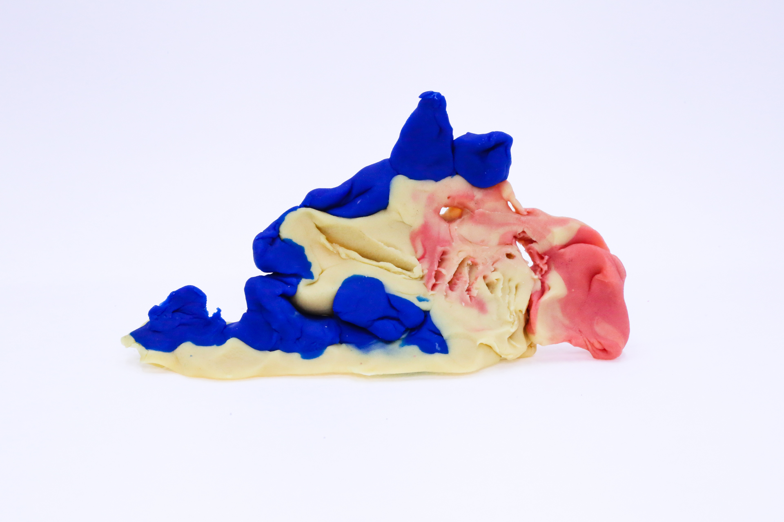400
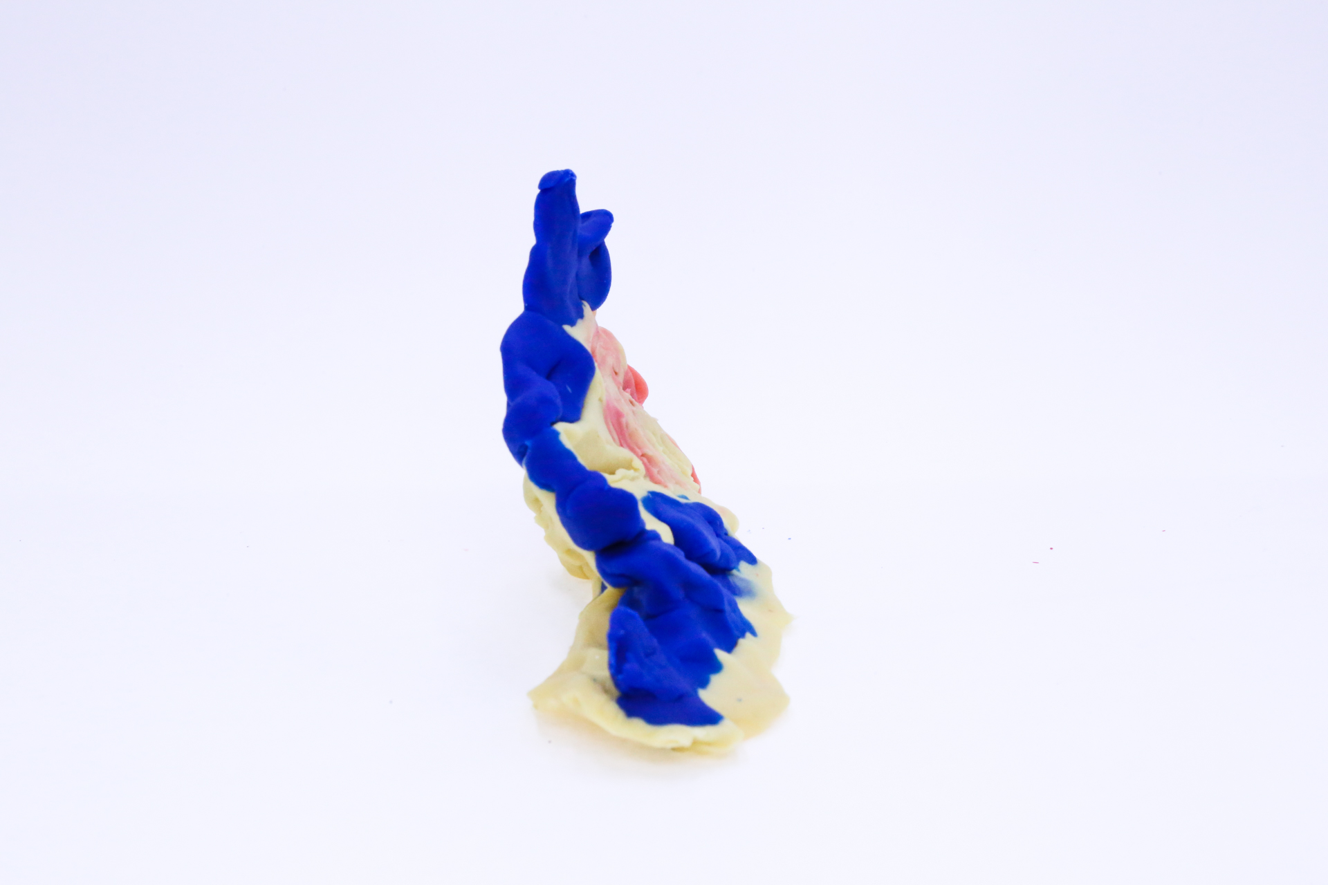400
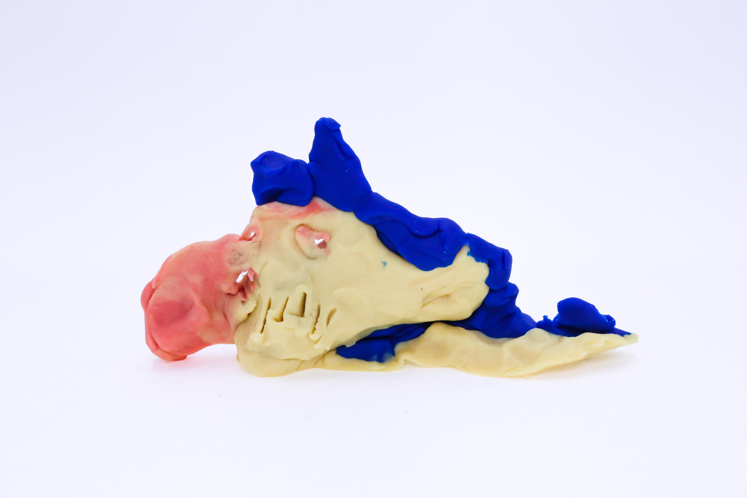400
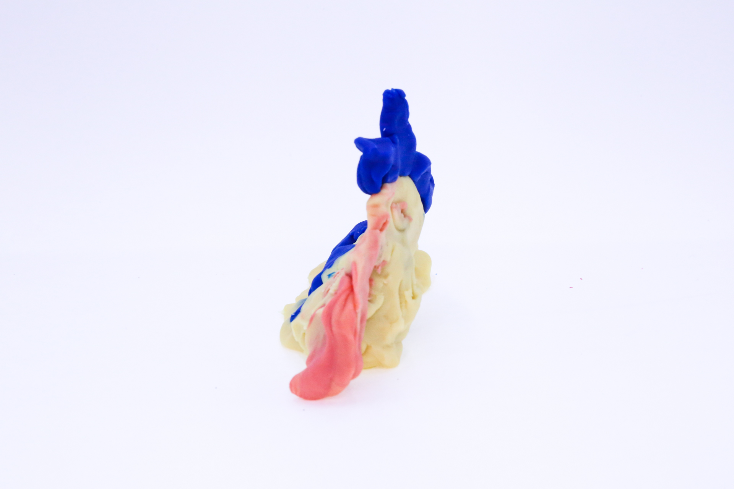400

A recording Spikey can be found here:
400

This is the unique QR code for this Imagined Thing. Right click it to save then share it, so you and others can find your way back to here to this point of The Well.

IT IS KNOWN! HUZZAH FOR THE GREAT & GRAND RUMPUS!

