54. Andy the Monster
HERE LIES THE ENTRY FOR AN IMAGINED THING
This is a thing imagined by Andrew, aged 8, on Wednesday May 12
The full name of this thing is: Andy the monster
It can be found in: An island nobody knows
It is known that: On cold night I on the coach when I woke up and find myself in an island walked around until I saw Andy the monster I ran back in the boat and went back home

An image of Andy the monster can be found here:
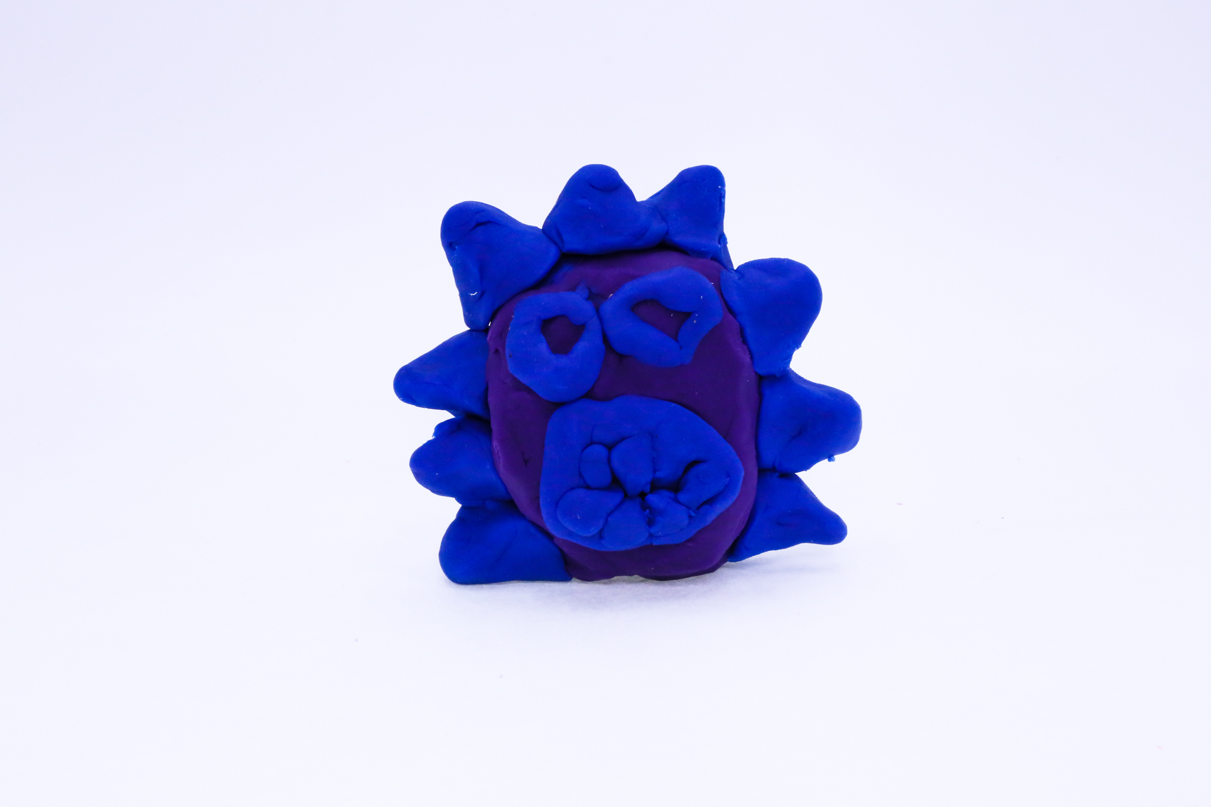400
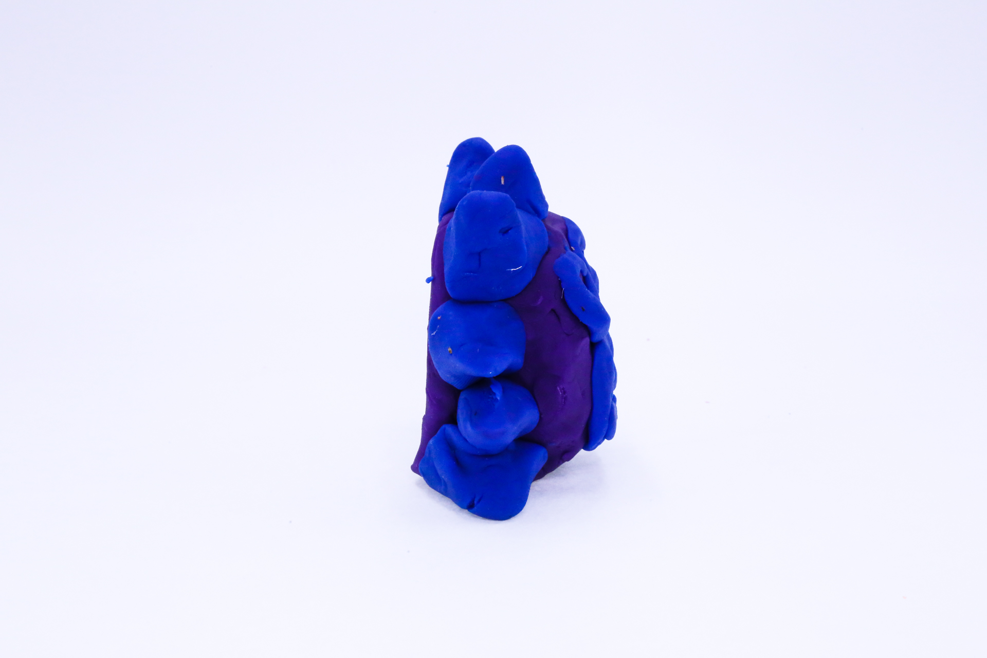400
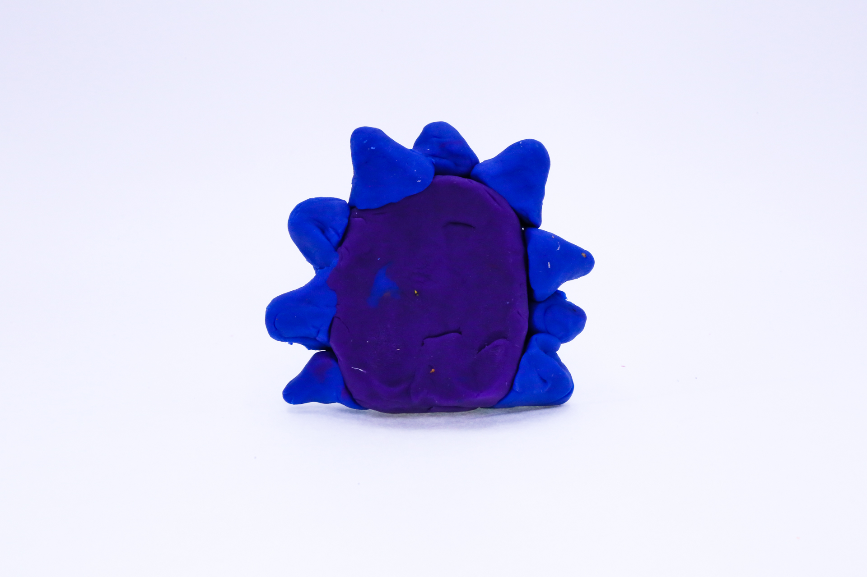400
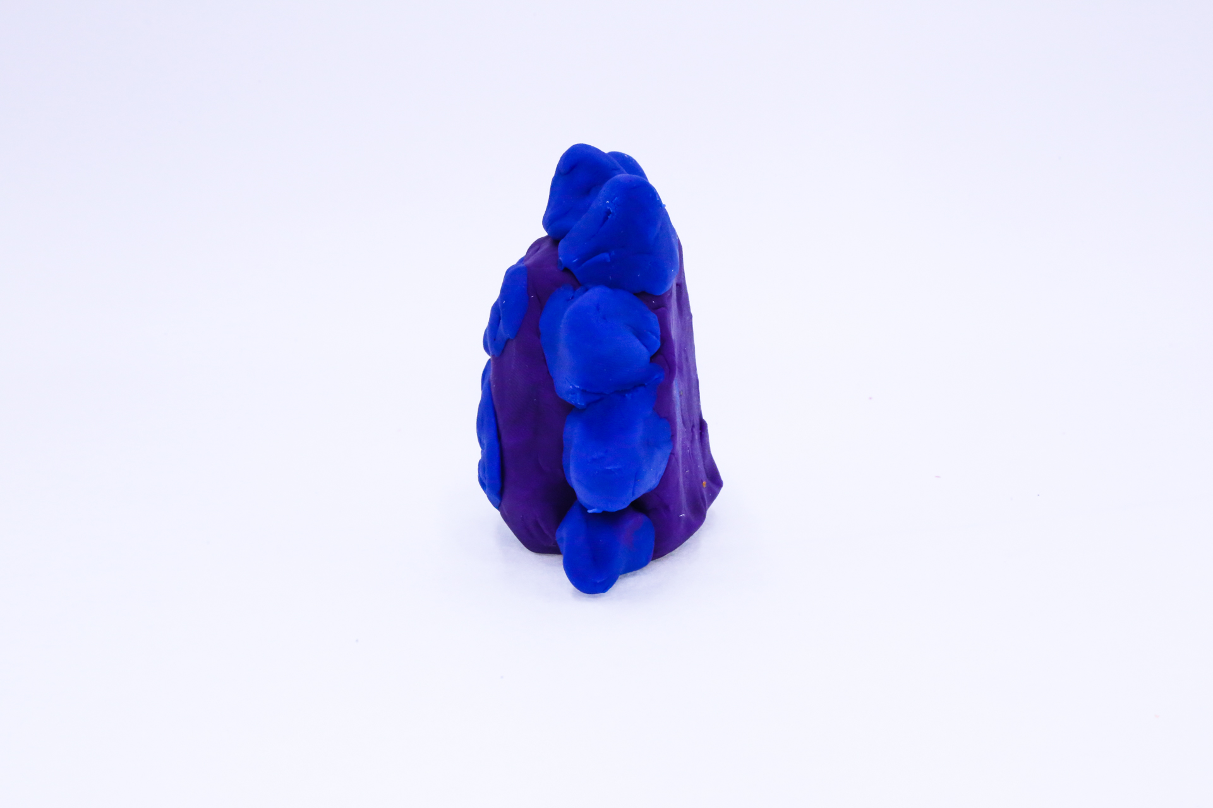400
400

This is the unique QR code for this Imagined Thing. Right click it to save then share it, so you and others can find your way back to here to this point of The Well.

IT IS KNOWN! HUZZAH FOR THE GREAT & GRAND RUMPUS!

