52. Hybrid
HERE LIES THE ENTRY FOR AN IMAGINED THING
This is a thing imagined by Rohulla, aged 8, on Wednesday May 12
The full name of this thing is: Hybrid
It can be found in: An Afghan desert
It is known that: An Afghan scientist had DNA of a saber tooth tiger he got from the bones and a sample of DNA of a tiger. He combined the DNA and a monster appeared. He ran for his life. The monster ran for him.
This thing has three important features: stripes, head, and teeth

An image of Hybrid can be found here:
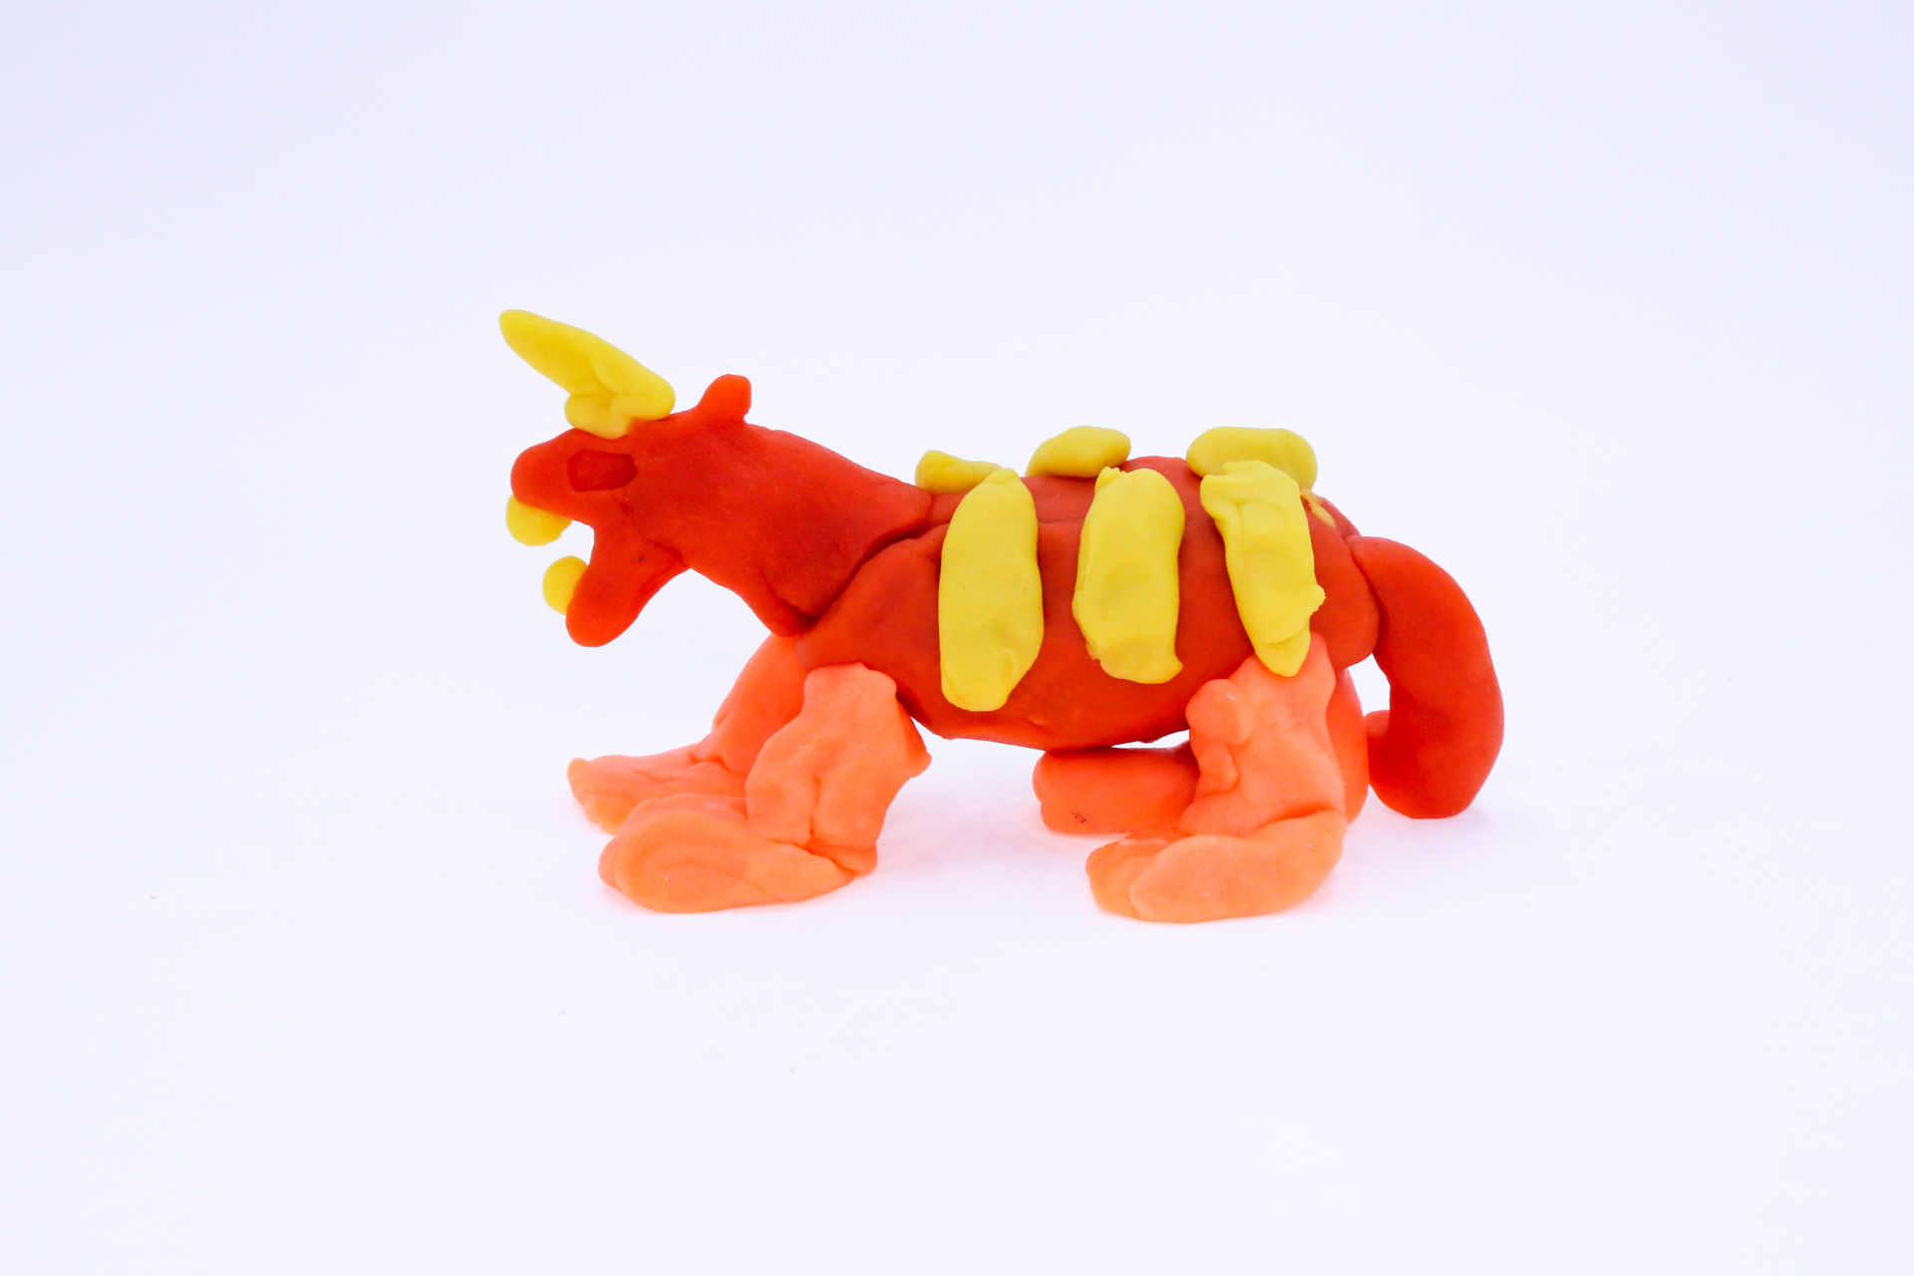400
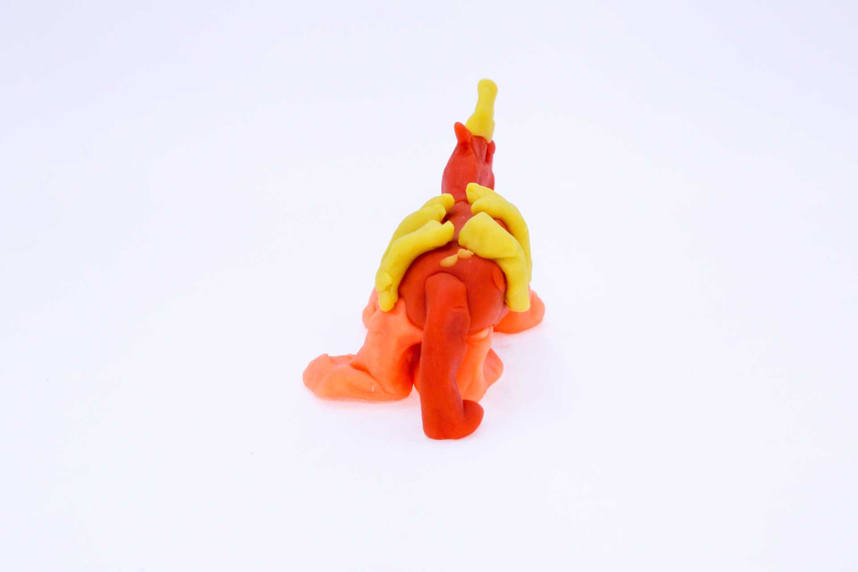400
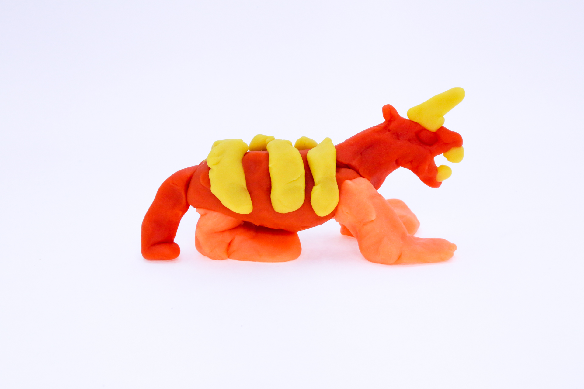400
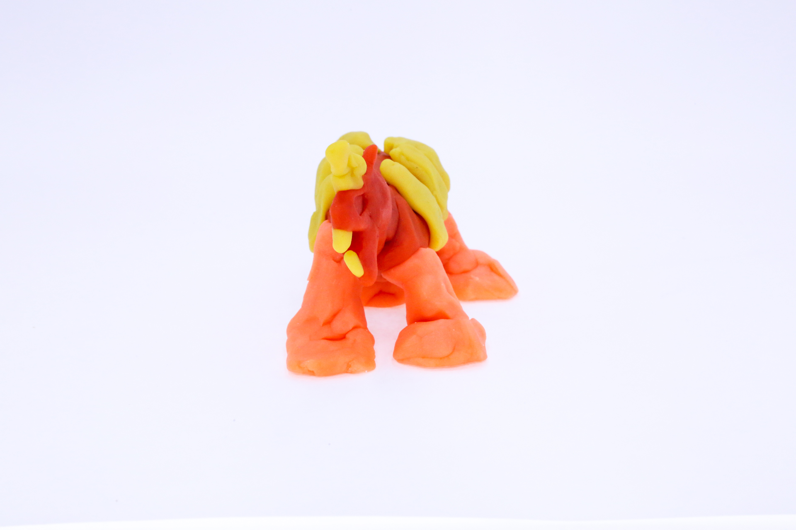400
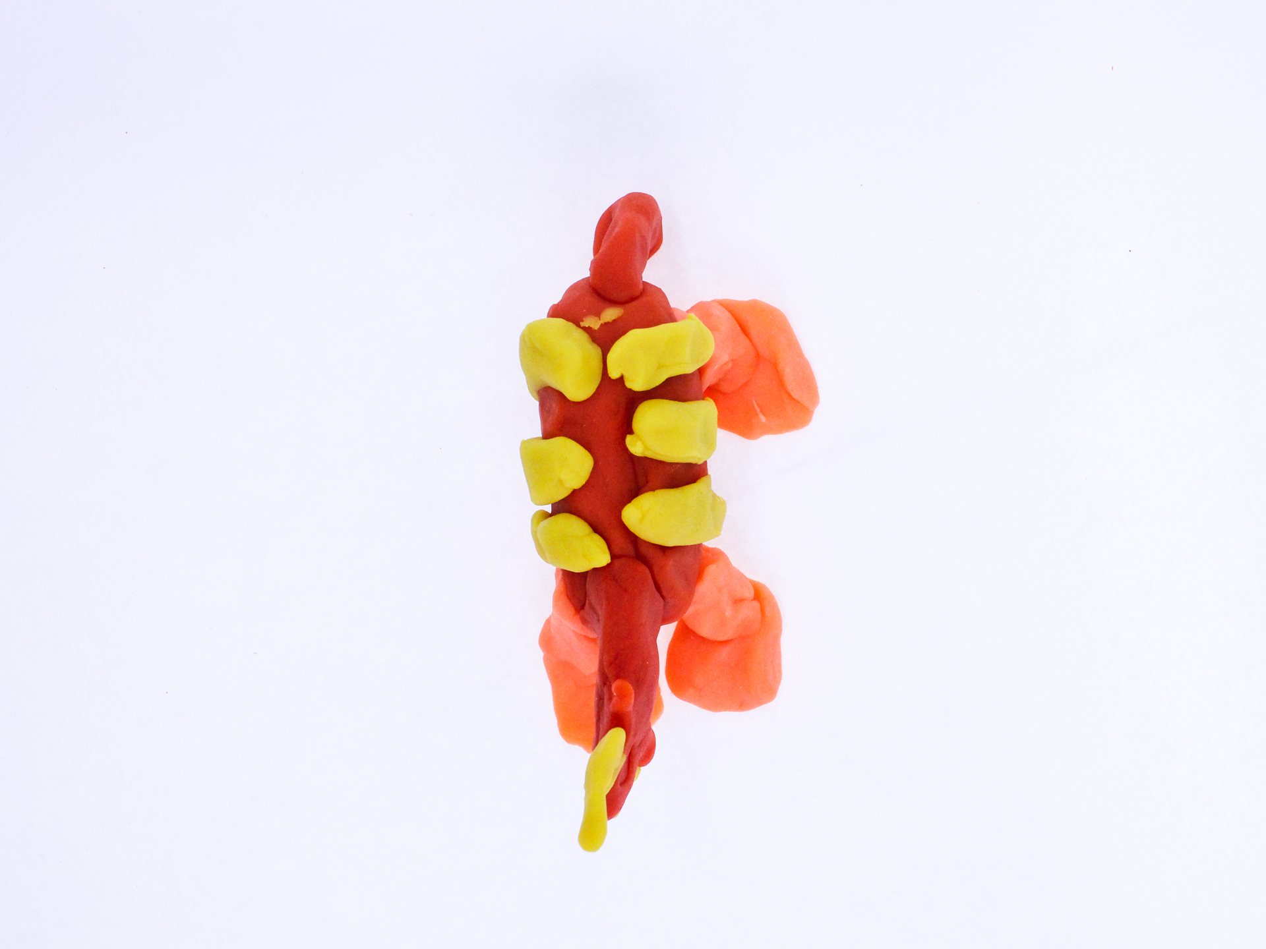400

A recording Hybrid can be found here:
400

This is the unique QR code for this Imagined Thing. Right click it to save then share it, so you and others can find your way back to here to this point of The Well.

IT IS KNOWN! HUZZAH FOR THE GREAT & GRAND RUMPUS!

