51. Silly
HERE LIES THE ENTRY FOR AN IMAGINED THING
This is a thing imagined by Liyah, aged 8, on Wednesday May 12
The full name of this thing is: Silly
It can be found in: imashanashon wrold
It is known that: Once upon a time there lived a monster under my teachers desk. One day the monster got so hungrey that he ate the teachers food and all my lunch. I told him to stop now we are friends

An image of Silly can be found here:
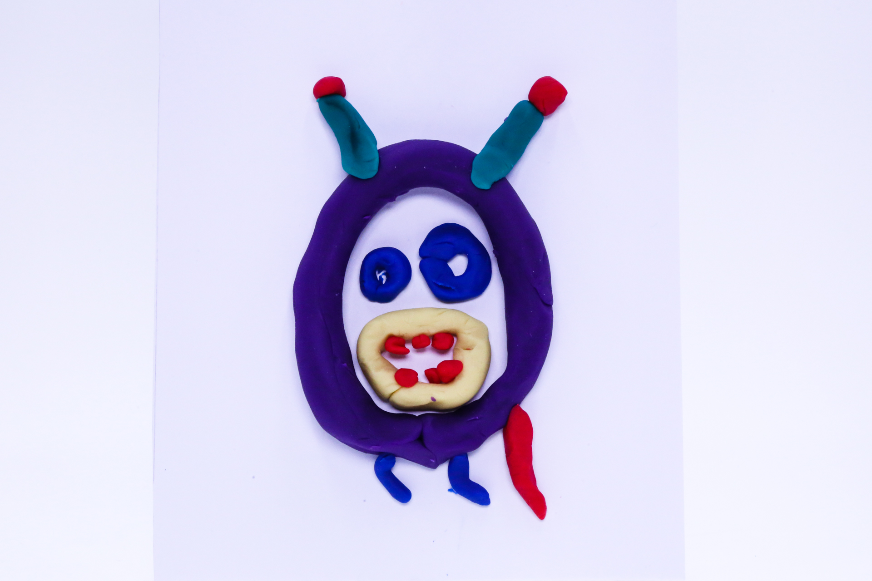400

A recording Silly can be found here:
400

This is the unique QR code for this Imagined Thing. Right click it to save then share it, so you and others can find your way back to here to this point of The Well.

IT IS KNOWN! HUZZAH FOR THE GREAT & GRAND RUMPUS!

