5. Shark Komododragon - Chosen Thing
HERE LIES THE ENTRY FOR AN IMAGINED THING
This is a thing imagined by Eh Bu, aged 10, on Wednesday April 21
The full name of this thing is: Shark komododragon
It can be found in: It from a eart that is a rainbow.
It is known that: I was in a white room then a door appeared then I open the door it was a colourful forest then I saw a lizard but with shark fin I name it shark komododragon.
This thing has three important features: the shark fin, the claw, and the tail

An image of Shark komododragon can be found here:
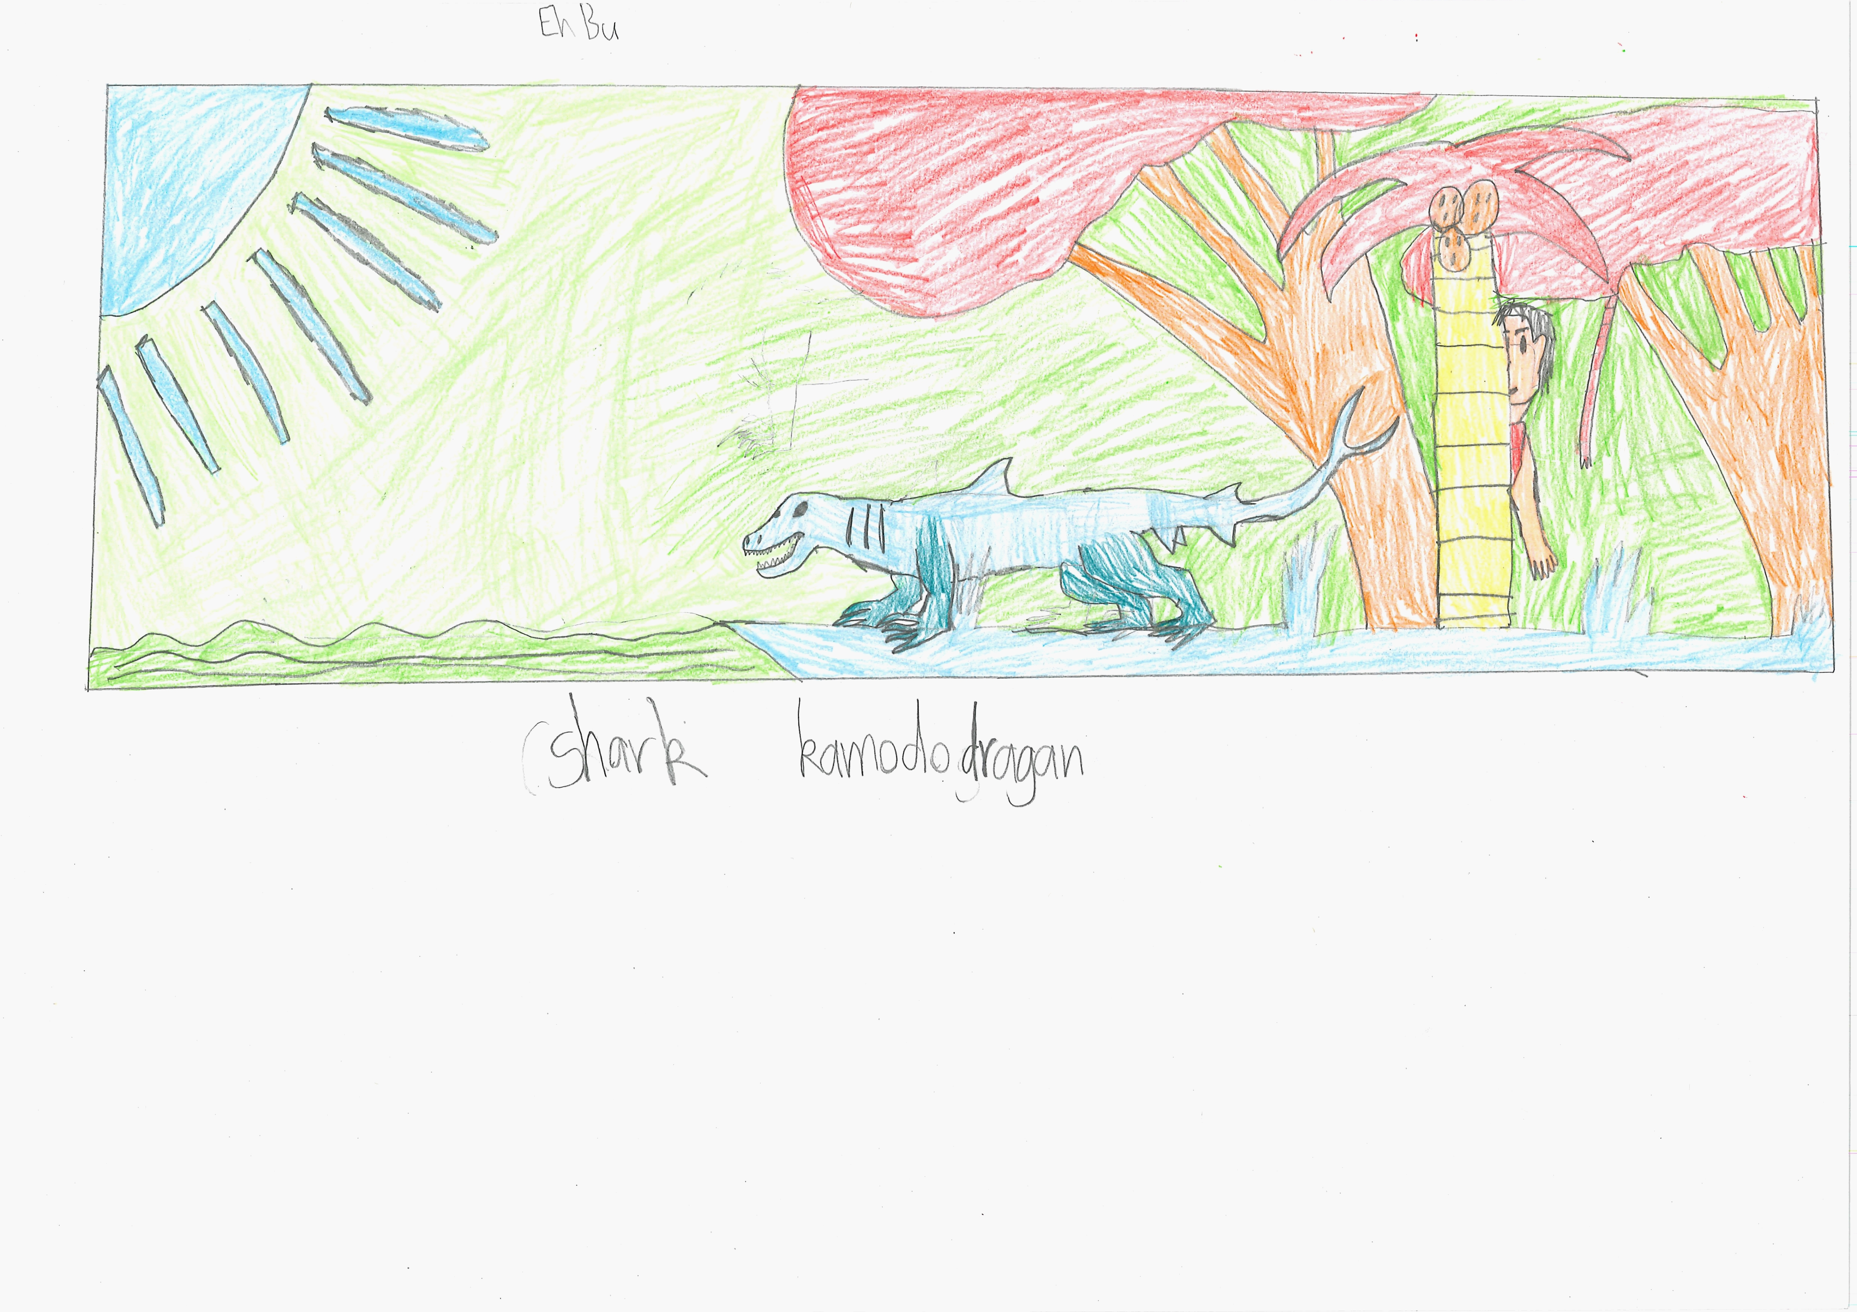400

A recording Shark komododragon can be found here:
400

This is the unique QR code for this Imagined Thing. Right click it to save then share it, so you and others can find your way back to here to this point of The Well.

IT IS KNOWN! HUZZAH FOR THE GREAT & GRAND RUMPUS!

