49. Beast X - Chosen Thing
HERE LIES THE ENTRY FOR AN IMAGINED THING
This is a thing imagined by Zenimoatel , aged 8, on Wednesday May 12
The full name of this thing is: Beast X
It can be found in: A mystery Island
It is known that: One night I was in bed and I had this weird dream So I named it up and the mystery beast was called Beast X then it was protecting me.
This thing has three important features: Sharp hands, head, and the eyes

An image of Beast X can be found here:
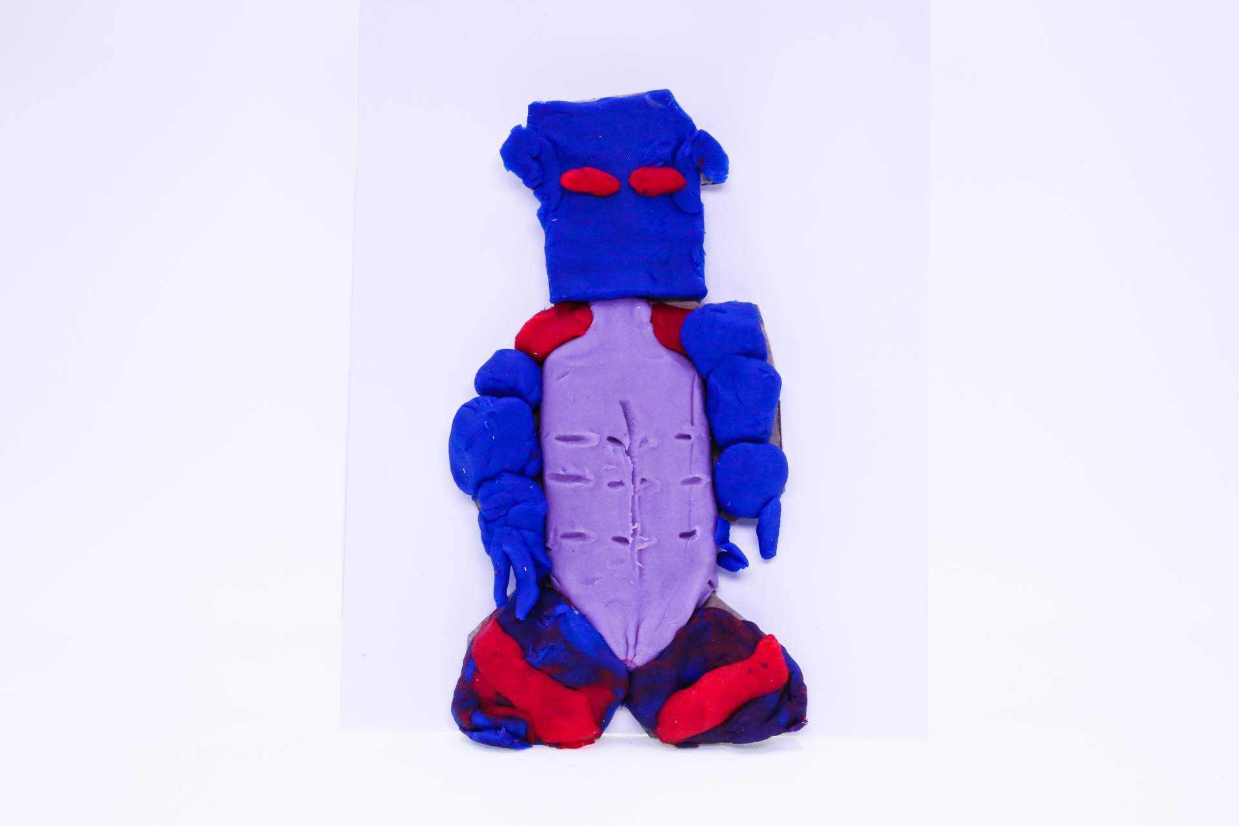400

A recording Beast X can be found here:
400

This is the unique QR code for this Imagined Thing. Right click it to save then share it, so you and others can find your way back to here to this point of The Well.

IT IS KNOWN! HUZZAH FOR THE GREAT & GRAND RUMPUS!

