44. Sun Flower Girl
HERE LIES THE ENTRY FOR AN IMAGINED THING
This is a thing imagined by Lorence, aged 8, on Wednesday May 12
The full name of this thing is: sun flower girl
It can be found in: Aralier
It is known that: THE WOLF AND THE GIRL. One day there was a worlf and the litte girl there was frends bu One day something happen they had a faeit and a lette sun flower girl made them eat samthing and there all becaem friends.
This thing has three important features: clay, food calrerring, and bricks

An image of sun flower girl can be found here:
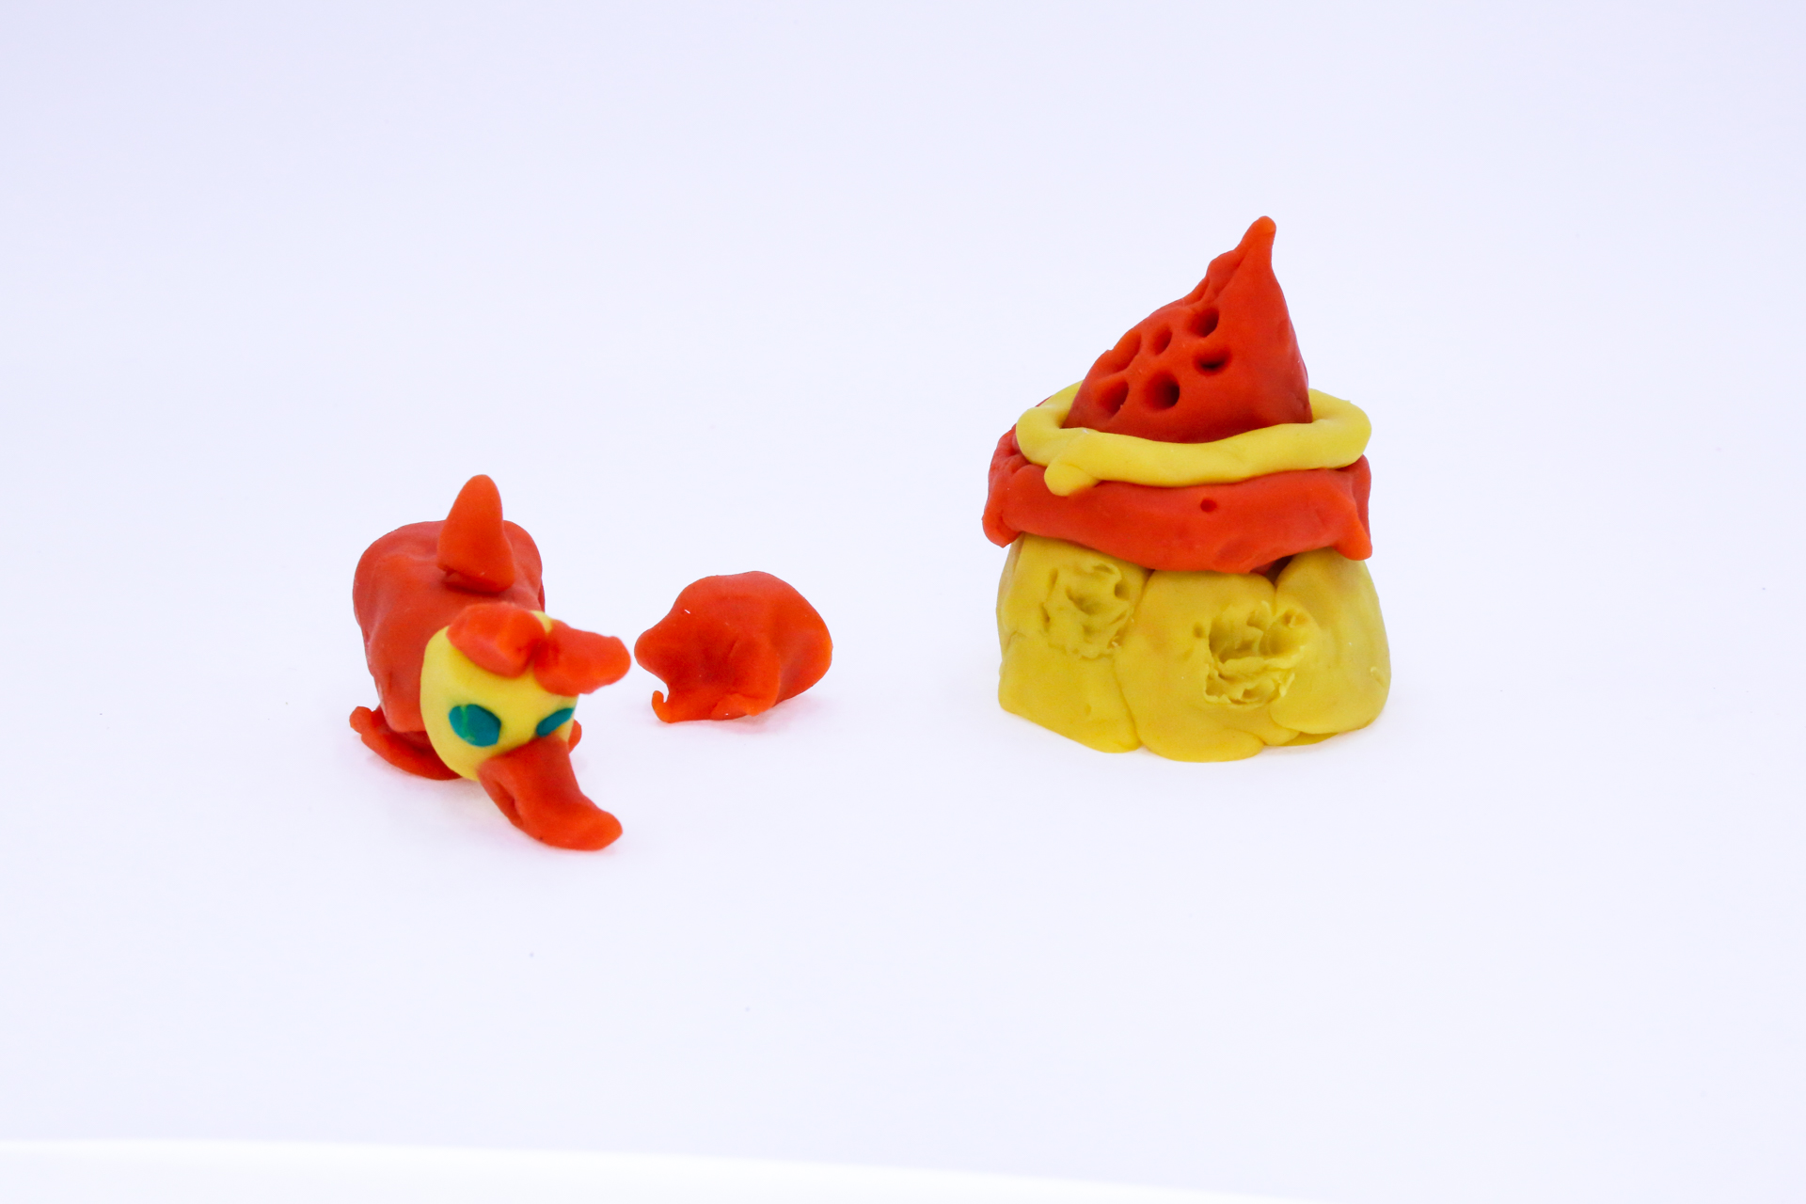400
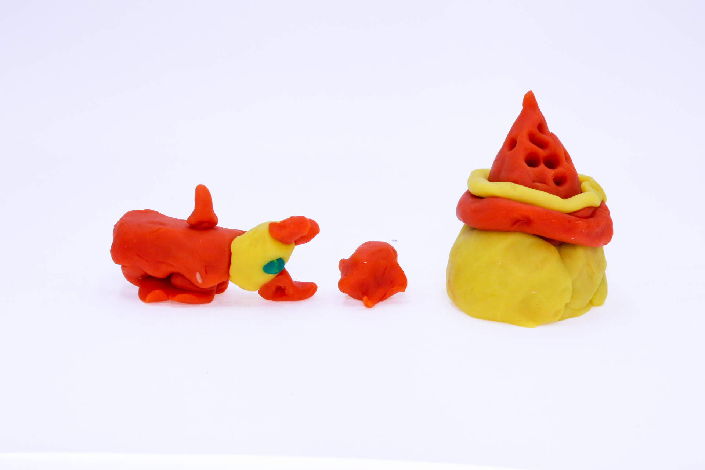400
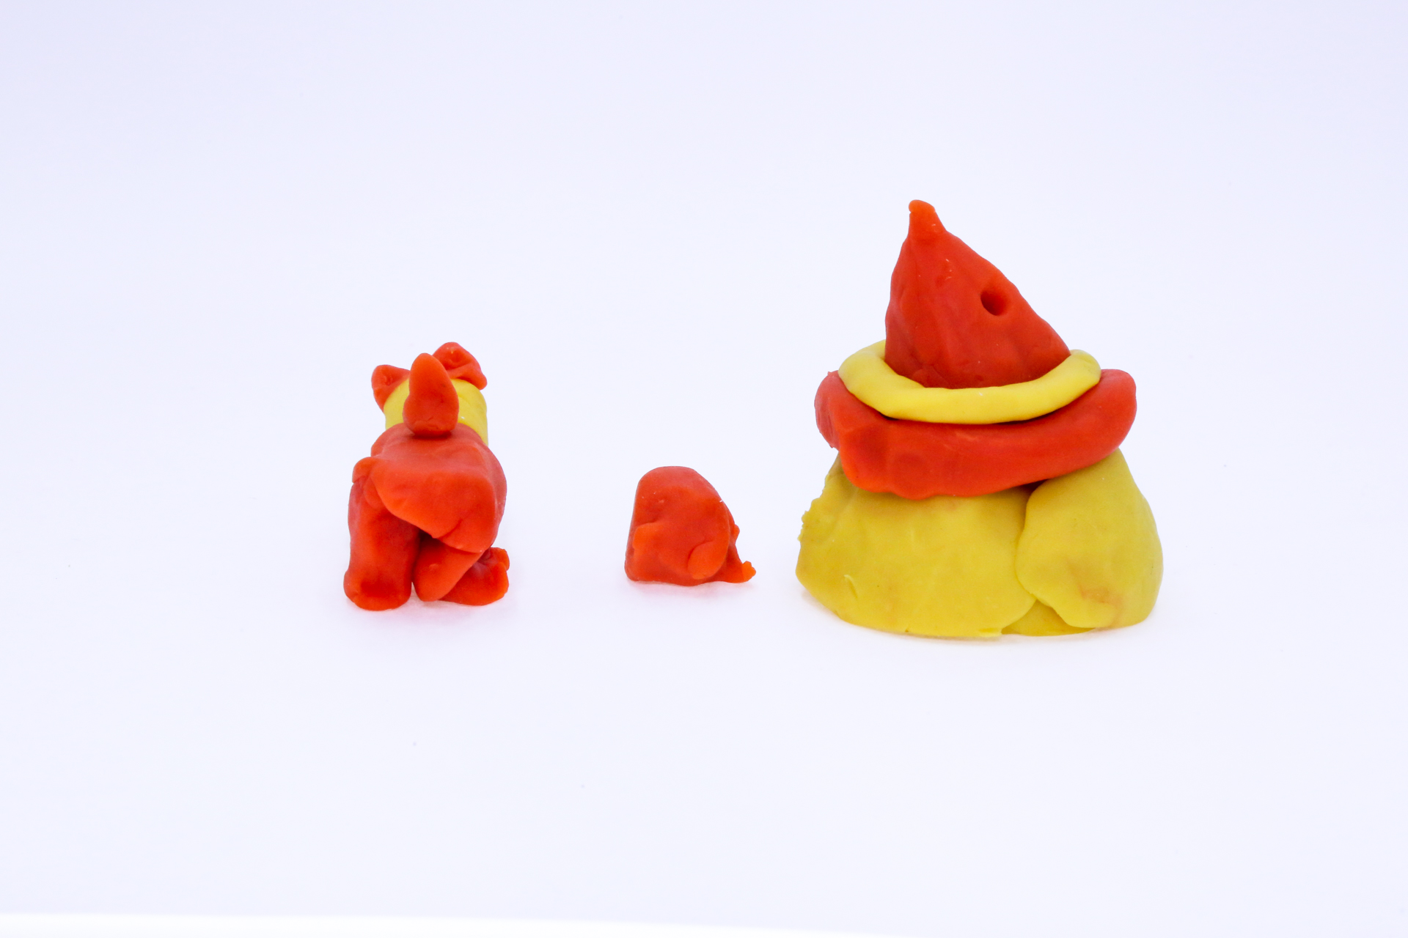400
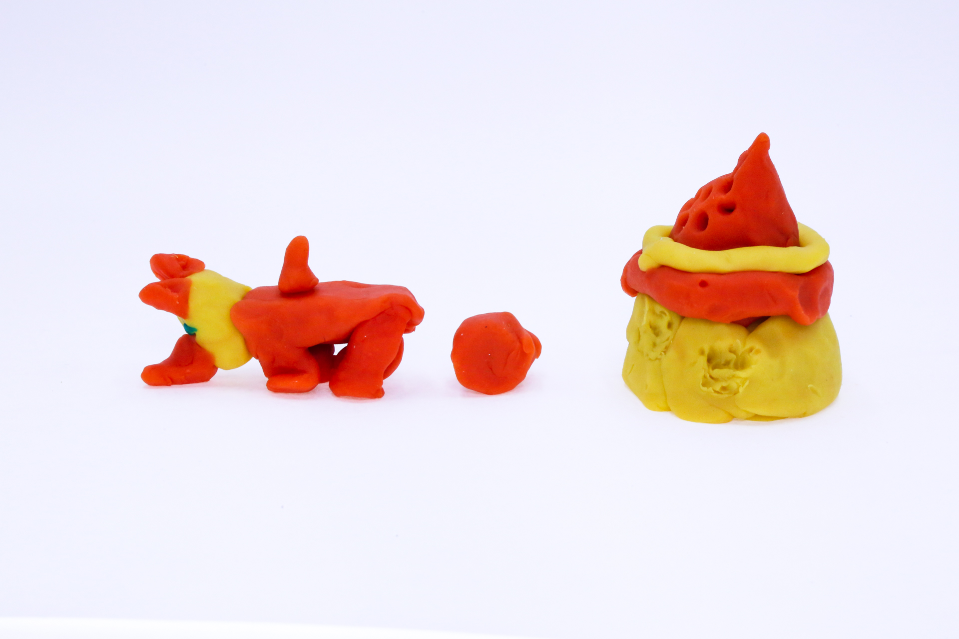400

A recording sun flower girl can be found here:
400

This is the unique QR code for this Imagined Thing. Right click it to save then share it, so you and others can find your way back to here to this point of The Well.

IT IS KNOWN! HUZZAH FOR THE GREAT & GRAND RUMPUS!

