42. Brian Shane
HERE LIES THE ENTRY FOR AN IMAGINED THING
This is a thing imagined by Eligh, aged 11, on Tuesday May 11
The full name of this thing is: Brian Shane
It can be found in: In my imagination
It is known that: I opened the door I looked around behind me and I saw this strange creature on a rock.
This thing has three important features: Head - has a mouth and eyes, Small, and Has legs

An image of Brian Shane can be found here:
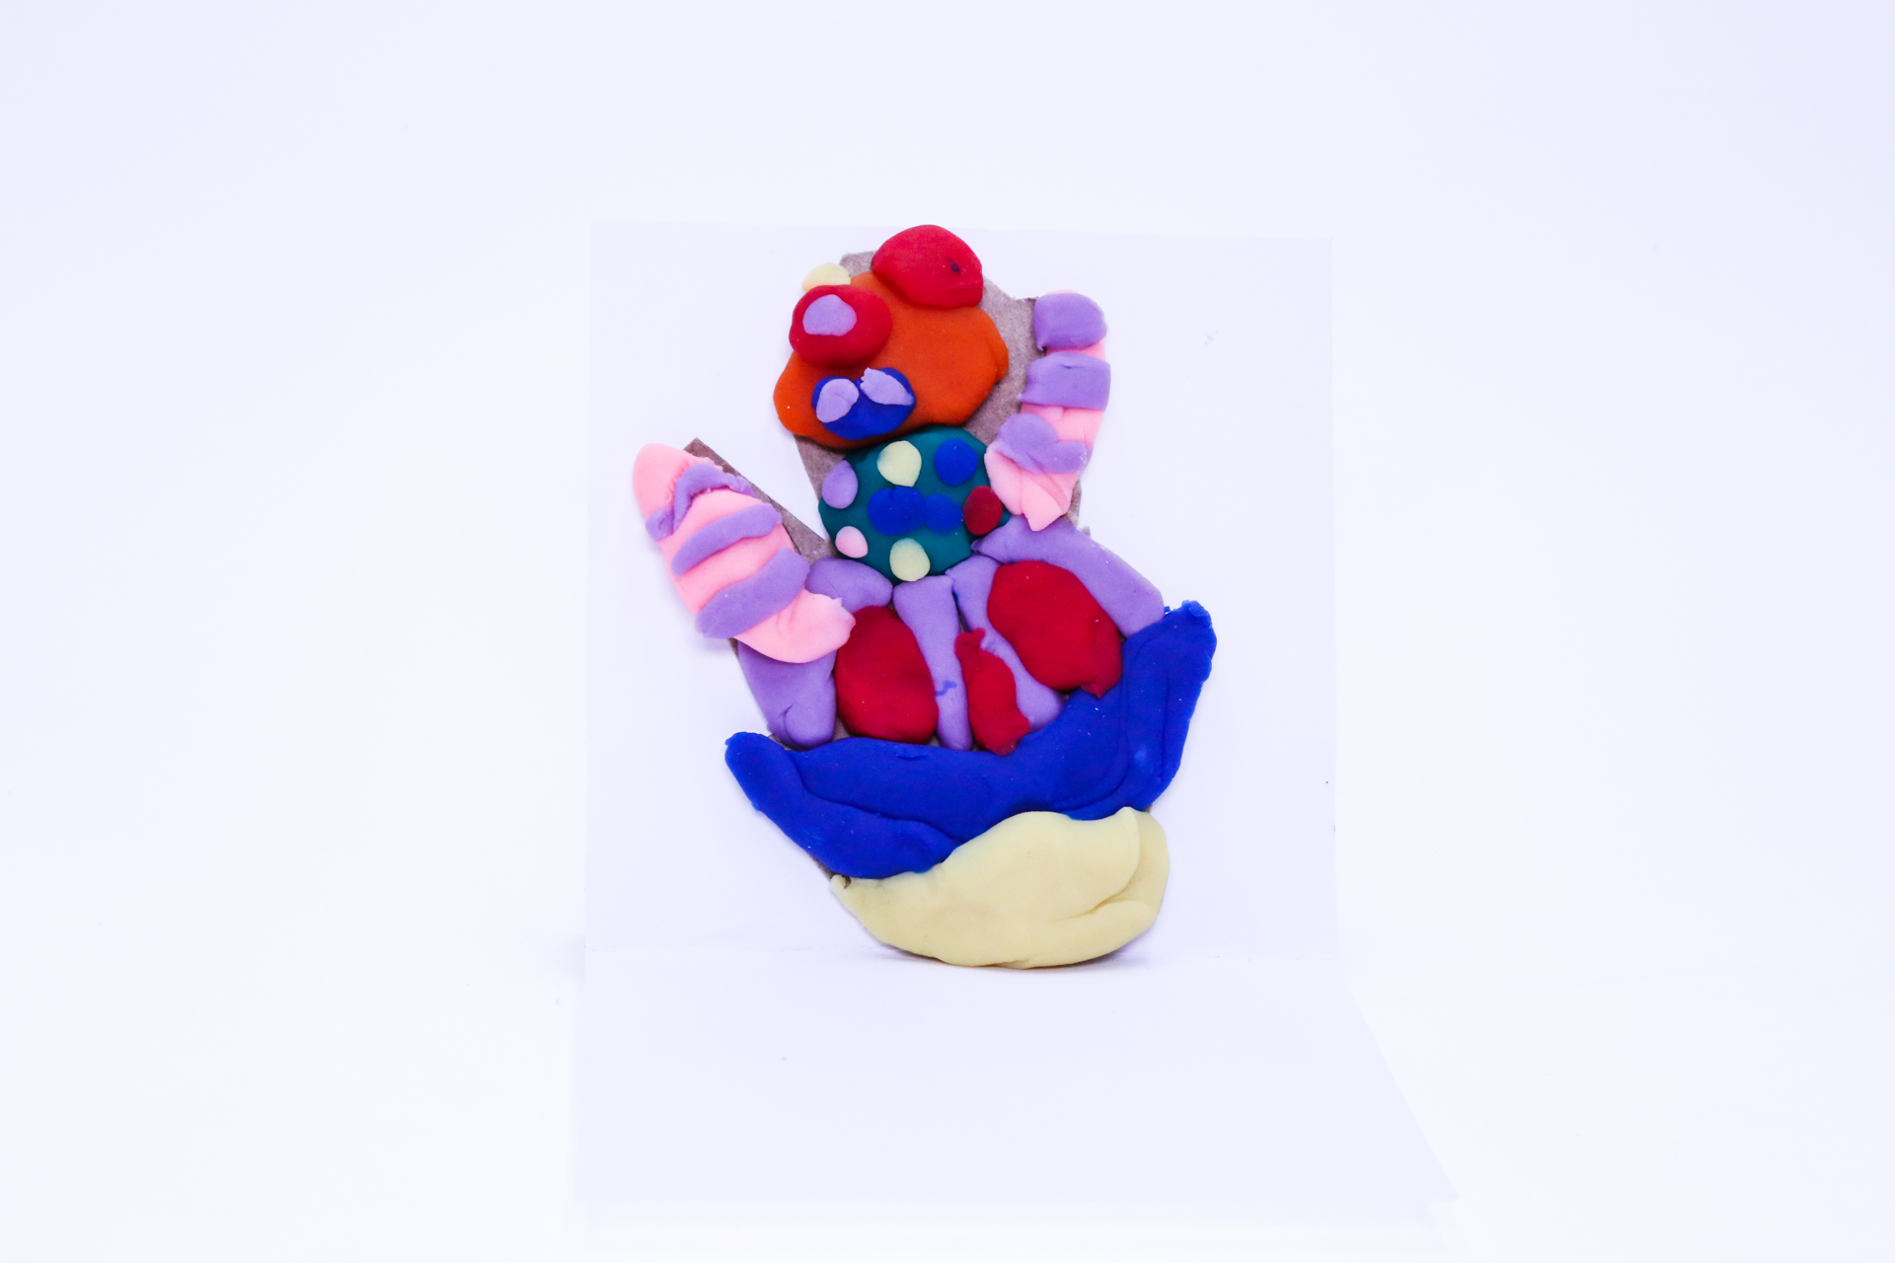400

This is the unique QR code for this Imagined Thing. Right click it to save then share it, so you and others can find your way back to here to this point of The Well.

IT IS KNOWN! HUZZAH FOR THE GREAT & GRAND RUMPUS!

