40. Dave
HERE LIES THE ENTRY FOR AN IMAGINED THING
This is a thing imagined by Edison, aged 11, on Tuesday May 11
The full name of this thing is: Dave
It can be found in: My creature is from an african forest.
It is known that: my creature hunts for food in the forest. It has sharp teeth and claws and has a talk and bright colours all over him to survive from his predetors. It camouflage it self to match from the environment.
This thing has three important features: colourful food, sharp teeth, and claws for hunting

An image of Dave can be found here:
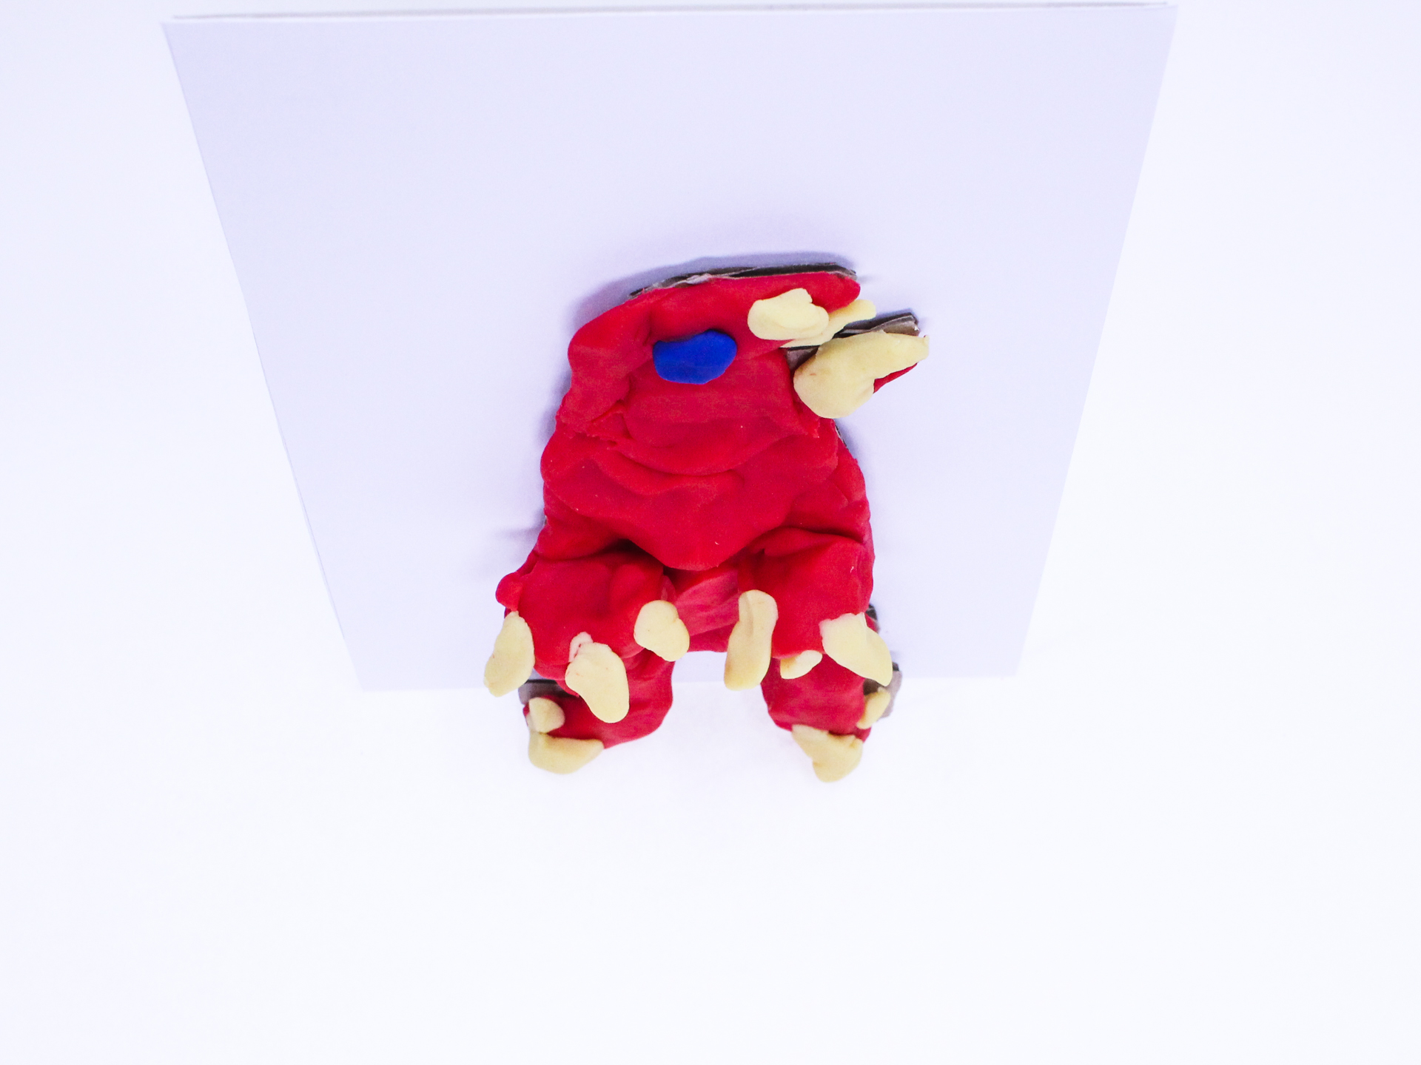
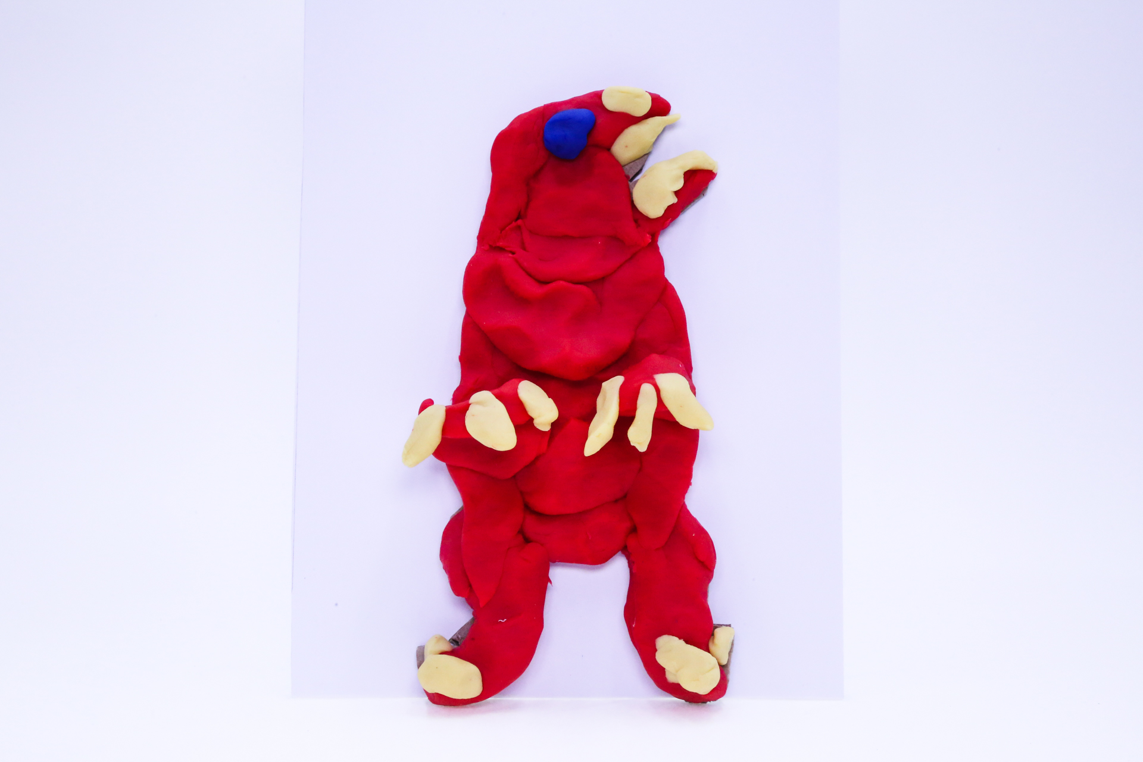400
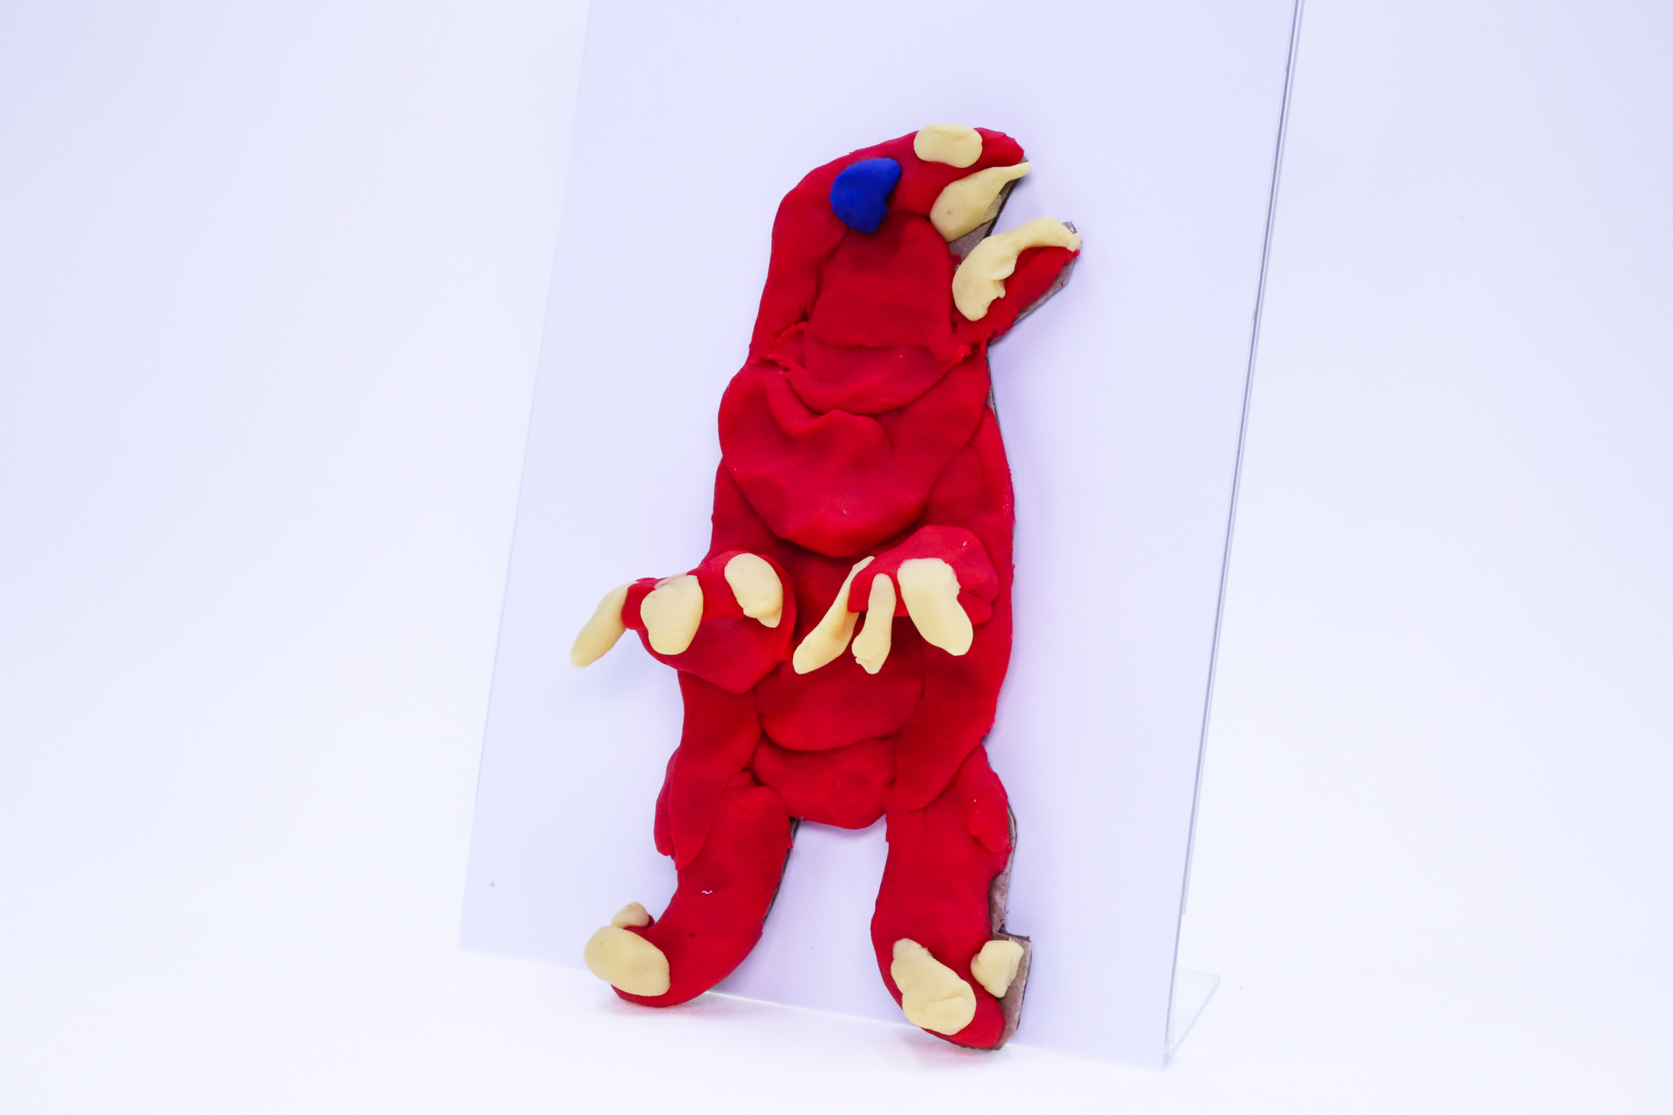400

A recording Dave can be found here:
400

This is the unique QR code for this Imagined Thing. Right click it to save then share it, so you and others can find your way back to here to this point of The Well.

IT IS KNOWN! HUZZAH FOR THE GREAT & GRAND RUMPUS!

