4. Ociana
HERE LIES THE ENTRY FOR AN IMAGINED THING
This is a thing imagined by Chanel, aged 10, on Wednesday April 21
The full name of this thing is: Ociana
It can be found in: my thing is from unicorn island
It is known that: She was born in unicorn Island and most of the human beings killied half of her pack. And she lives in a valley with her family. I did rainbow bushes, a raspberry tree, light green grass and neon yellow and blue moon and a crown and halow over the unicorn and some wings.
This thing has three important features: She is a princess, She can teleport, and She can fly very high

An image of Ociana can be found here:
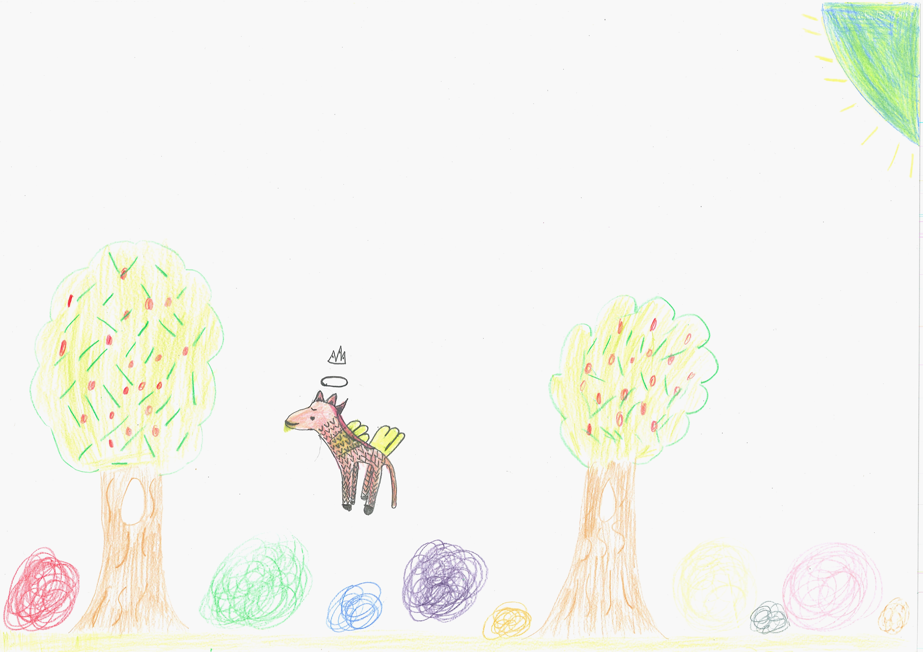400

A recording Ociana can be found here:
400

This is the unique QR code for this Imagined Thing. Right click it to save then share it, so you and others can find your way back to here to this point of The Well.

IT IS KNOWN! HUZZAH FOR THE GREAT & GRAND RUMPUS!

