39. Mutant Monkey
HERE LIES THE ENTRY FOR AN IMAGINED THING
This is a thing imagined by Tee-Moo, aged 11, on Tuesday May 11
The full name of this thing is: Mutant Monkey
It can be found in: A jungle that has fully grown creatures.
It is known that: He was born in the mutant jungle he was a normal size monkey when he was first born he learned to survive and now he is 5 years old.
This thing has three important features: claw, jump, and strong roar

An image of Mutant Monkey can be found here:
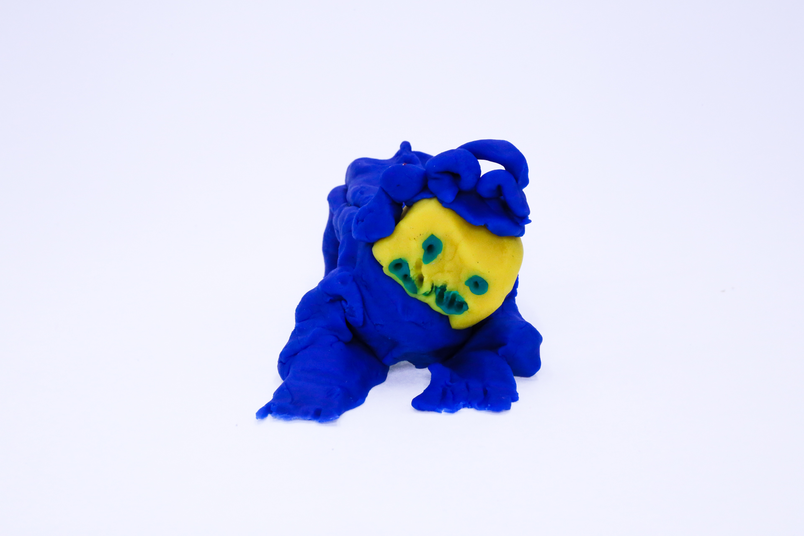400
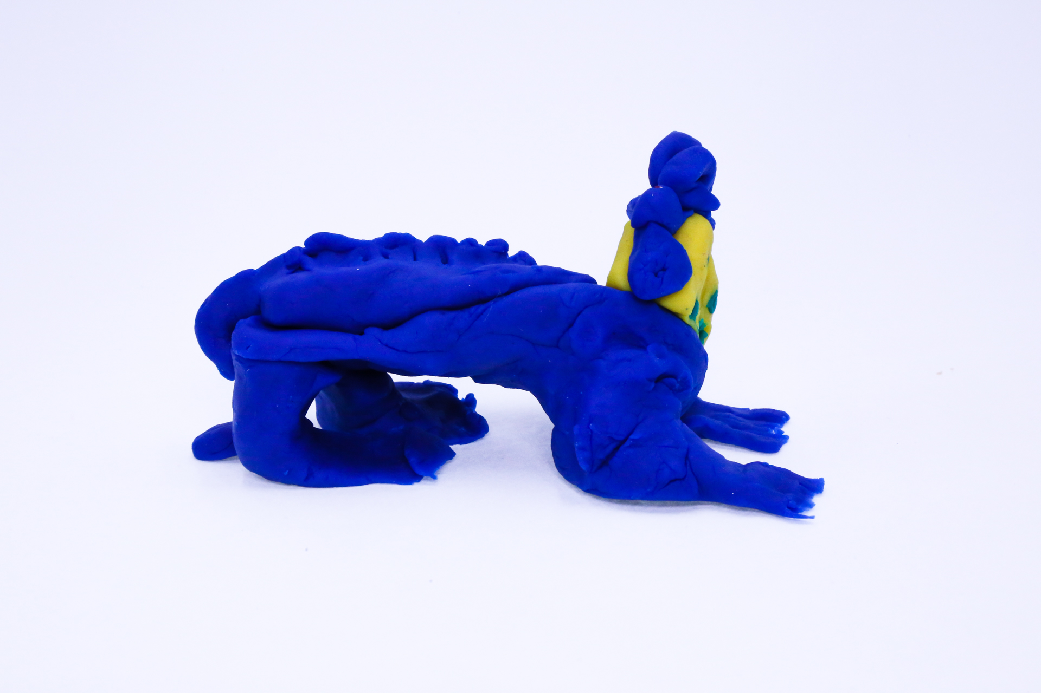400
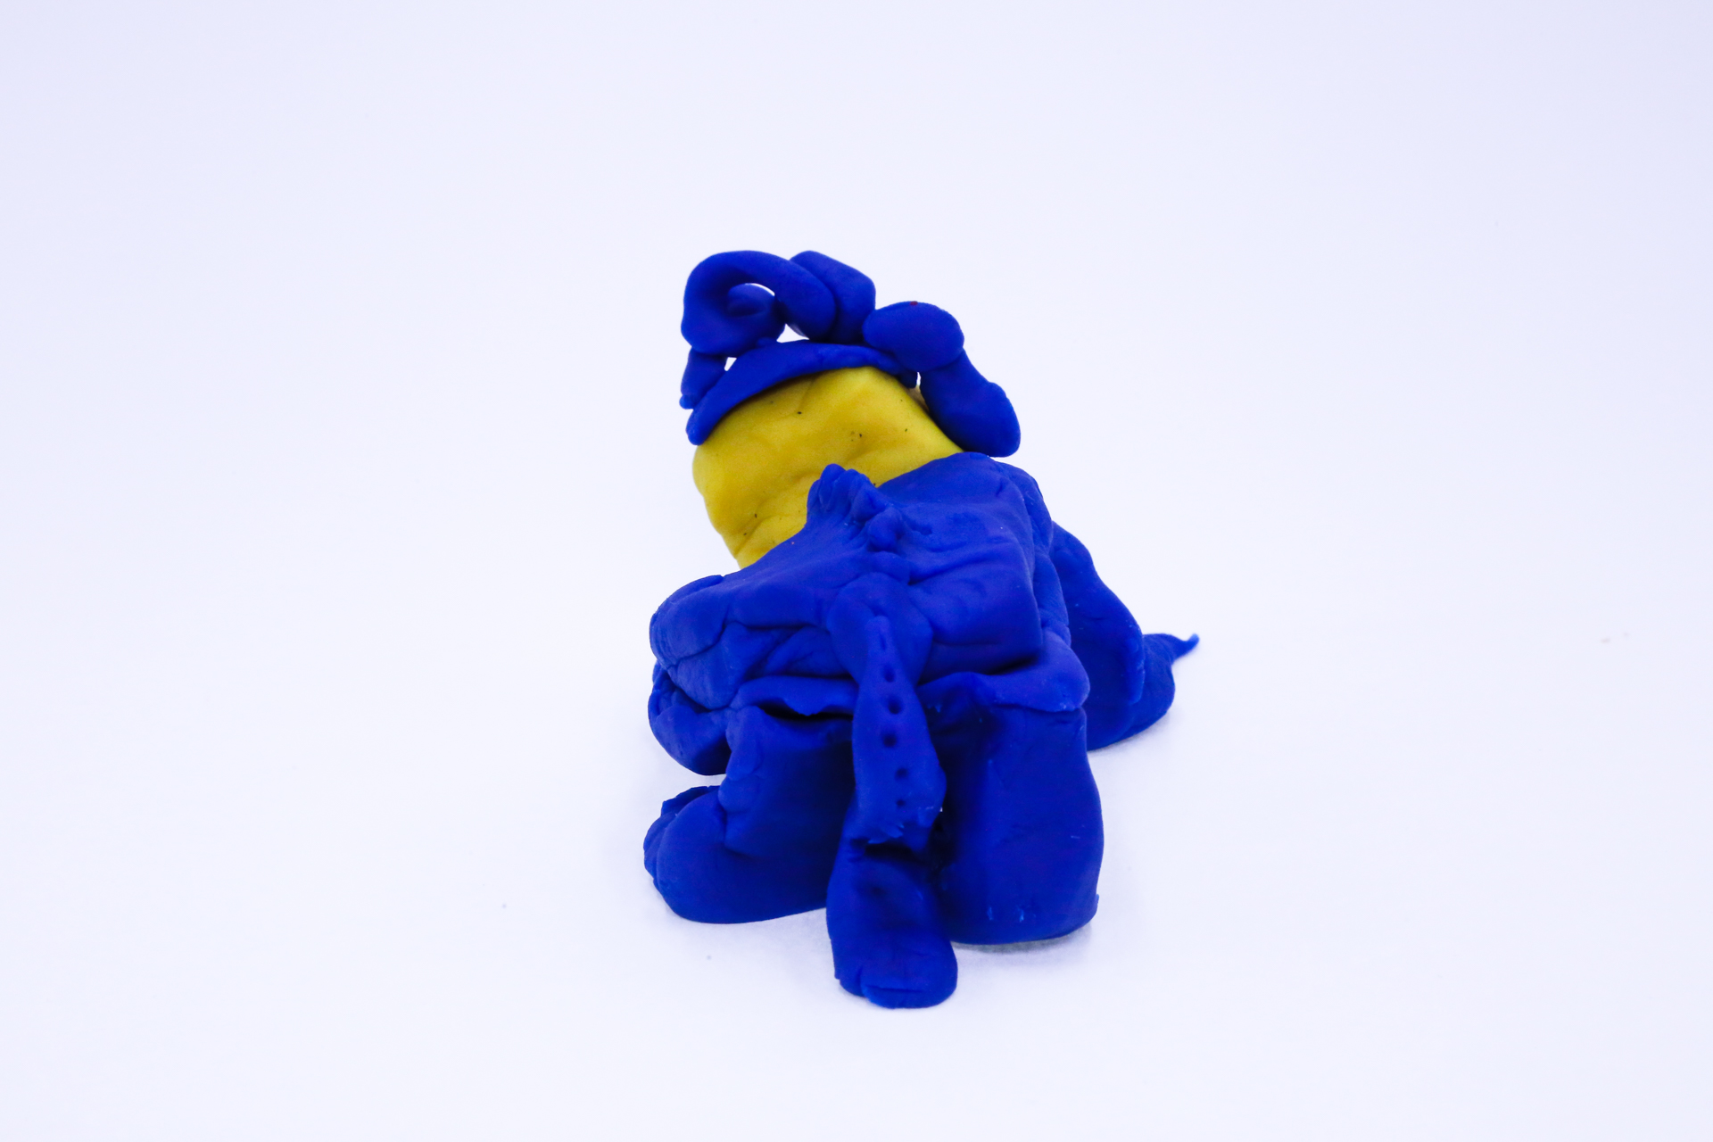400
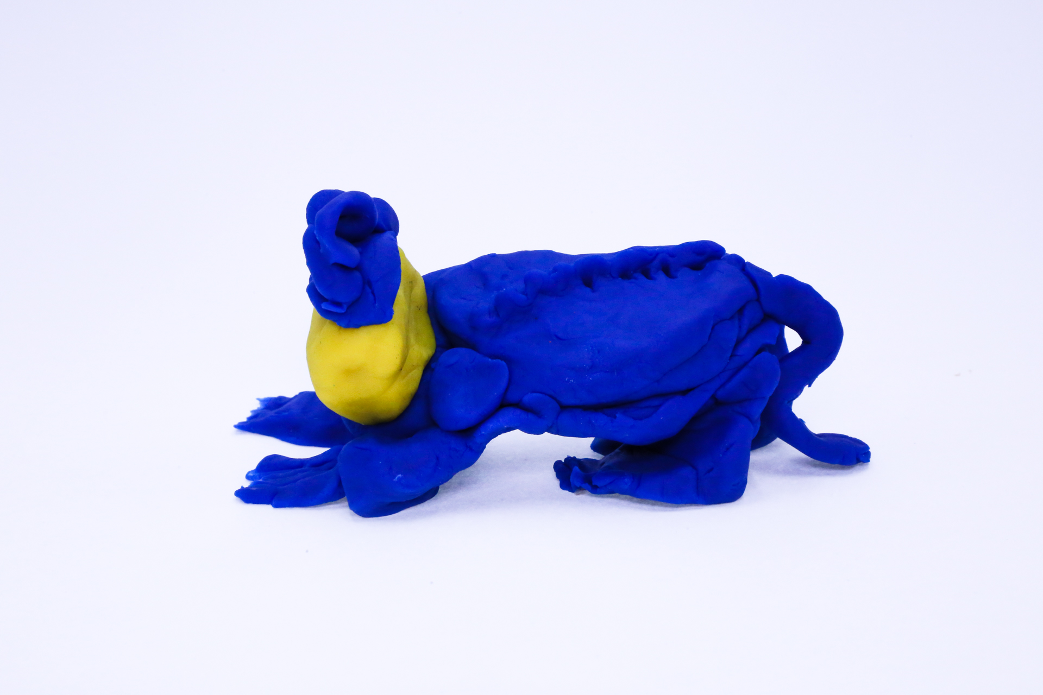400
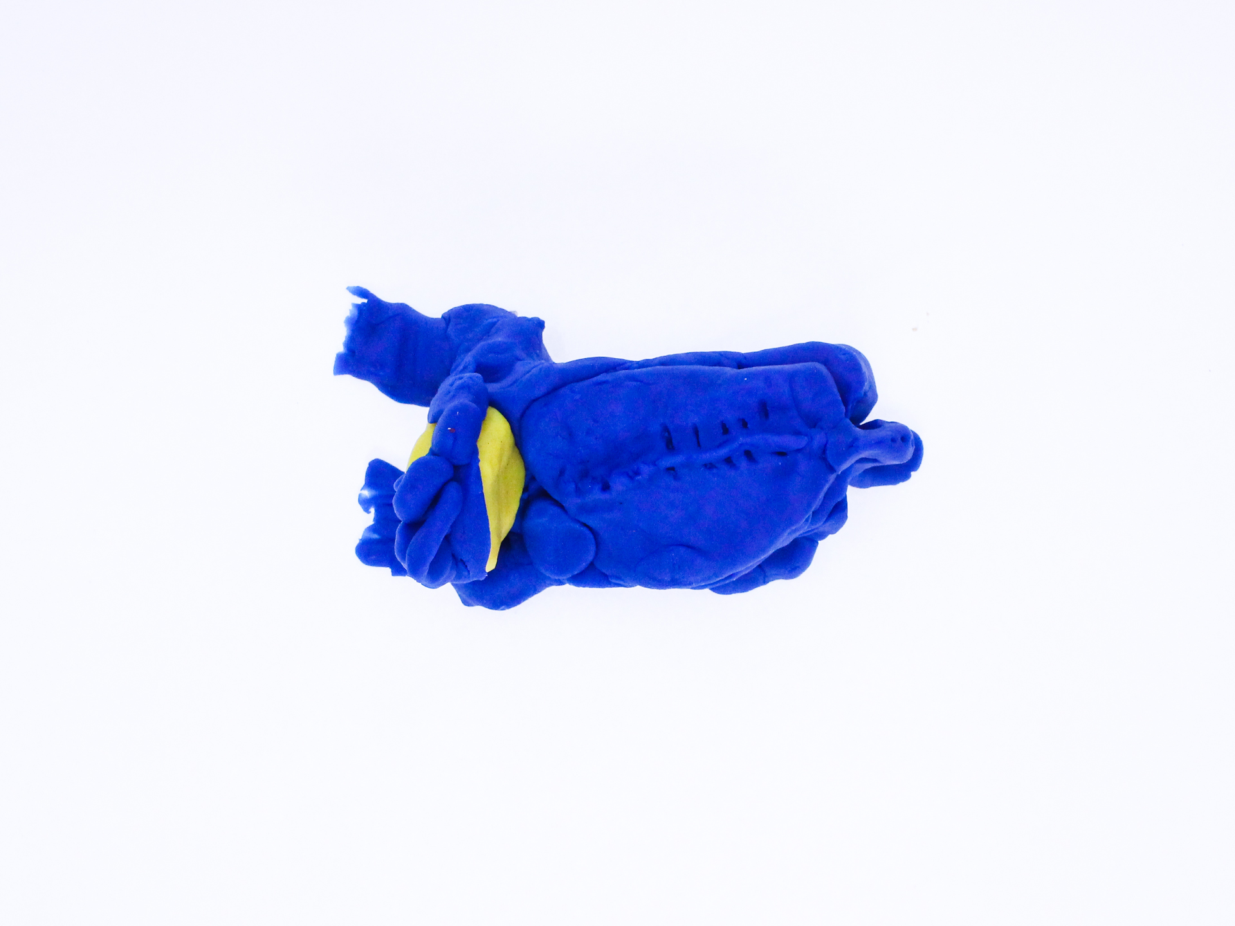400

A recording Mutant Monkey can be found here:
400

This is the unique QR code for this Imagined Thing. Right click it to save then share it, so you and others can find your way back to here to this point of The Well.

IT IS KNOWN! HUZZAH FOR THE GREAT & GRAND RUMPUS!

