35. The Mighty Bear
HERE LIES THE ENTRY FOR AN IMAGINED THING
This is a thing imagined by Jeremiah, aged 11, on Tuesday May 11
The full name of this thing is: The Mighty Bear
It can be found in: It is from a colourful place and it lives up the rainbows
It is known that: This bear can to many colourful suff. it can use it's colour spots to make people feel better. And it lives up the rainbow.
This thing has three important features: body with colours, face, and eyes

An image of The Mighty Bear can be found here:
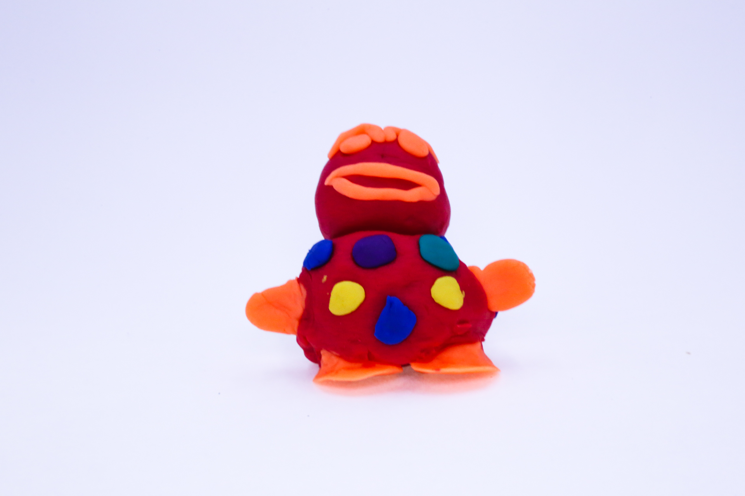400
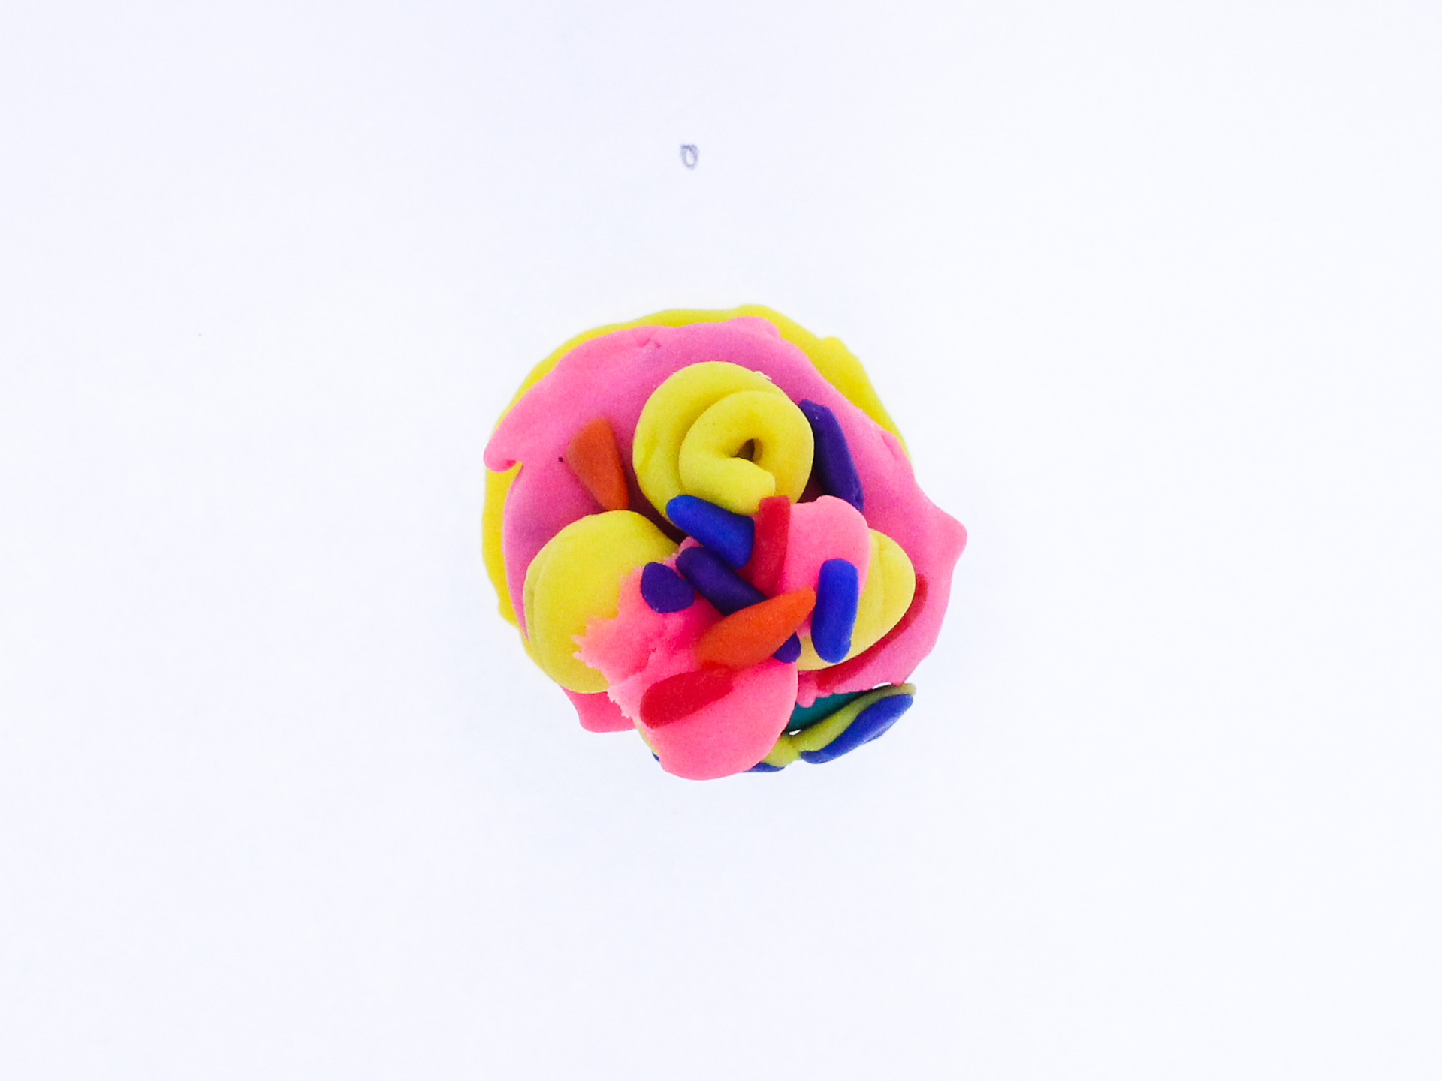400
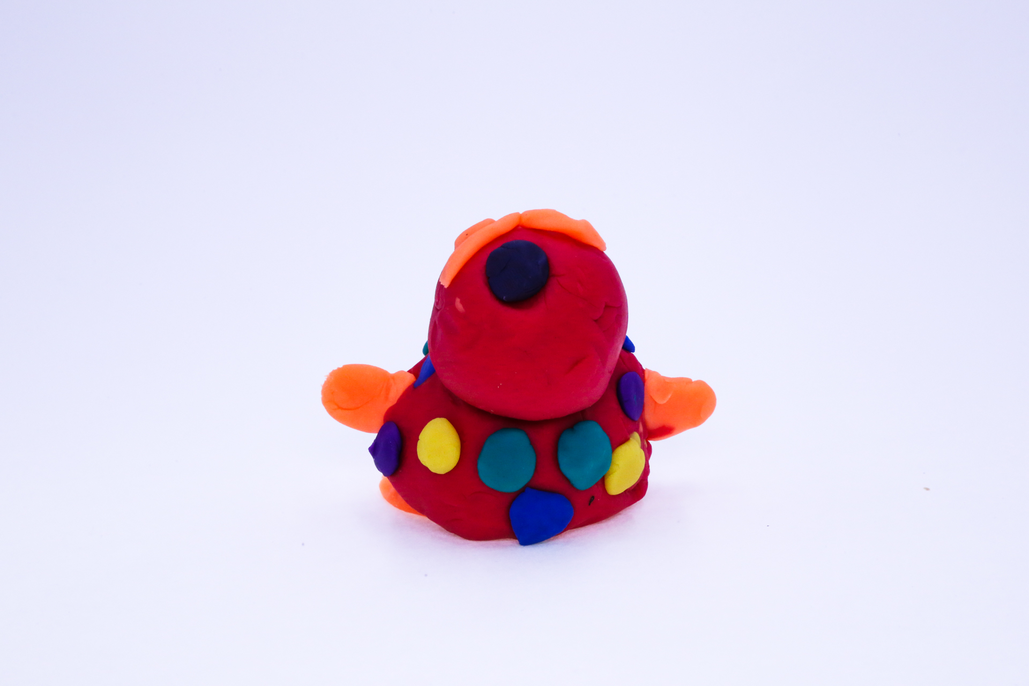400
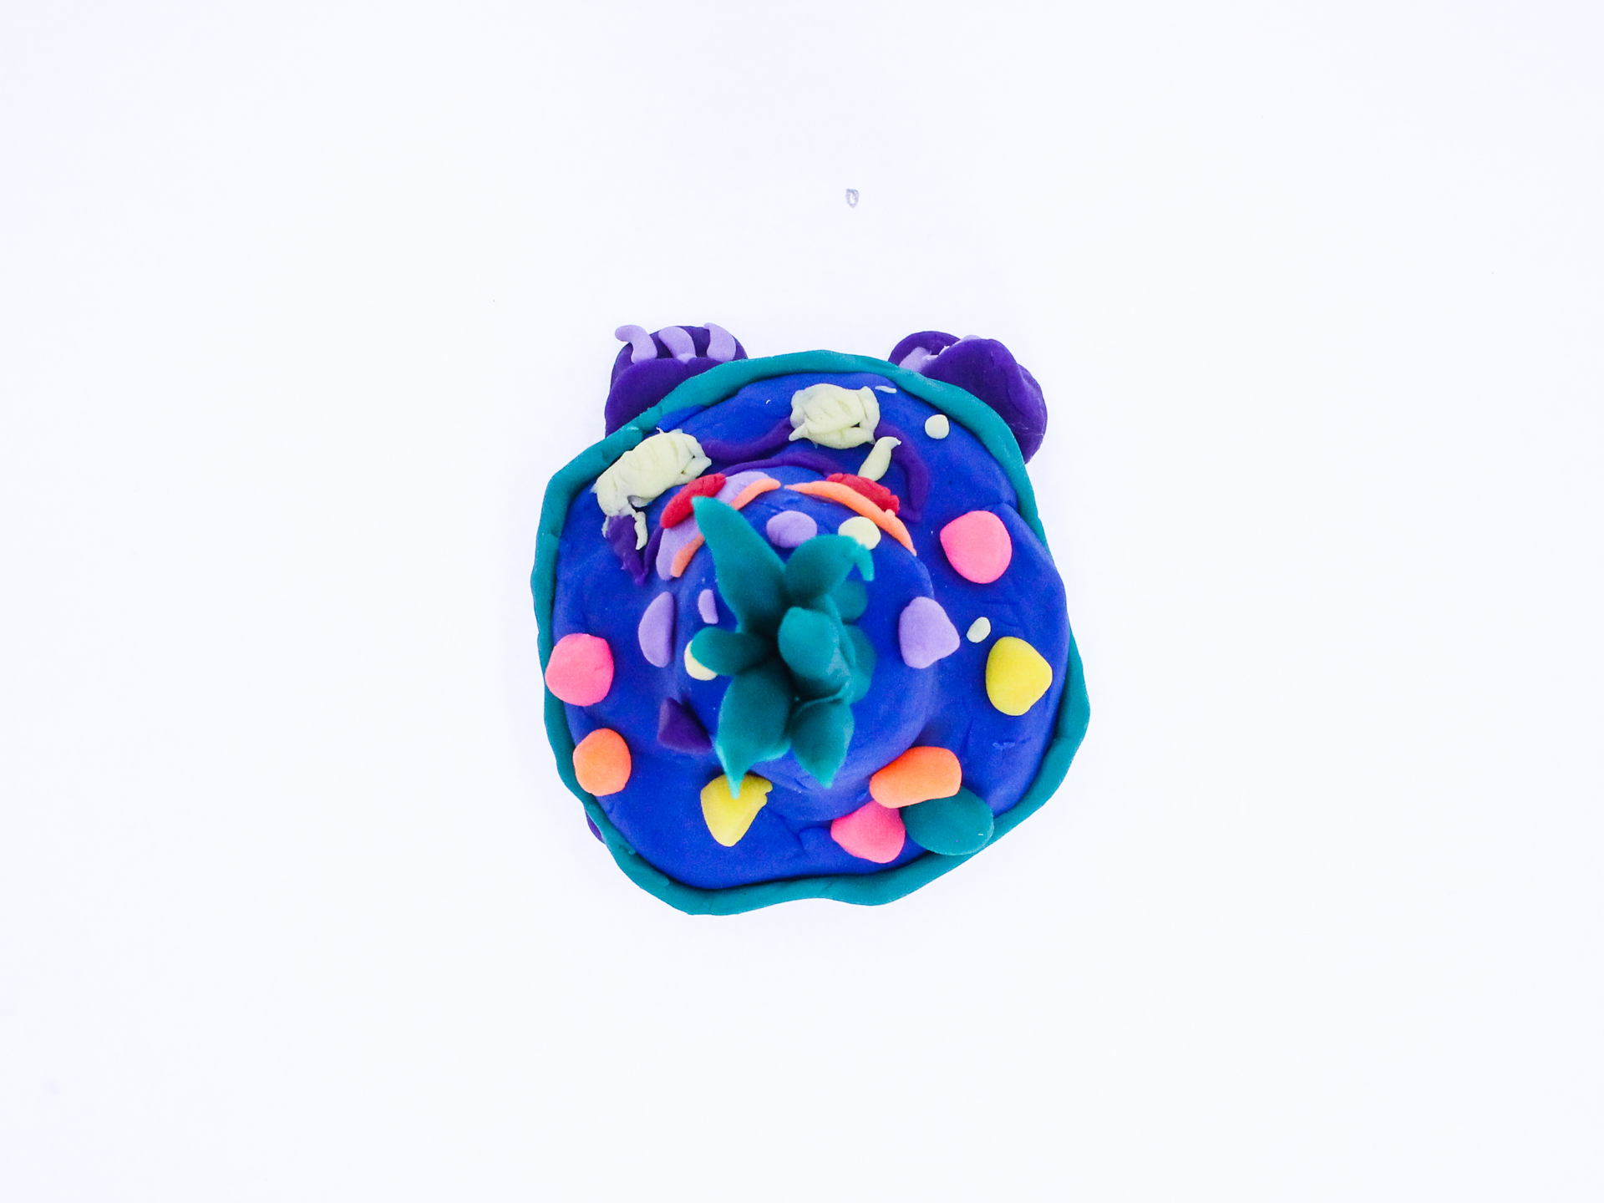400
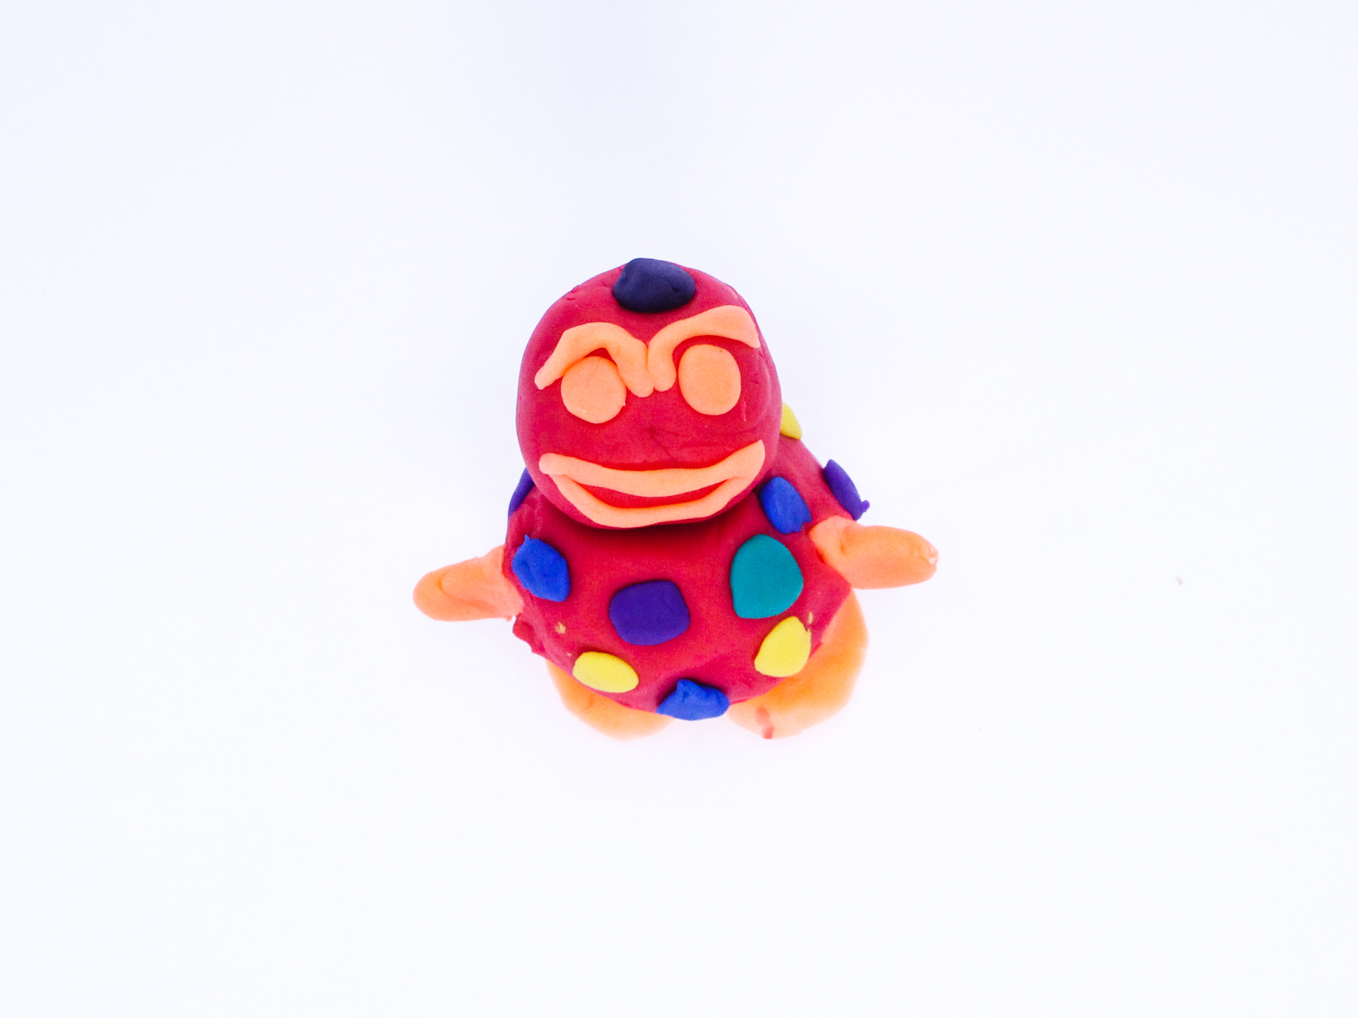400

A recording The Mighty Bear can be found here:
400

This is the unique QR code for this Imagined Thing. Right click it to save then share it, so you and others can find your way back to here to this point of The Well.

IT IS KNOWN! HUZZAH FOR THE GREAT & GRAND RUMPUS!

