34. Kairo
HERE LIES THE ENTRY FOR AN IMAGINED THING
This is a thing imagined by Xavier, aged 11, on Tuesday May 11
The full name of this thing is: Kairo (ky-ro)
It can be found in: Oboro planet with a couple of creatures and plants
It is known that: Has blue with red wings and yellow spikes, with pink spots and a red club tail. and a red and blue eye with a red horn. he lives on oboro planet and is scary but nice. Kairo (ky-ro) was born on Oboro planet and is a bit lonely.
This thing has three important features: wings, spikes, and club tail

An image of Kairo (ky-ro) can be found here:
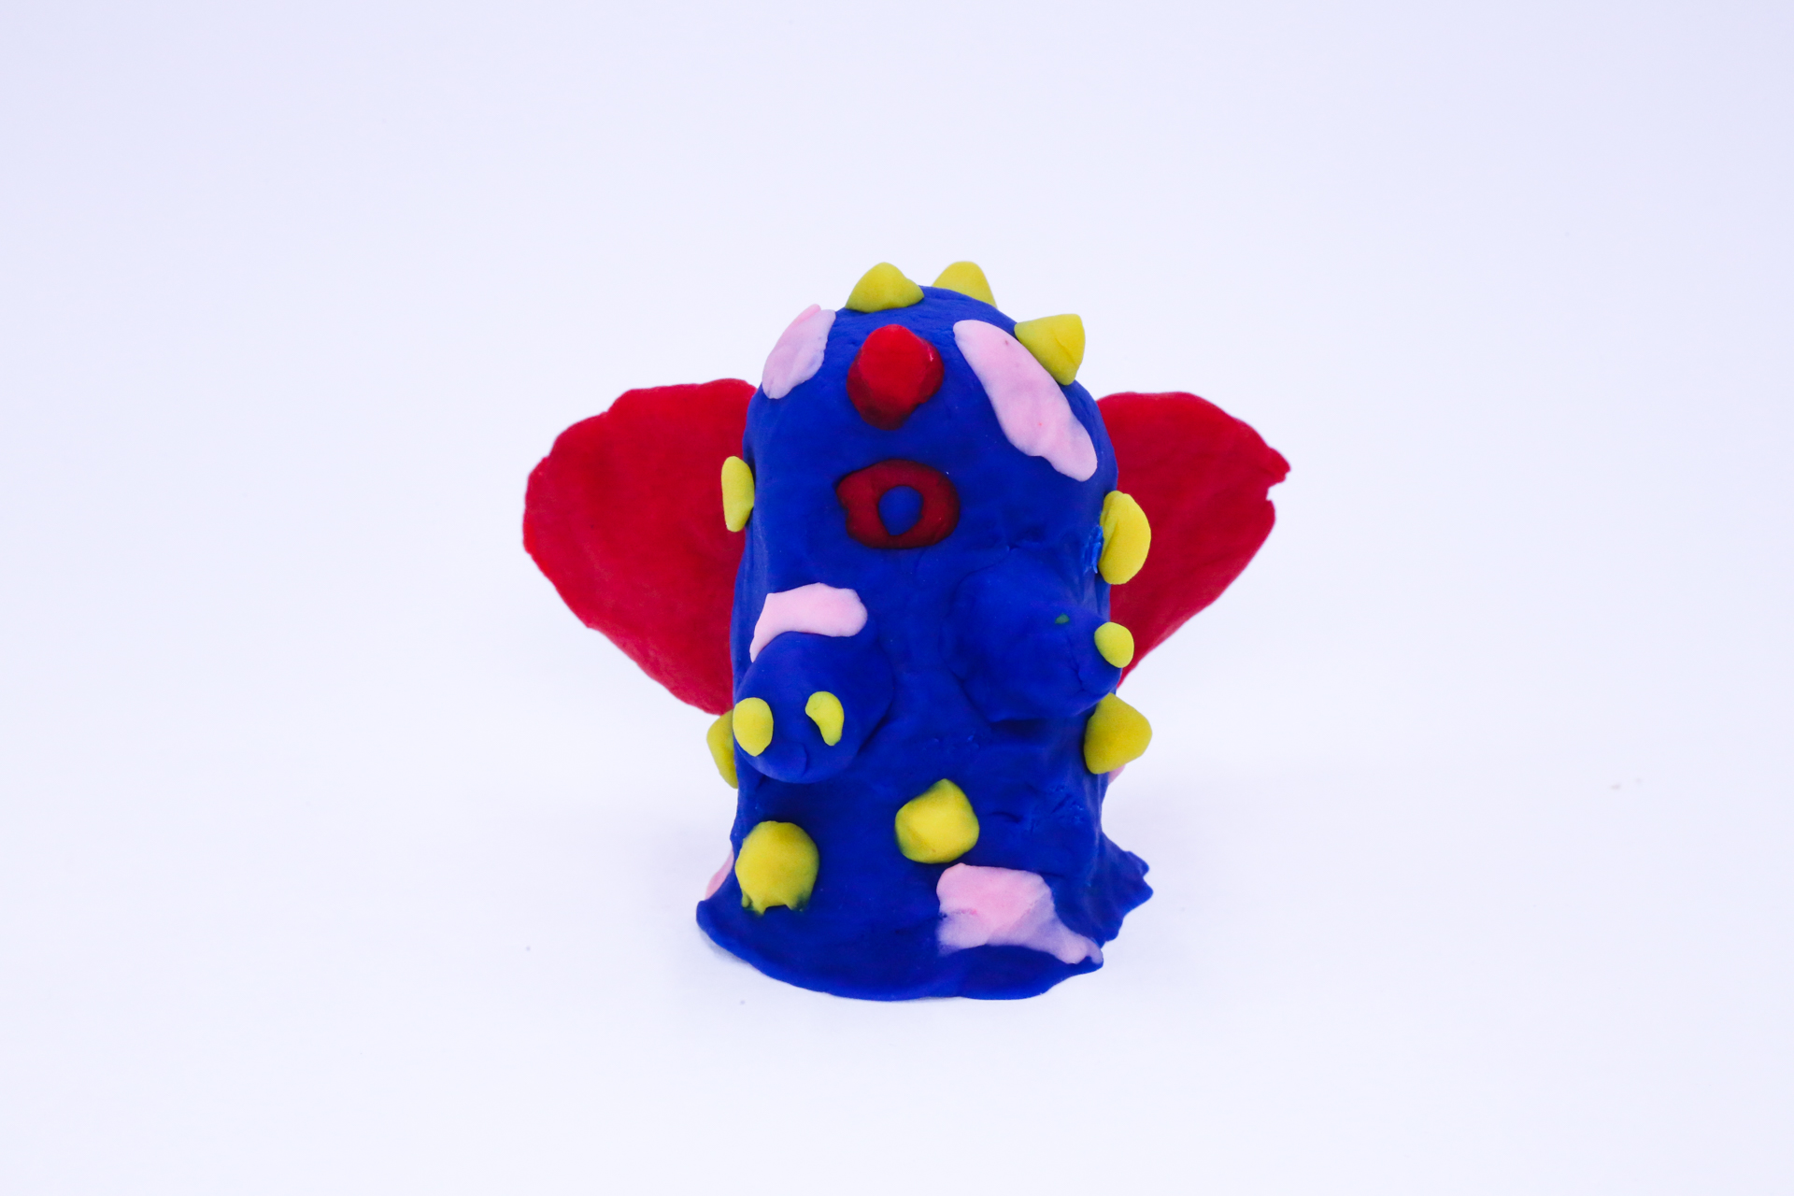400
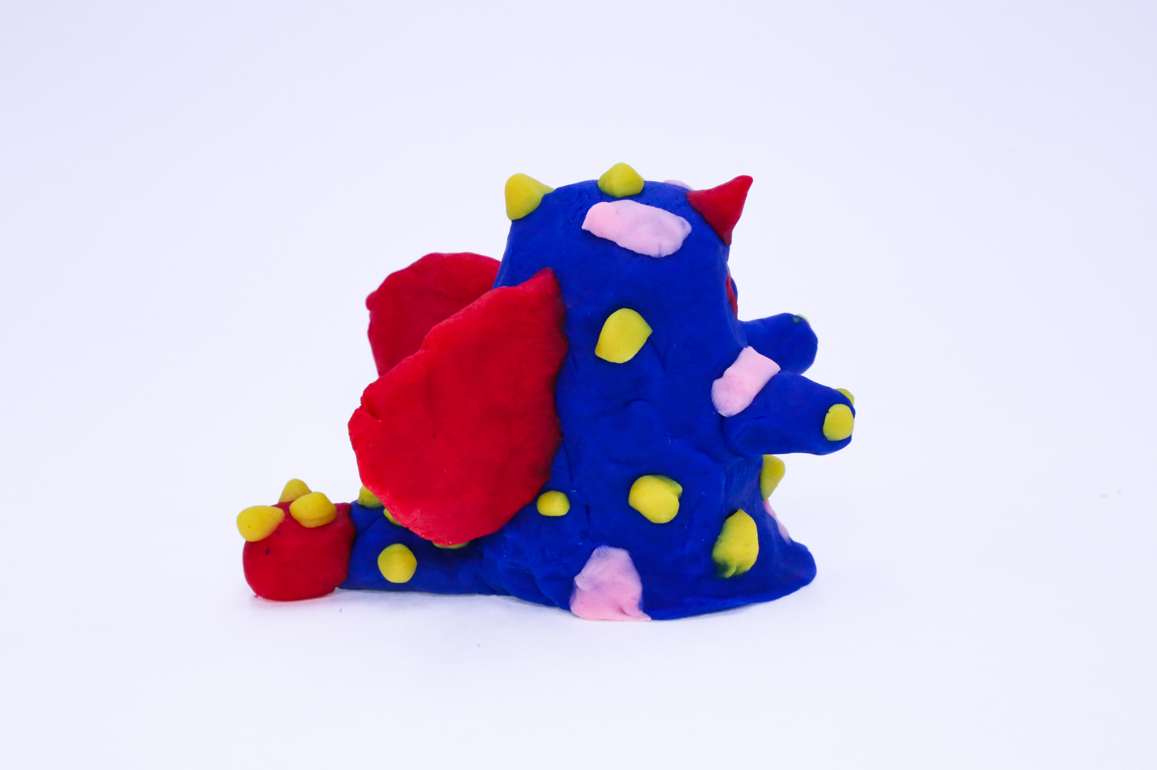400
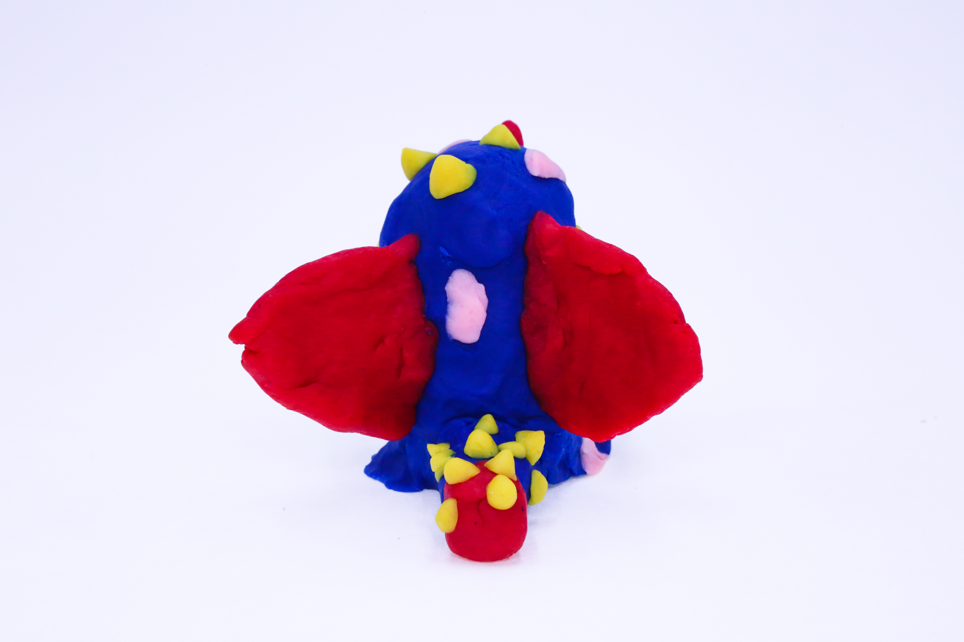400
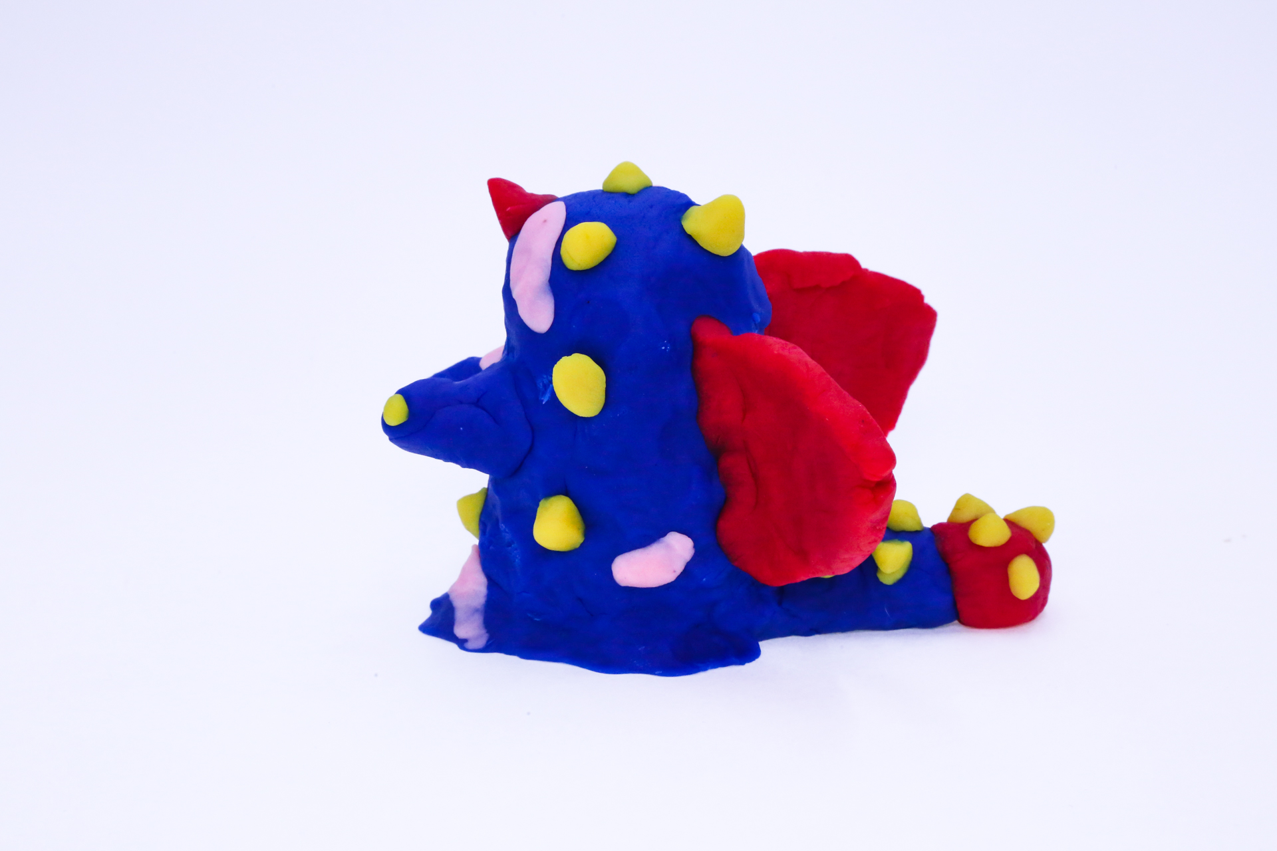400
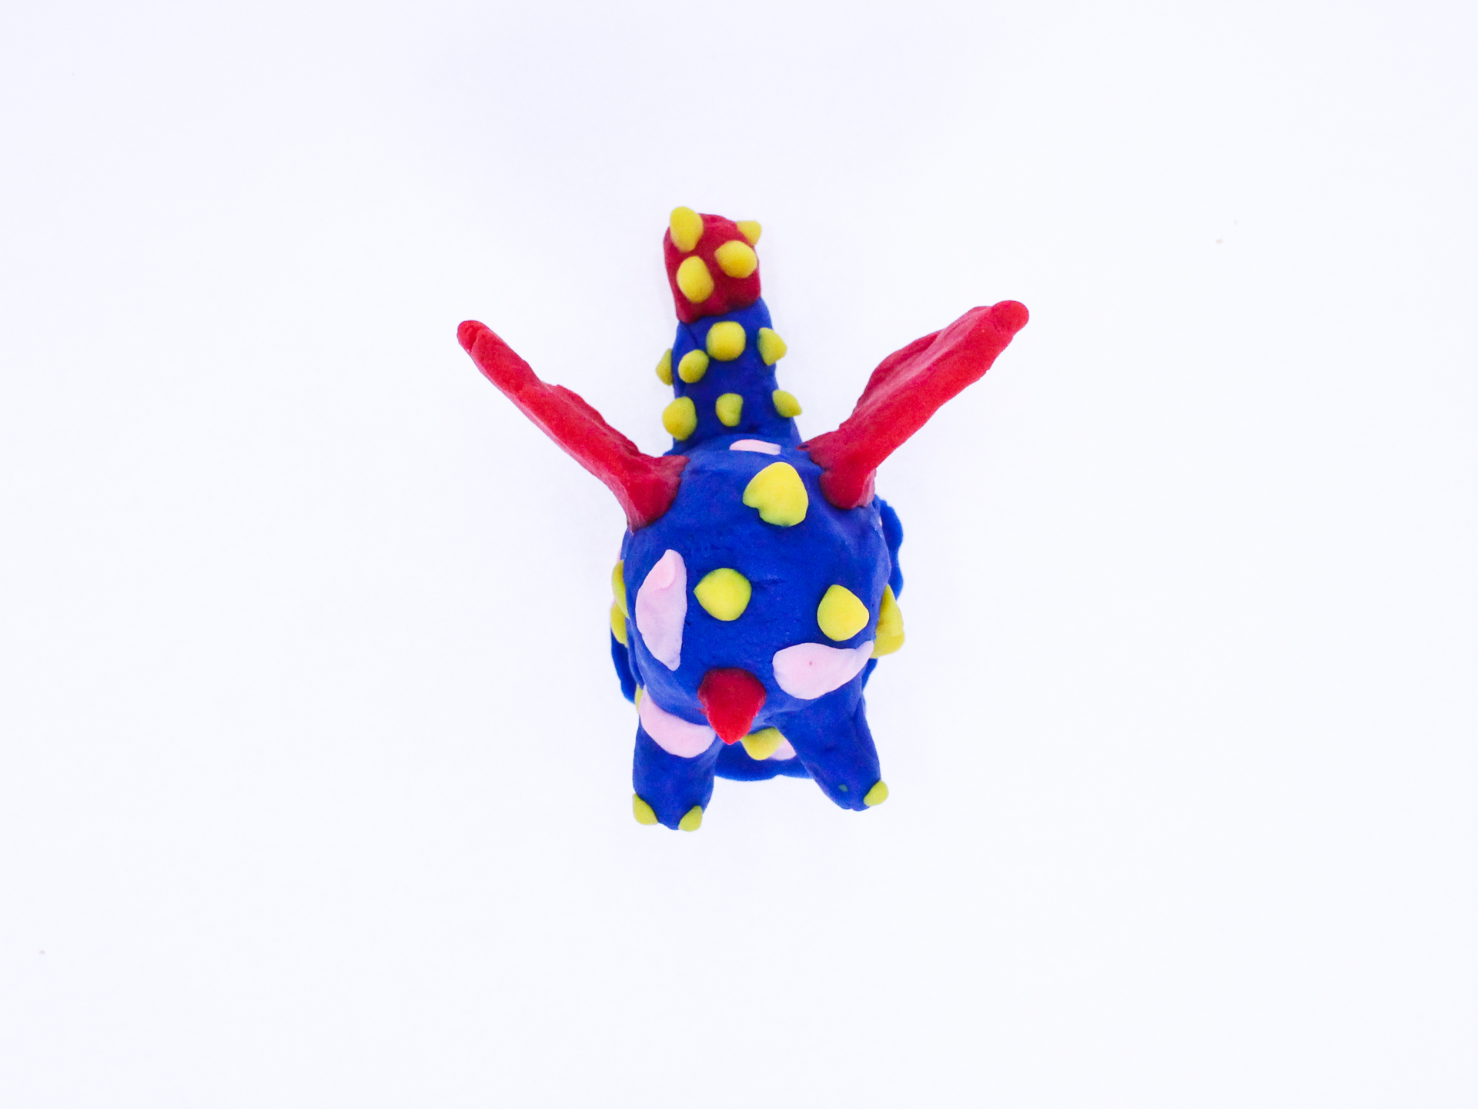400

A recording Kairo (ky-ro) can be found here:
400

This is the unique QR code for this Imagined Thing. Right click it to save then share it, so you and others can find your way back to here to this point of The Well.

IT IS KNOWN! HUZZAH FOR THE GREAT & GRAND RUMPUS!

