33. Ultrainstinct
HERE LIES THE ENTRY FOR AN IMAGINED THING
This is a thing imagined by Shuhiab, aged 11, on Tuesday May 11
The full name of this thing is: Ultrainstinct
It can be found in: Dubai because it's a dragon - it loves heat and lives in the desert.
It is known that: It is a kind lion dragon. it helps you from danger. it's always happy and caring. It attacks the enemy that is attacking you.
This thing has three important features: hard, looks like a mix of a dragon and a lion, and breathes fire

An image of Ultrainstinct can be found here:
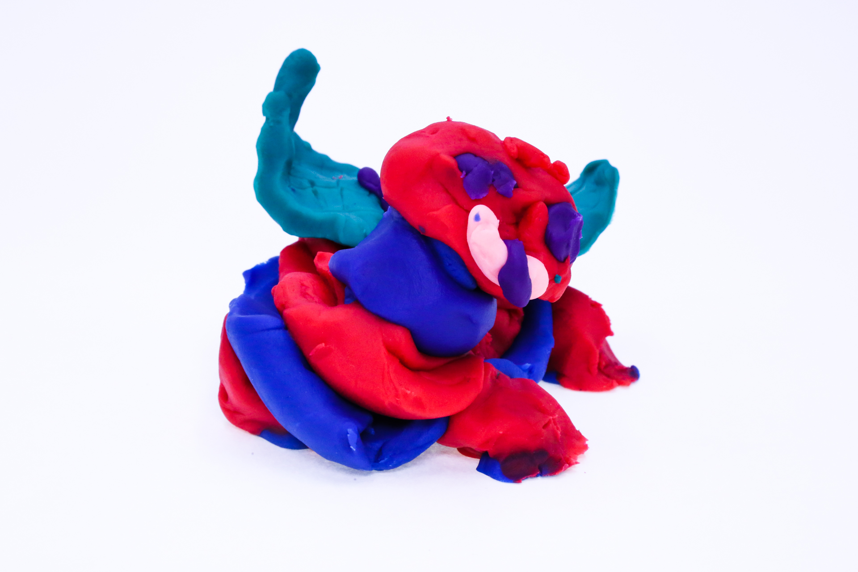400
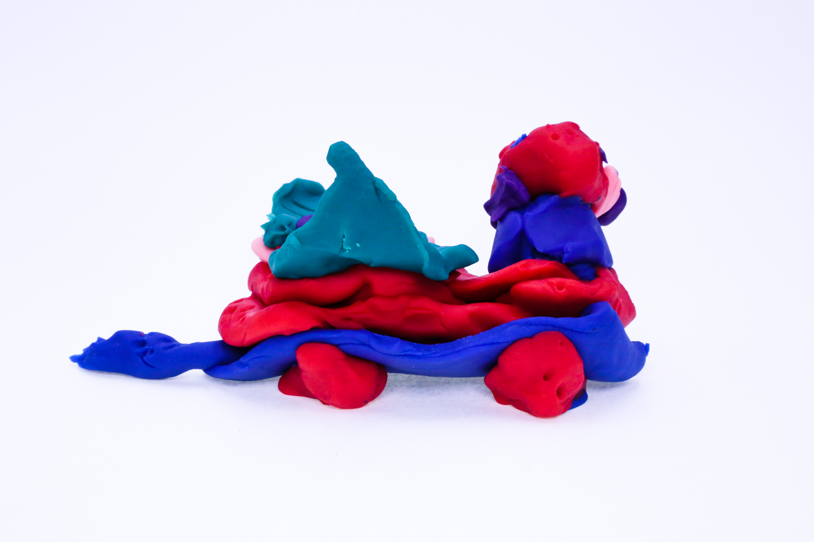400
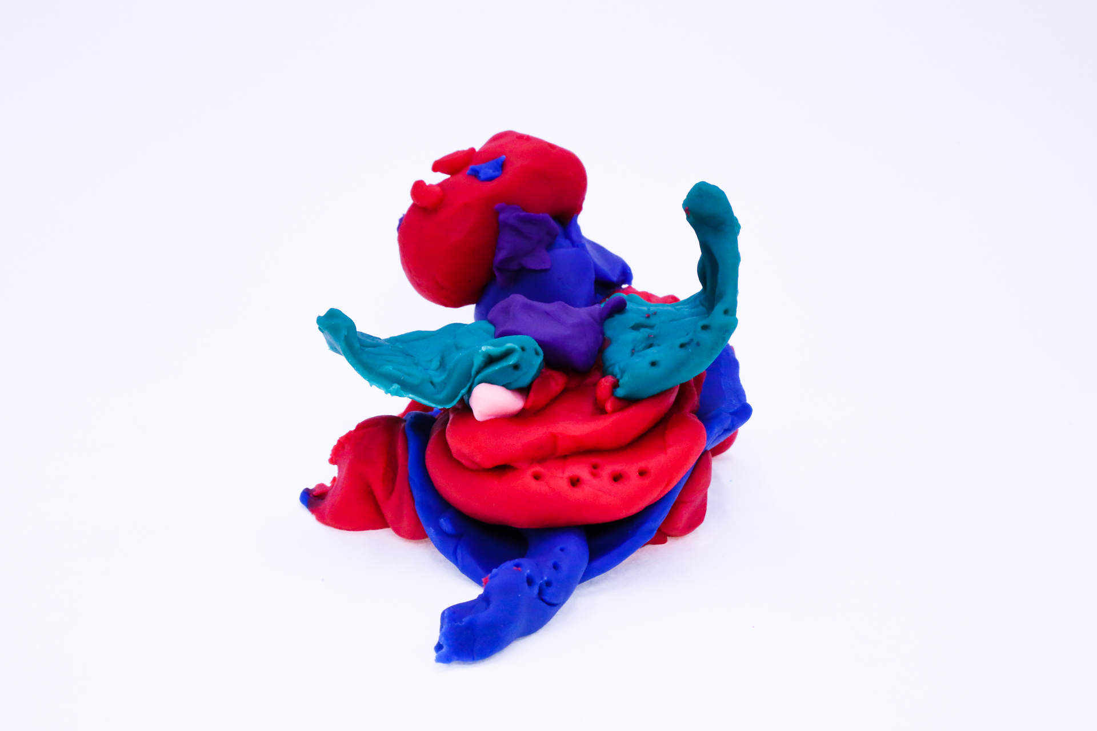400
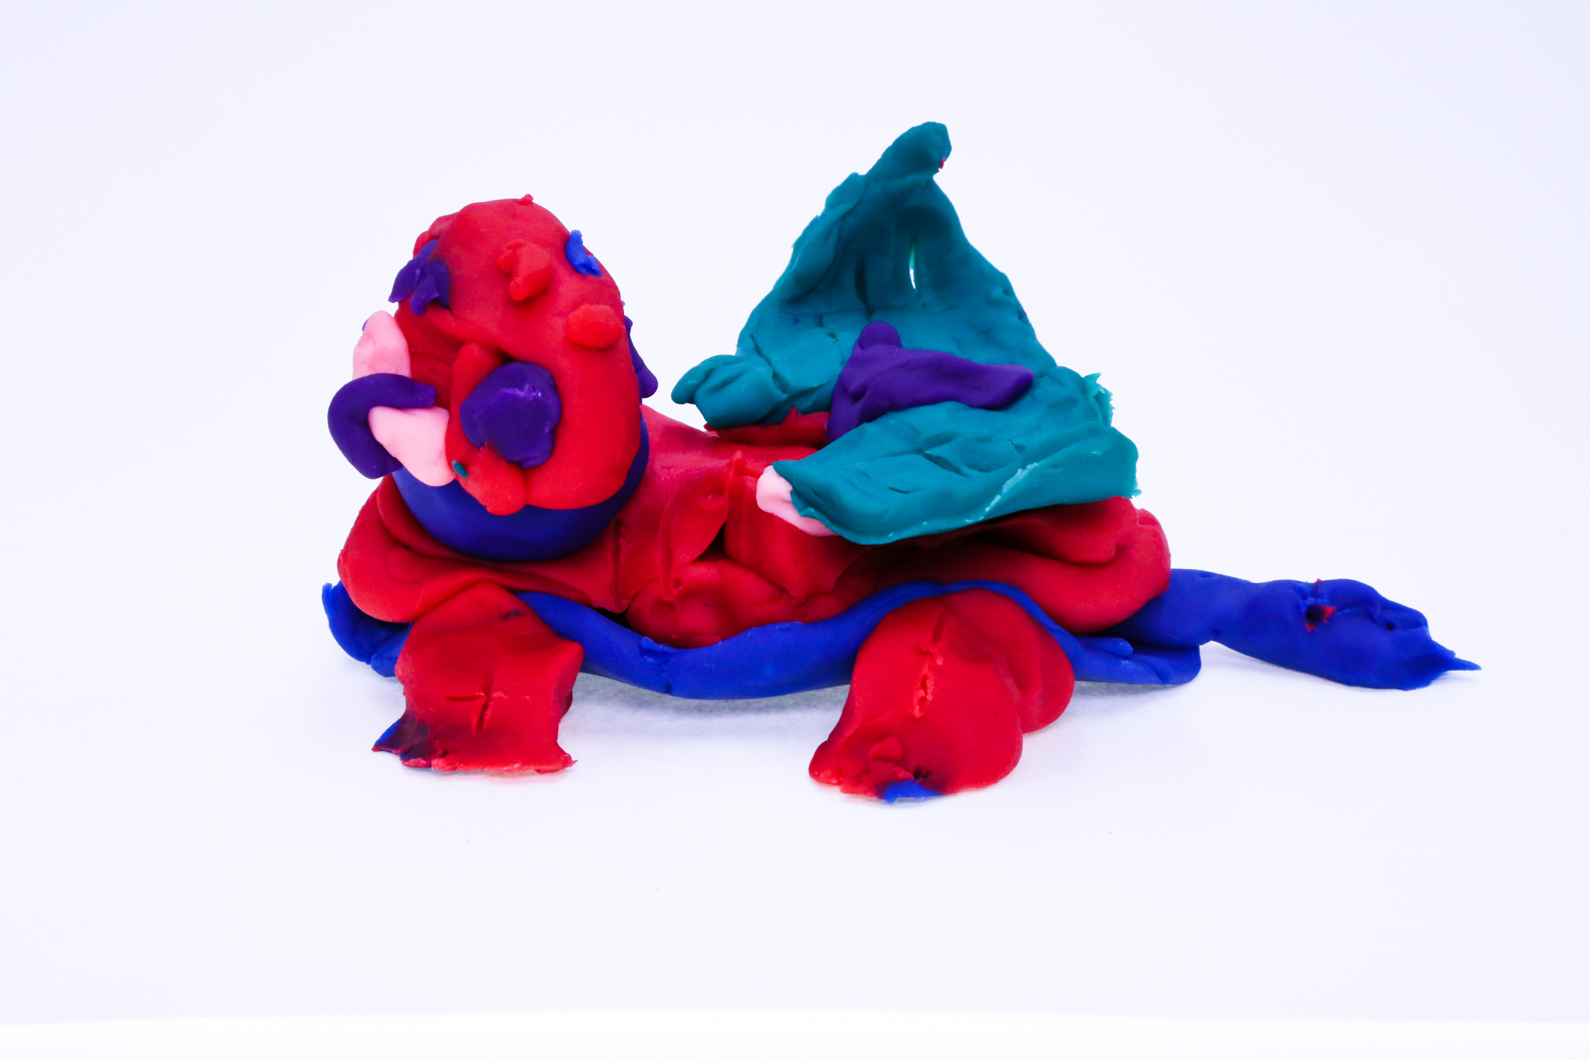400
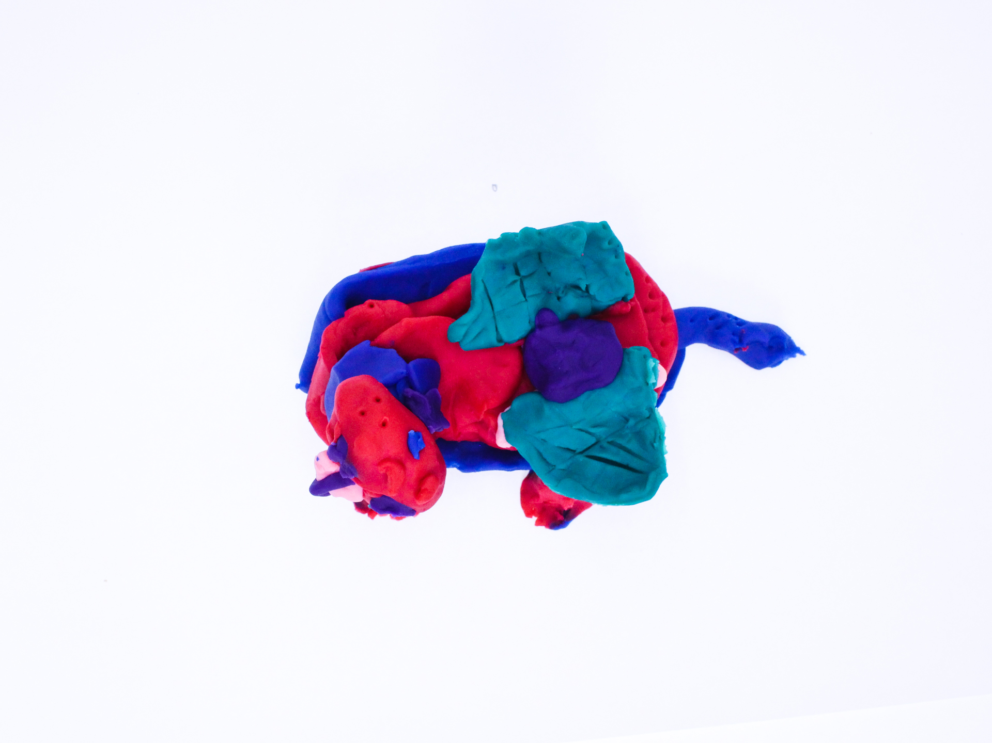400

A recording Ultrainstinct can be found here:
400

This is the unique QR code for this Imagined Thing. Right click it to save then share it, so you and others can find your way back to here to this point of The Well.

IT IS KNOWN! HUZZAH FOR THE GREAT & GRAND RUMPUS!

