31. Kitty Bear
HERE LIES THE ENTRY FOR AN IMAGINED THING
This is a thing imagined by Elikah, aged 11, on Tuesday May 11
The full name of this thing is: Kitty Bear
It can be found in: Halloween Town
It is known that: she used to be a teddy but she got abandoned from her owner. Then a potion spilt on her then she came alive.
This thing has three important features: Missing ear, Bear ears, and Whiskers

An image of Kitty Bear can be found here:
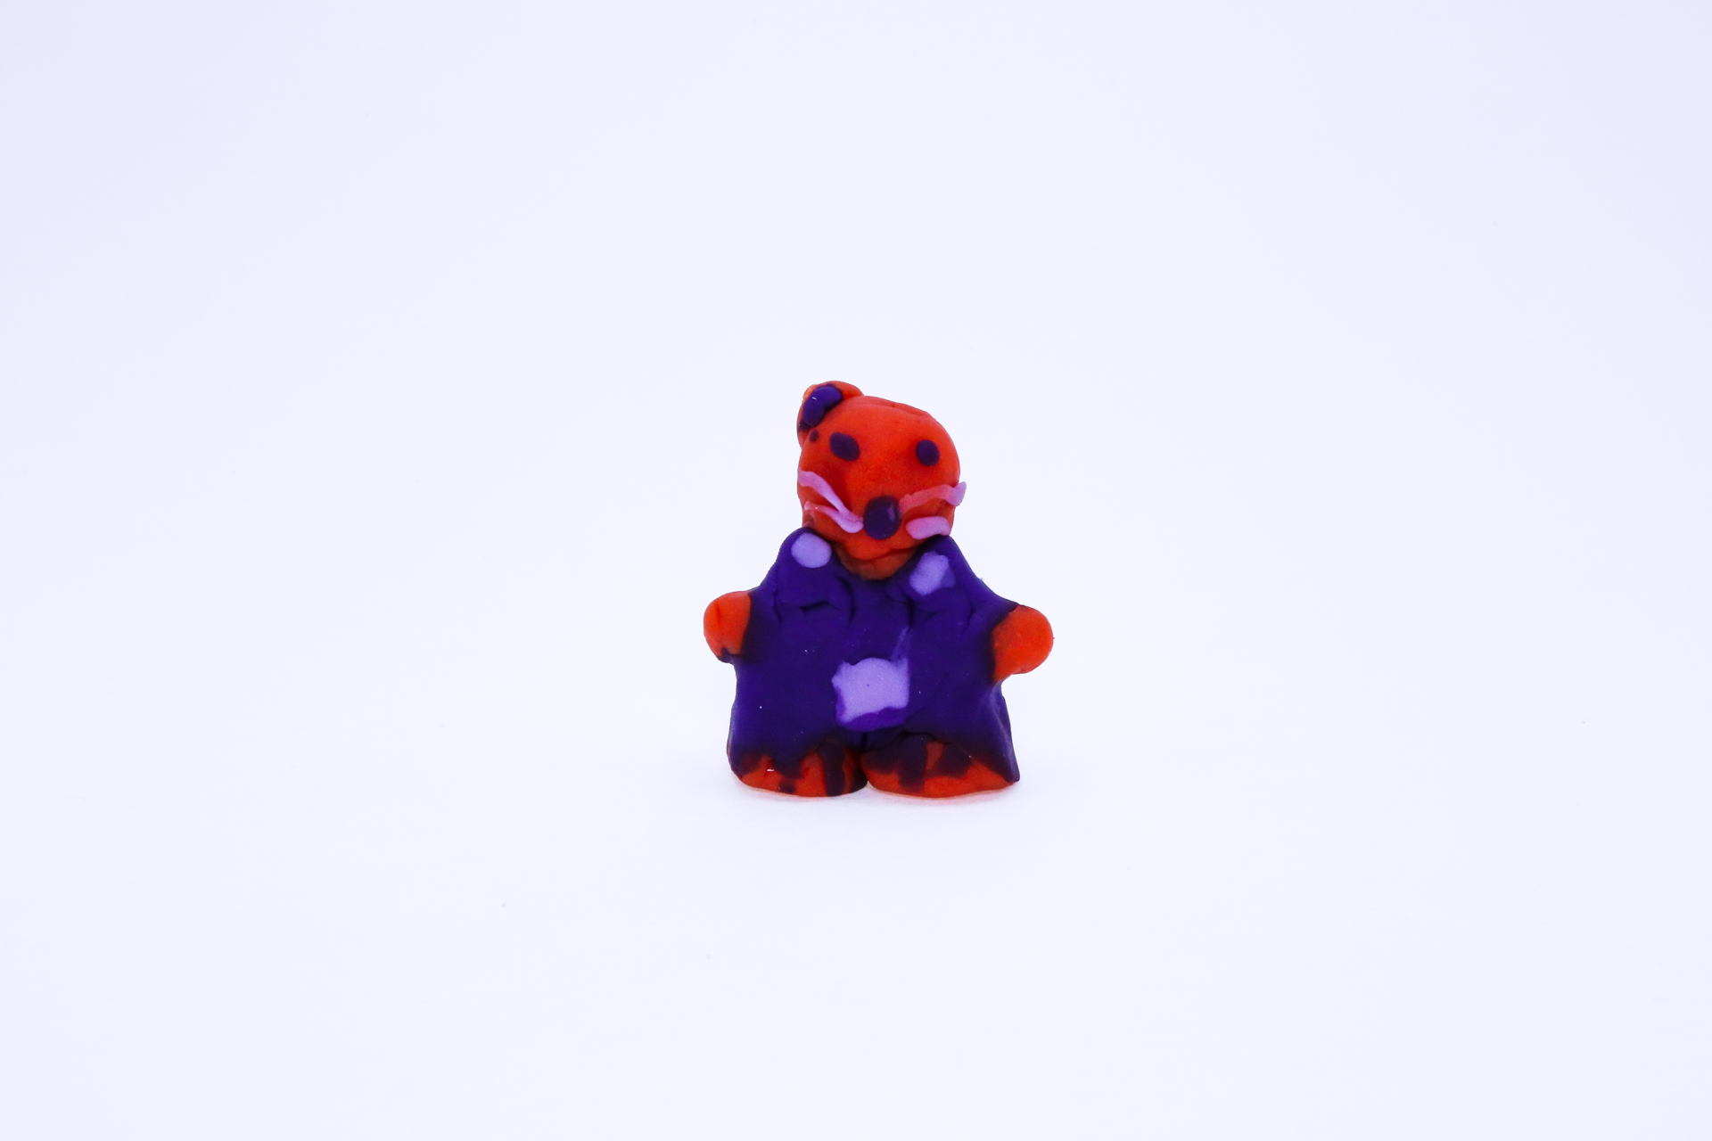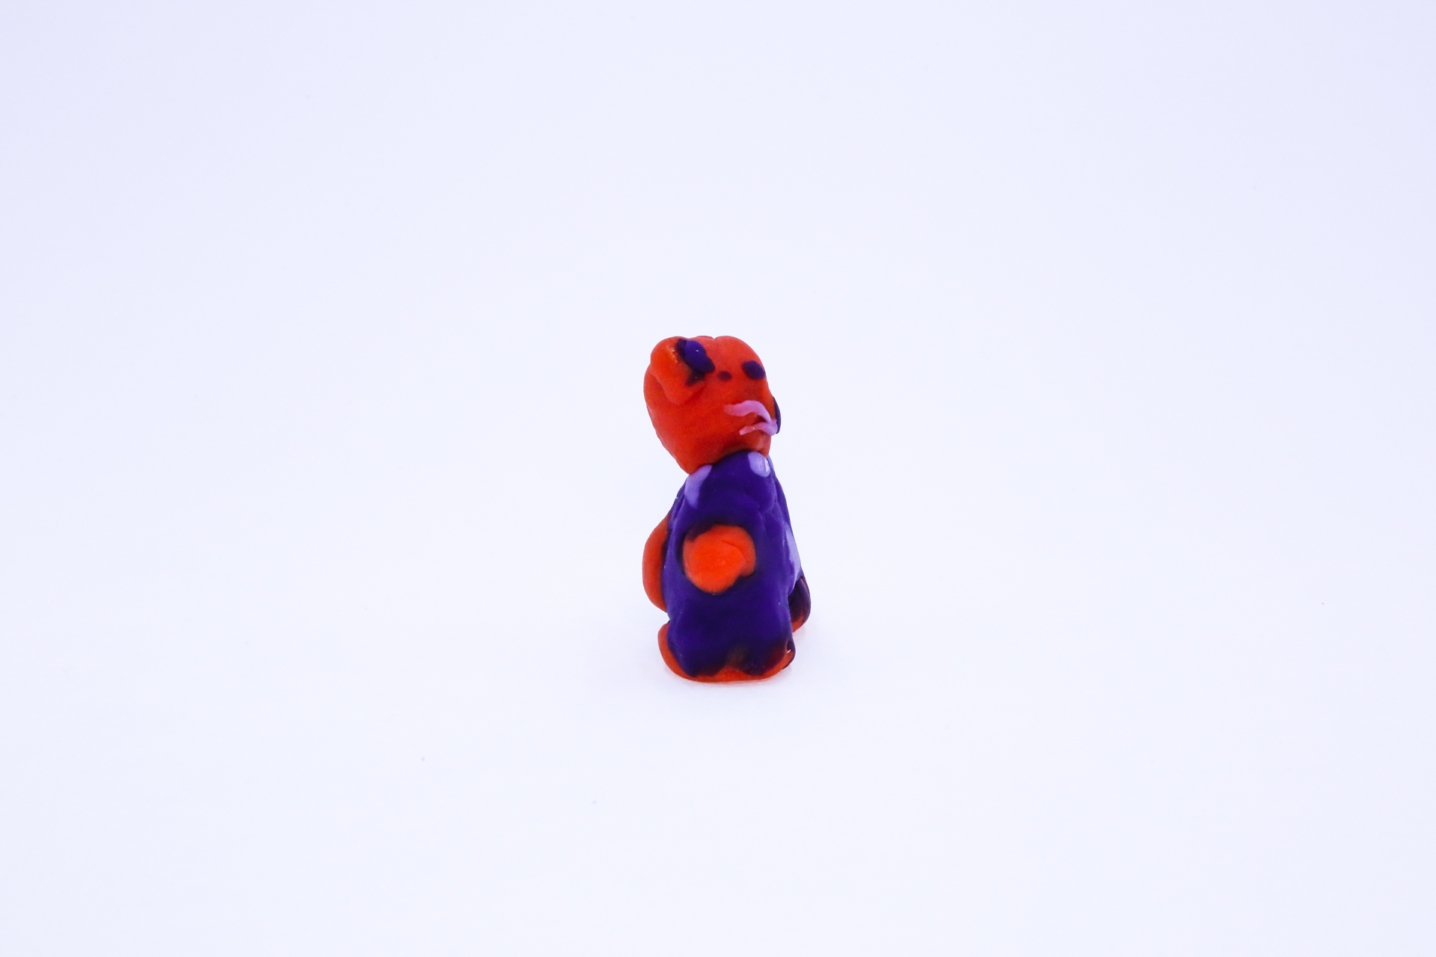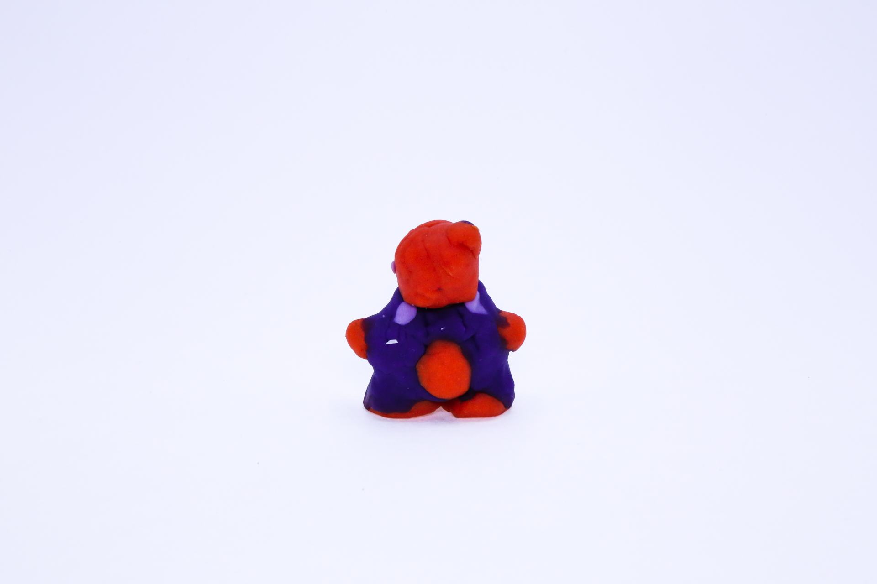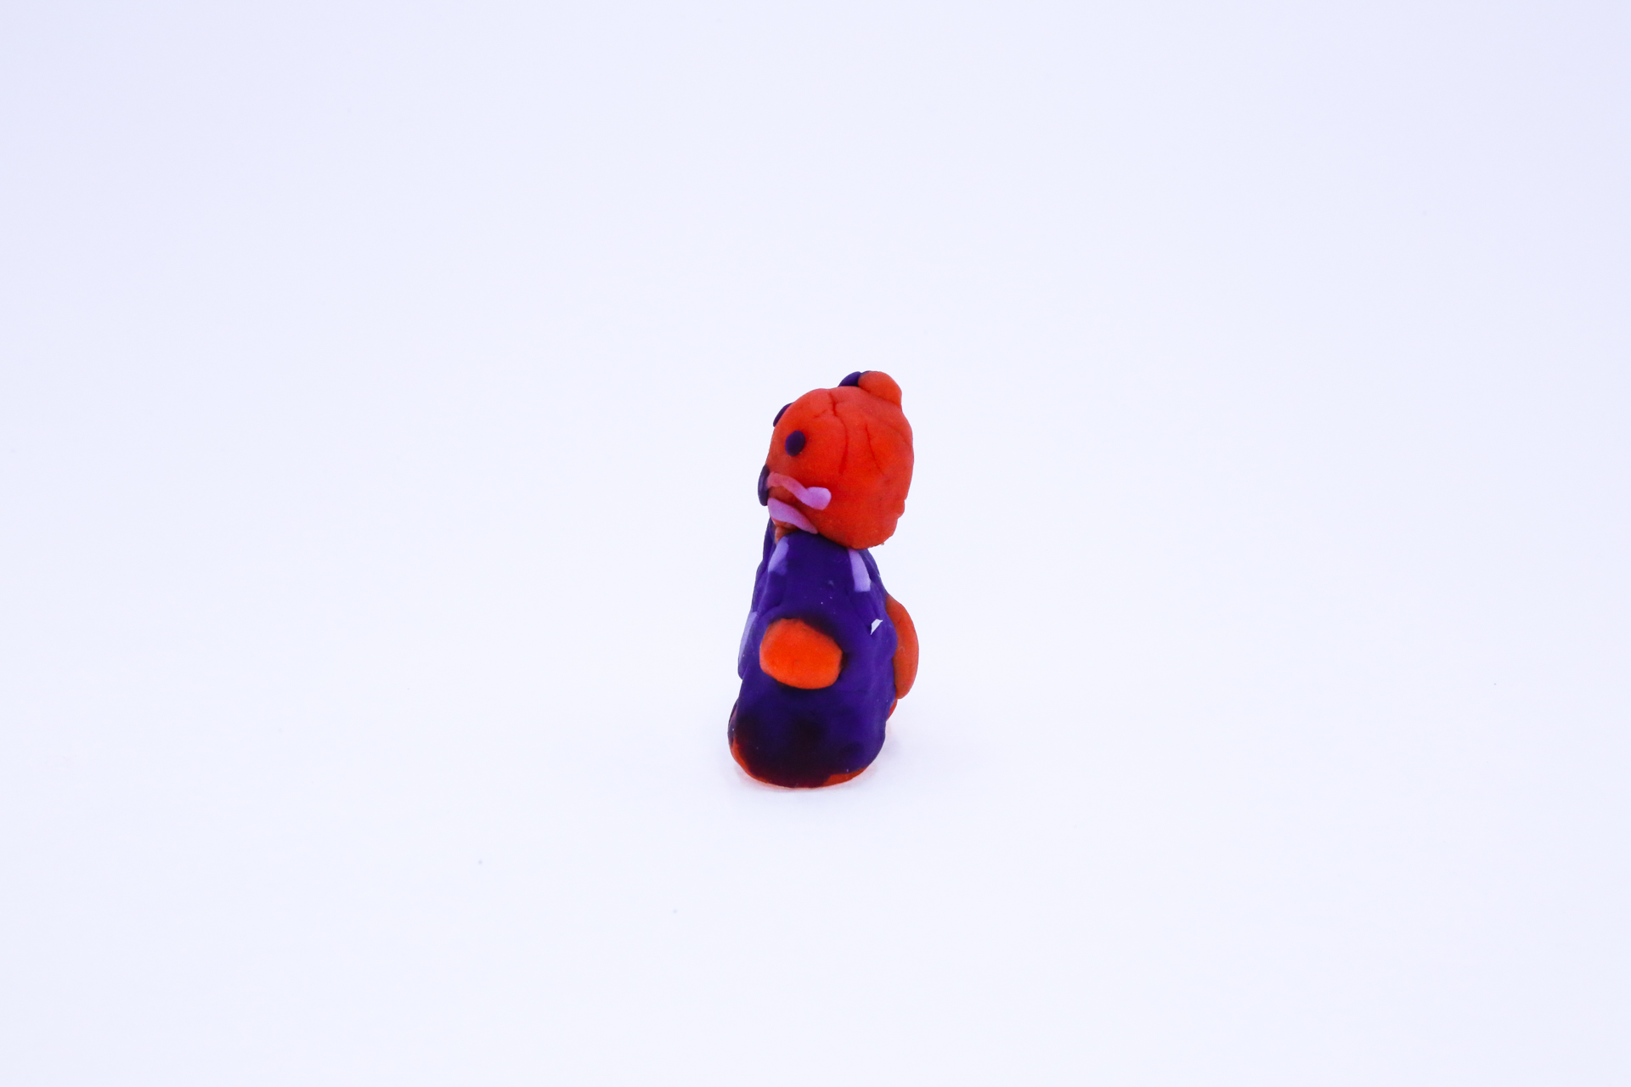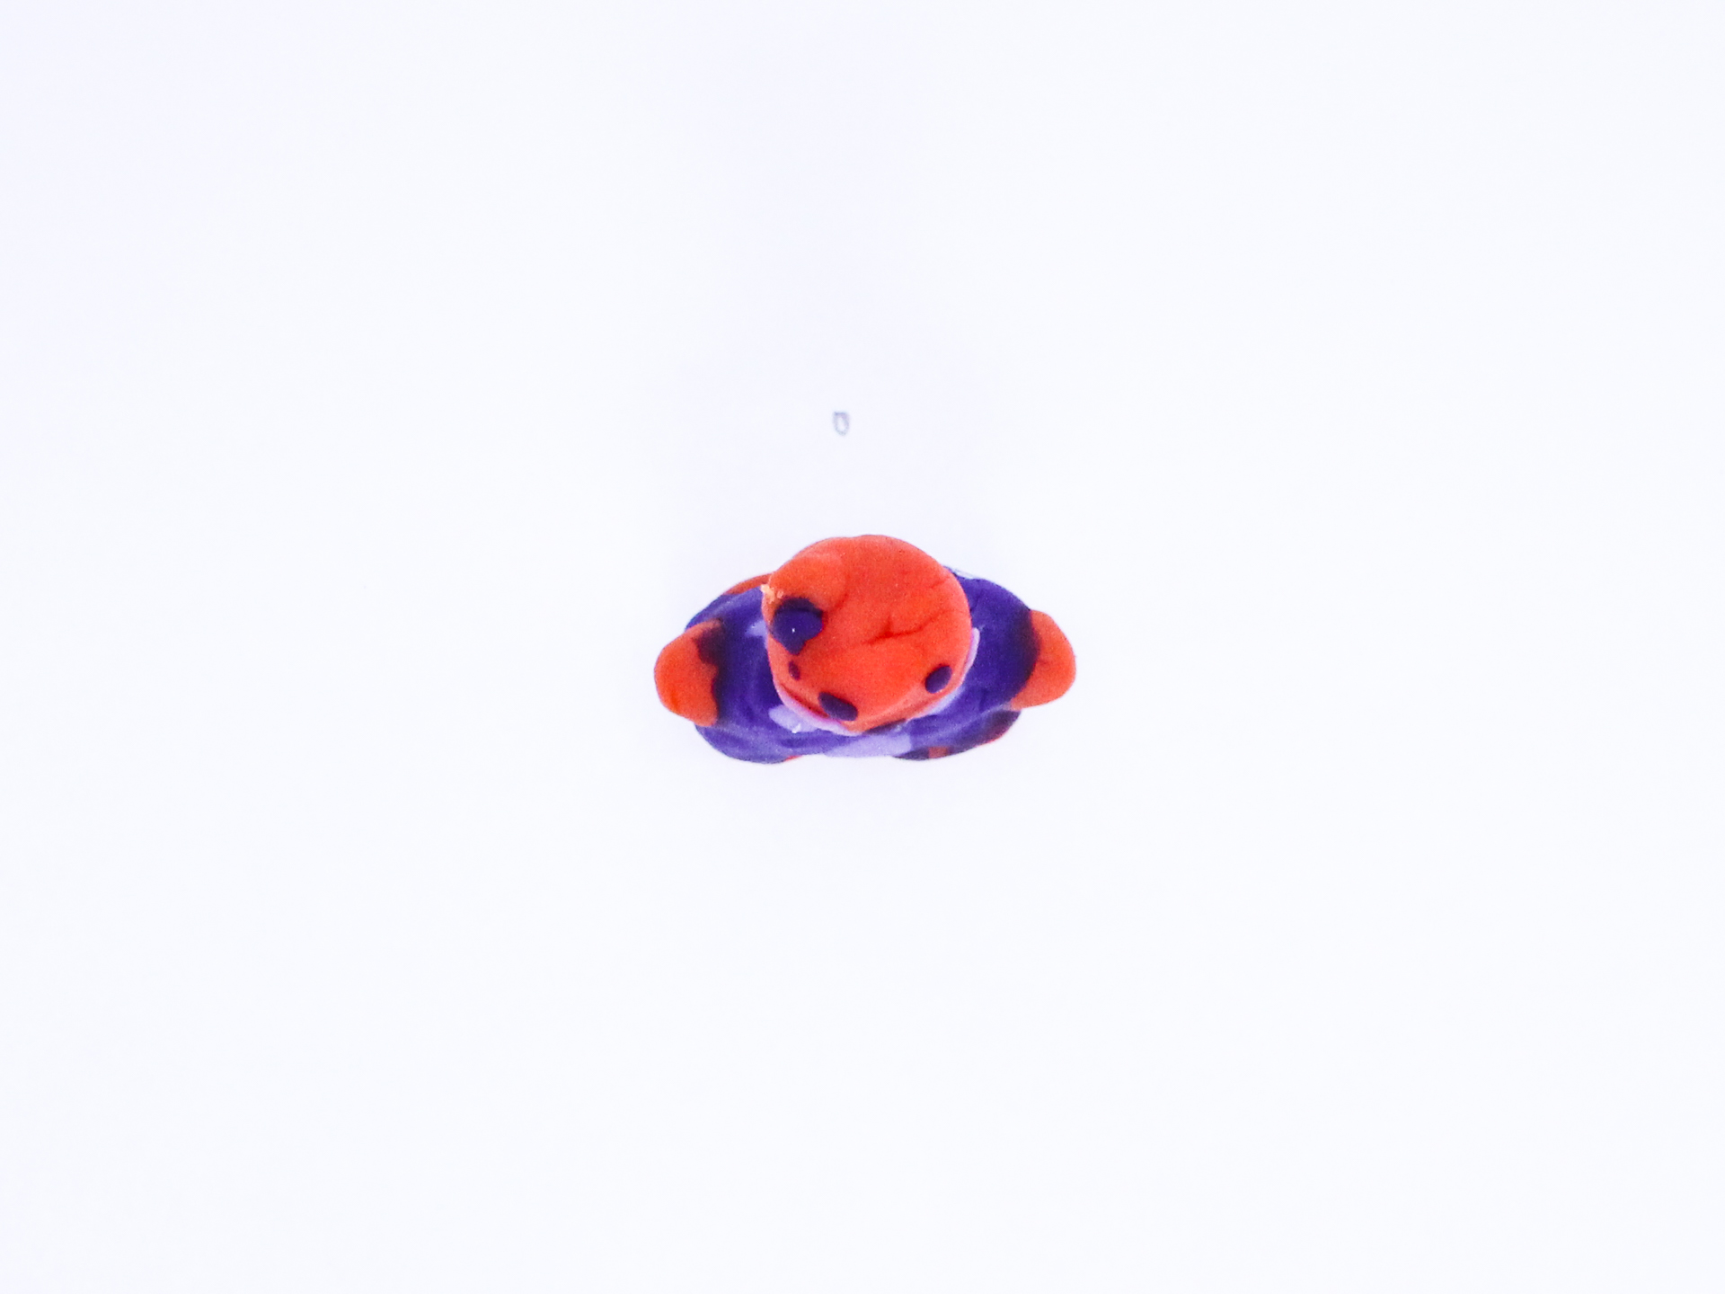

A recording Kitty Bear can be found here:
400

This is the unique QR code for this Imagined Thing. Right click it to save then share it, so you and others can find your way back to here to this point of The Well.

IT IS KNOWN! HUZZAH FOR THE GREAT & GRAND RUMPUS!

