30. Chris Jnr
HERE LIES THE ENTRY FOR AN IMAGINED THING
This is a thing imagined by Christian, aged 11, on Tuesday May 11
The full name of this thing is: Chris Jnr
It can be found in: A desert.
It is known that: One day in 1987 a animal appeared from the desert and it was super angry and it started breathing out really hot fire.
This thing has three important features: Breathing fire, Sharp bone crushing teeth, and Body shape

An image of Chris Jnr can be found here:
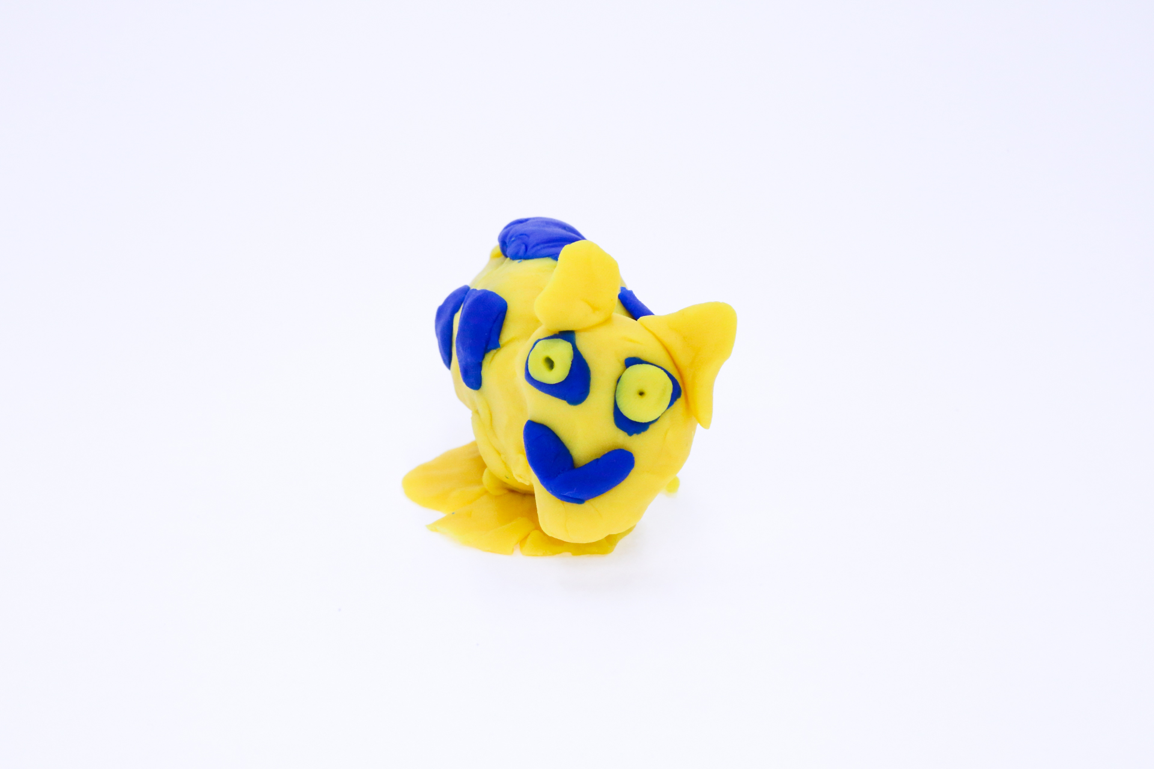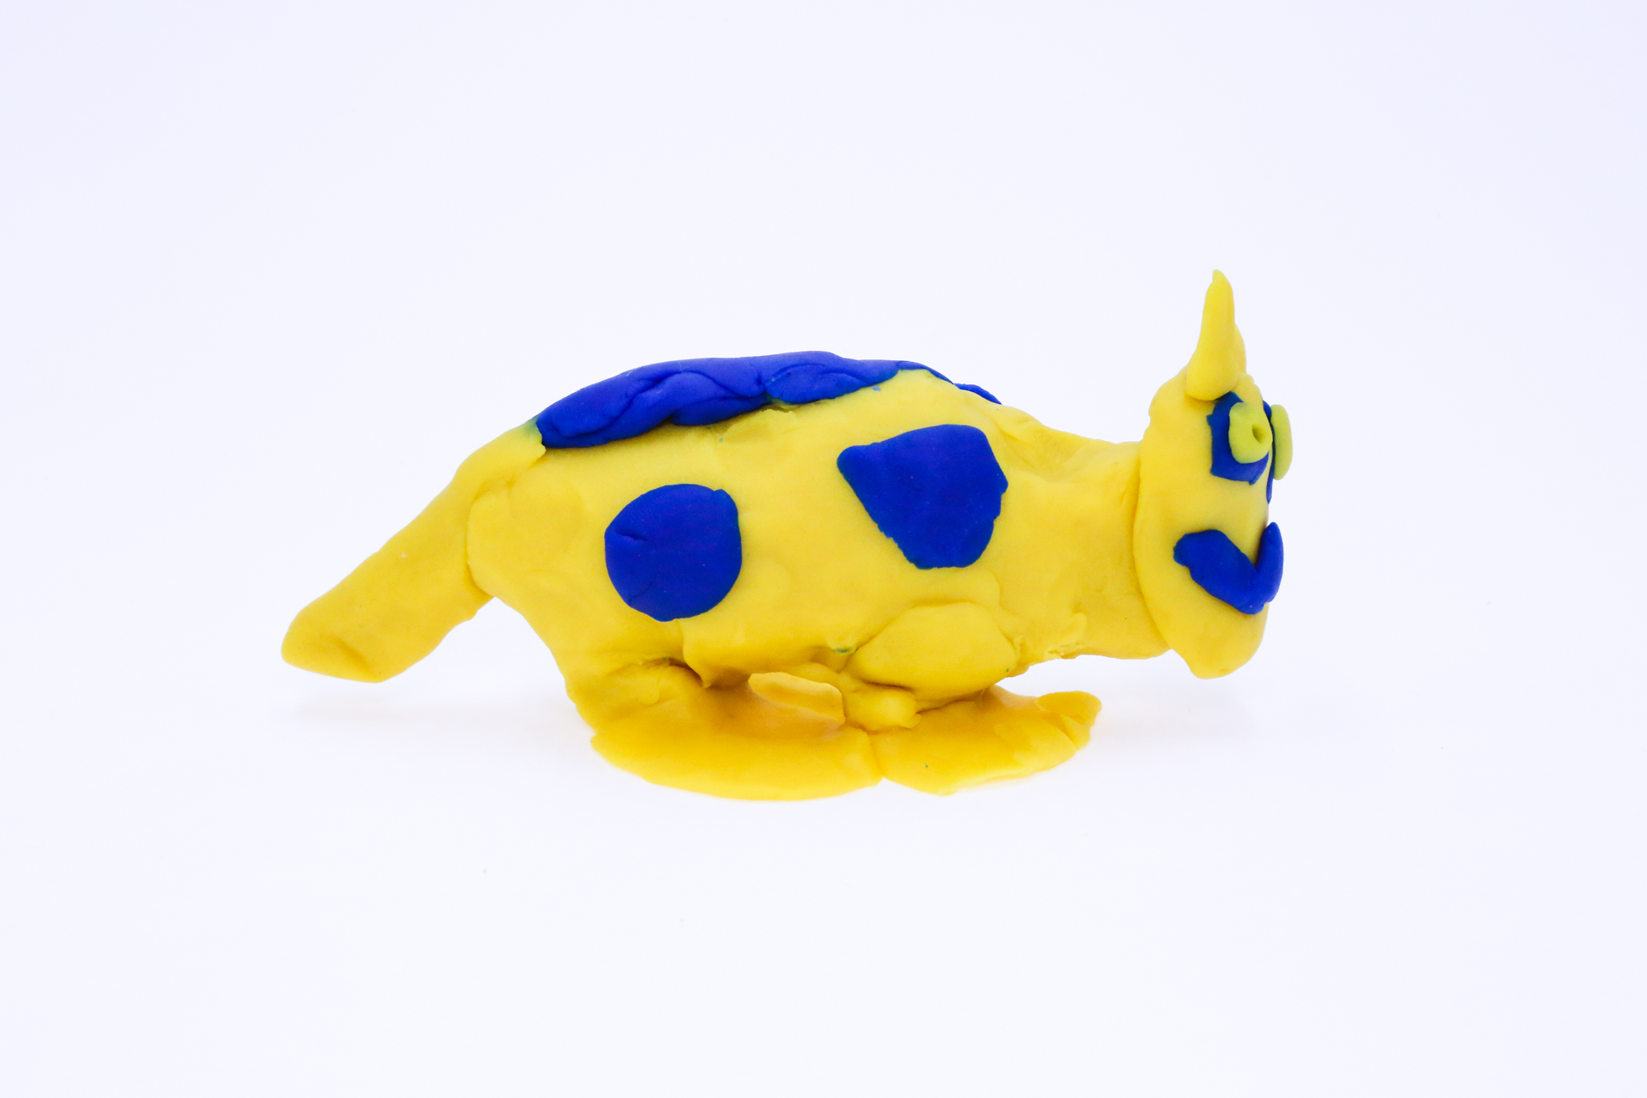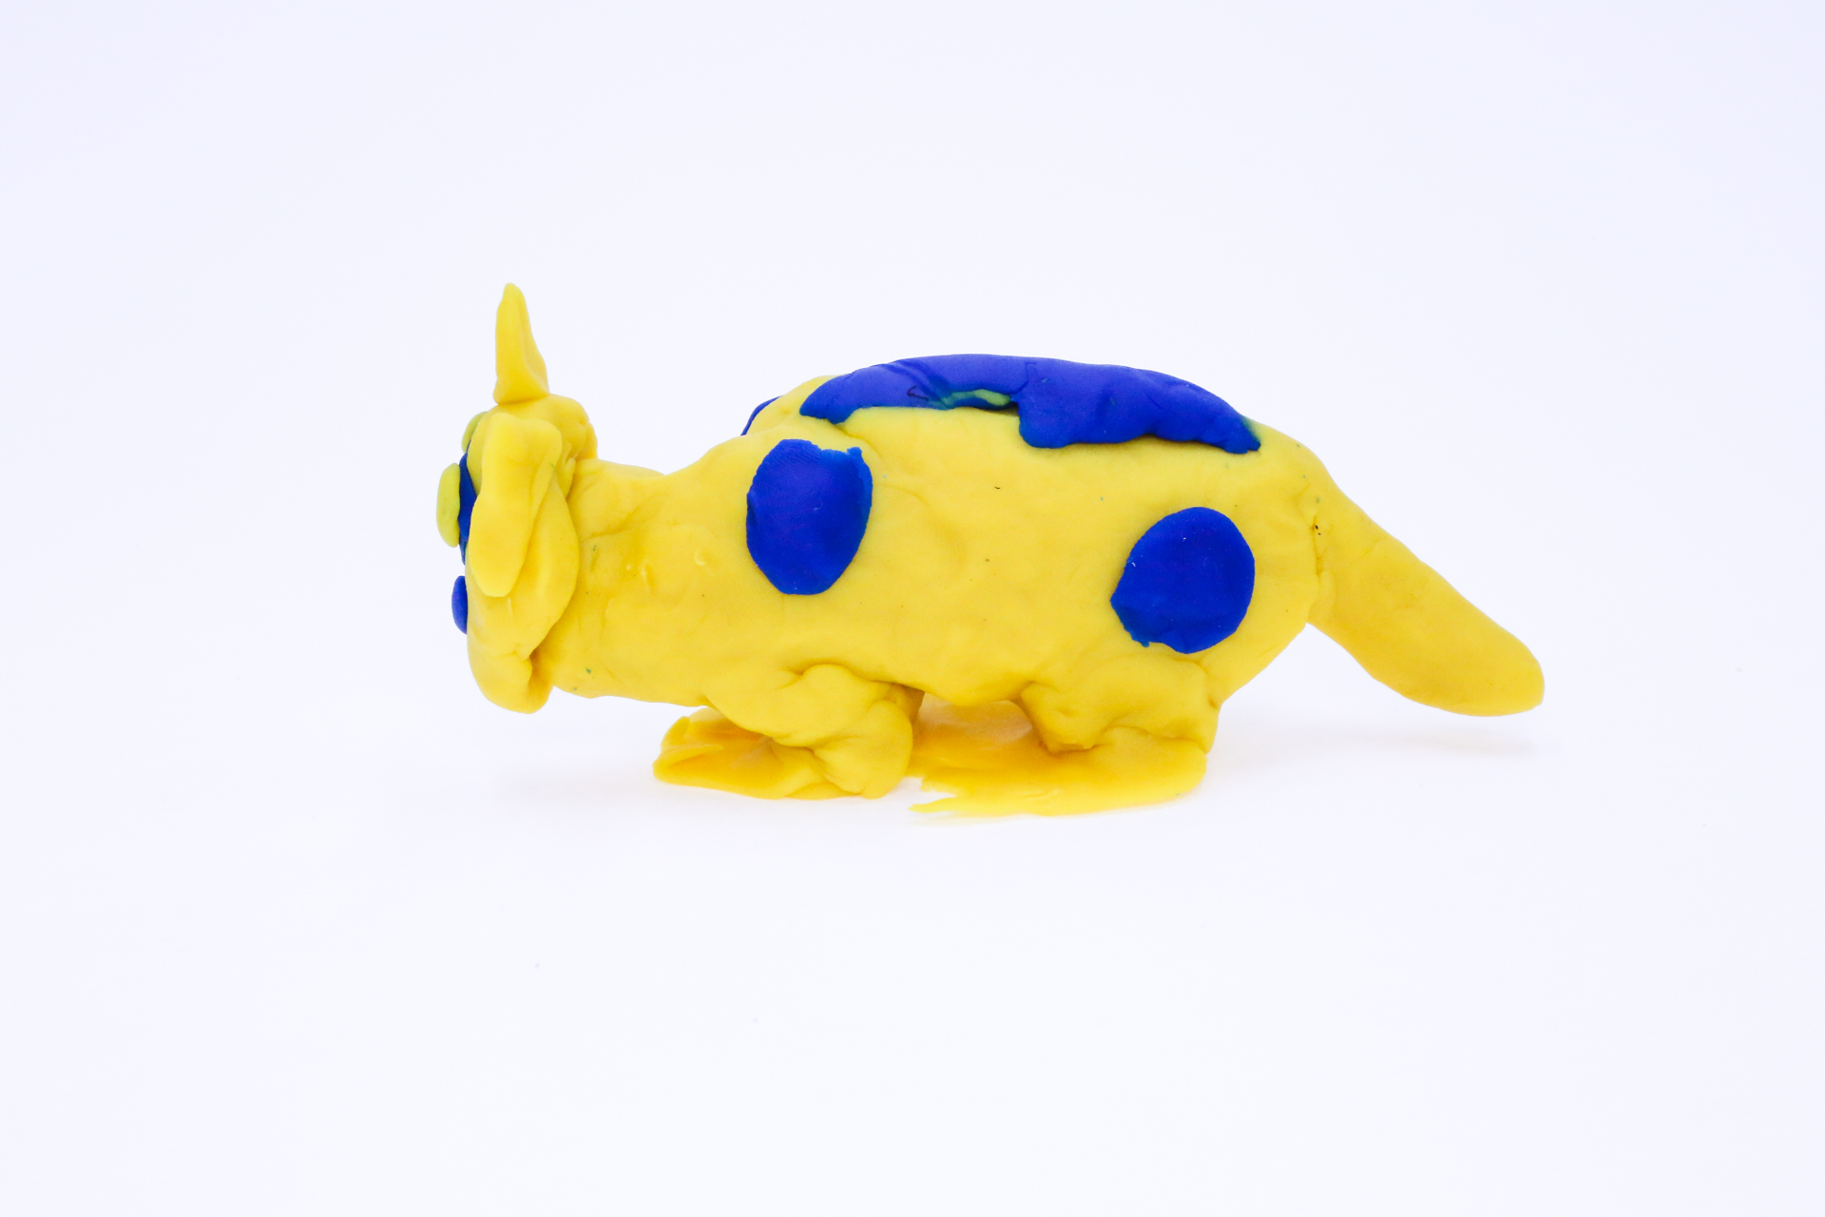

A recording Chris Jnr can be found here:
400

This is the unique QR code for this Imagined Thing. Right click it to save then share it, so you and others can find your way back to here to this point of The Well.

IT IS KNOWN! HUZZAH FOR THE GREAT & GRAND RUMPUS!

