3. Dimantic
HERE LIES THE ENTRY FOR AN IMAGINED THING
This is a thing imagined by Hajar, aged 10, on Wednesday April 21
The full name of this thing is: Dimantic
It can be found in: It is from the incredible room.
It is known that: When I entered the incredible room there was huge dimand and the name was dimantic there was so so much light and at the very top there was pink and purple light coming down.
This thing has three important features: Party lights, made out of silver, and Dimand at the top.

An image of Dimantic can be found here:
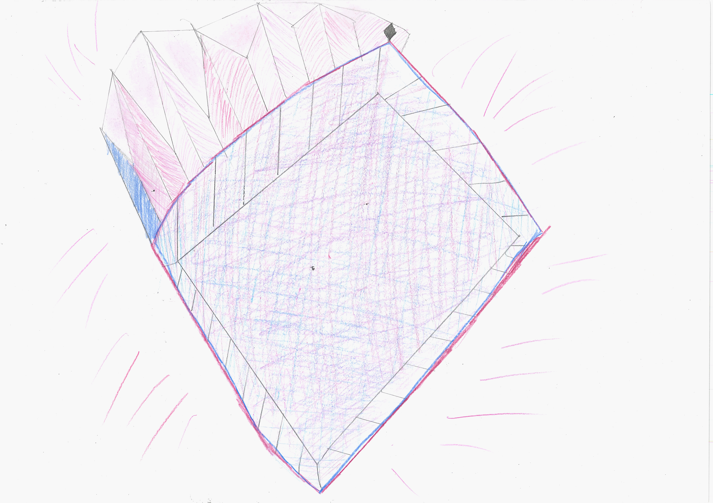400

A recording Dimantic can be found here:
hajar_4b.mp3

This is the unique QR code for this Imagined Thing. Right click it to save then share it, so you and others can find your way back to here to this point of The Well.

IT IS KNOWN! HUZZAH FOR THE GREAT & GRAND RUMPUS!

