29. Viperson
HERE LIES THE ENTRY FOR AN IMAGINED THING
This is a thing imagined by August, aged 11, on Tuesday May 11
The full name of this thing is: Viperson
It can be found in: My creature came from the dark forest.
It is known that: This creature was from the dark forest and met me in my imagination and what it can do is that it can teleport and senses everything that is near.
This thing has three important features: The body, The eyes, and The ears

An image of Viperson can be found here:
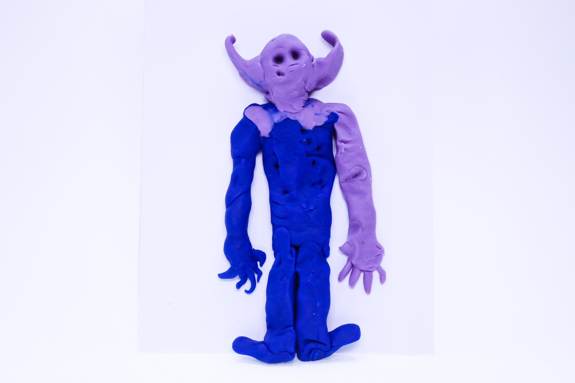400

A recording Viperson can be found here:
400

This is the unique QR code for this Imagined Thing. Right click it to save then share it, so you and others can find your way back to here to this point of The Well.

IT IS KNOWN! HUZZAH FOR THE GREAT & GRAND RUMPUS!

