28. One Eye - Chosen Thing
HERE LIES THE ENTRY FOR AN IMAGINED THING
This is a thing imagined by Mohammad, aged 11, on Tuesday May 11
The full name of this thing is: One Eye
It can be found in: Asia, Hong Kong
It is known that: One eye was in my imagination destroying a city destroying the buildings with a laser beam coming out of his eyes, missiles exploding from his legs.
This thing has three important features: flat feet, legs with missiles, and laser beam eyes

An image of One Eye can be found here:
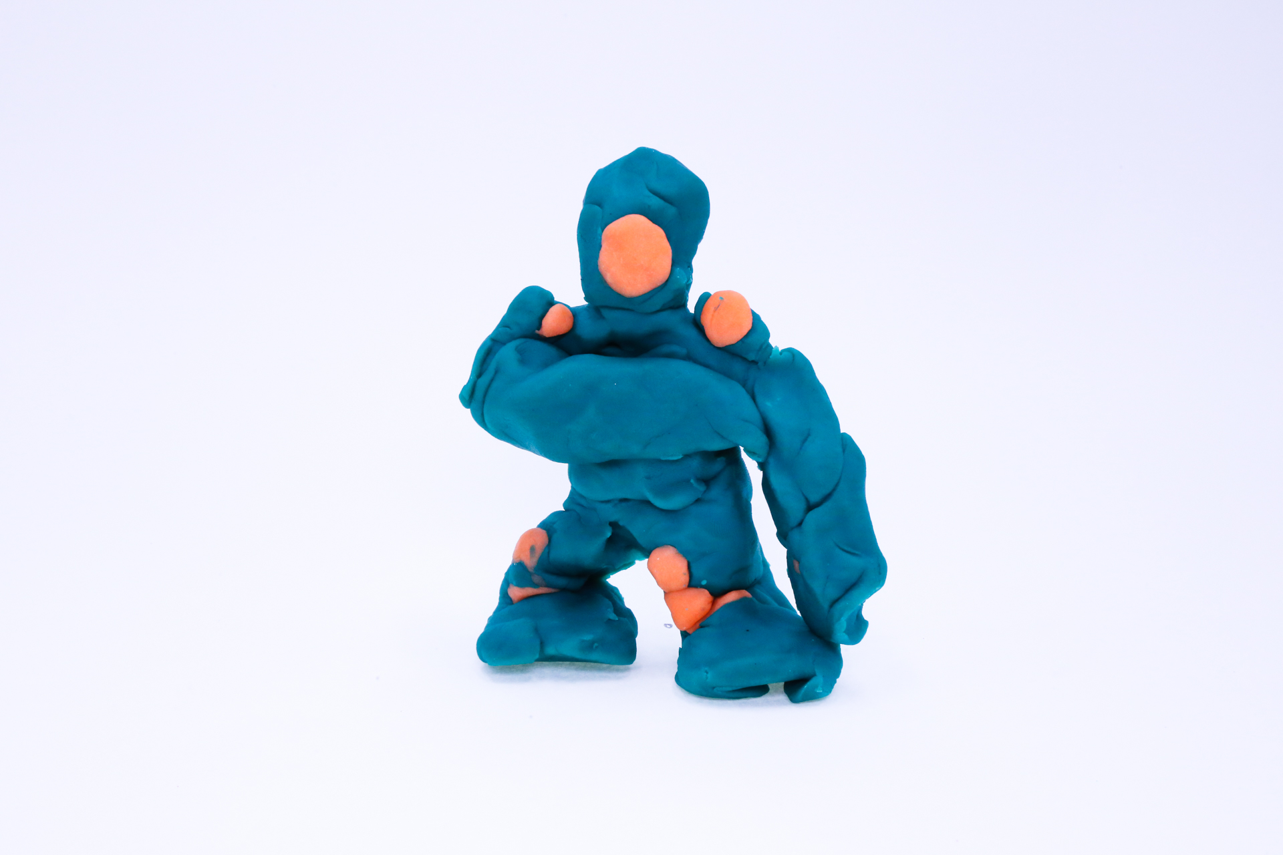400
400
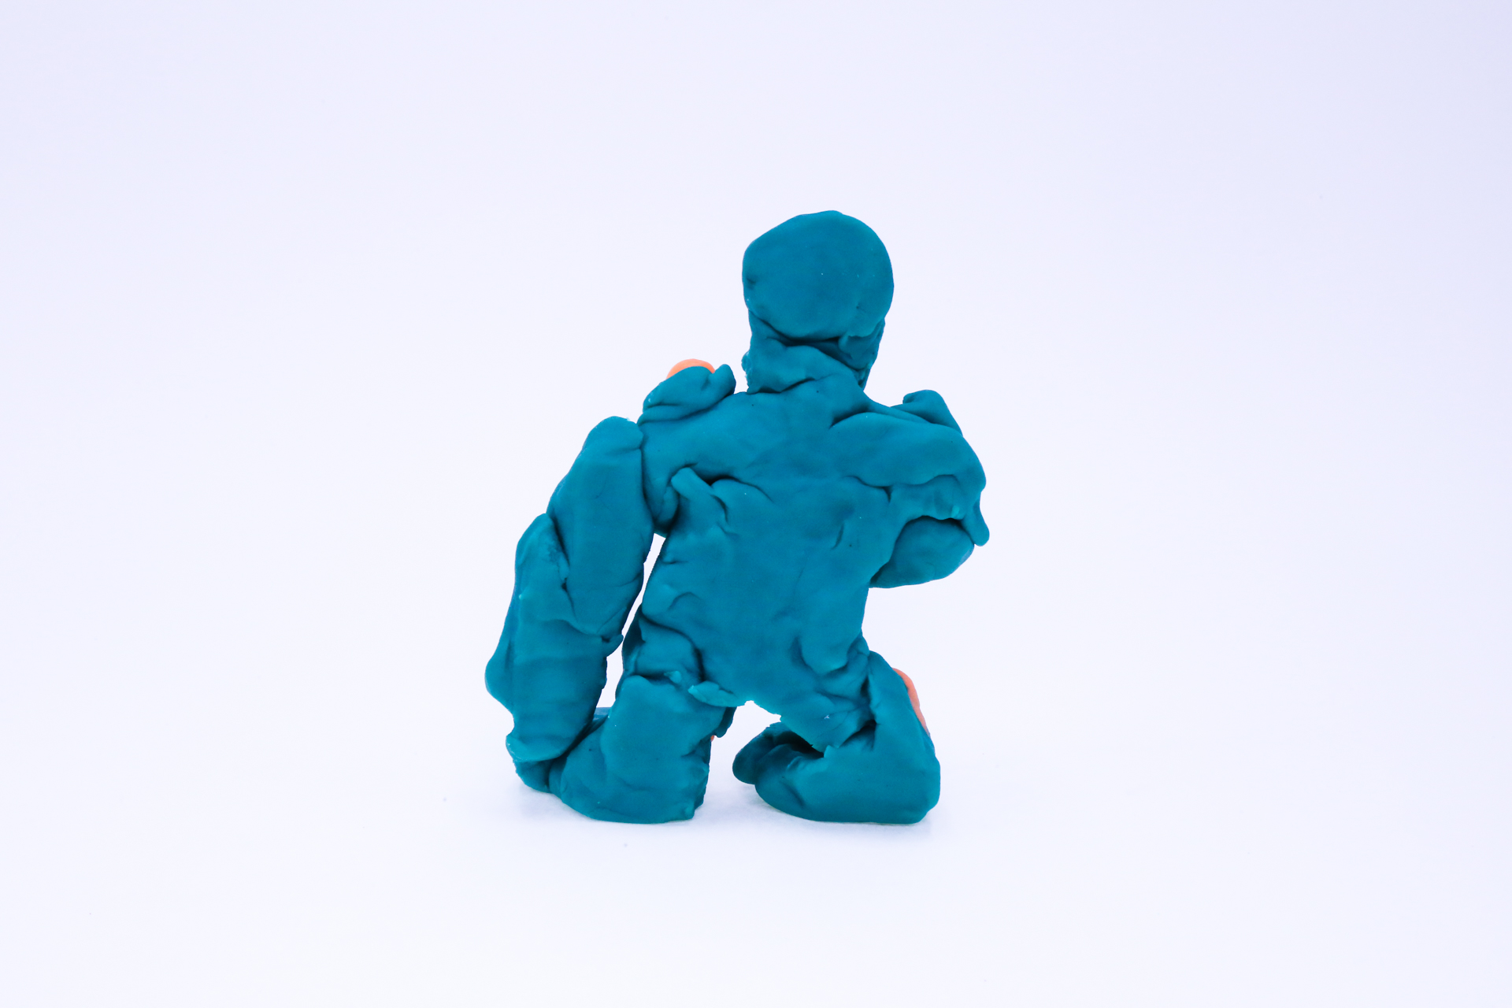400
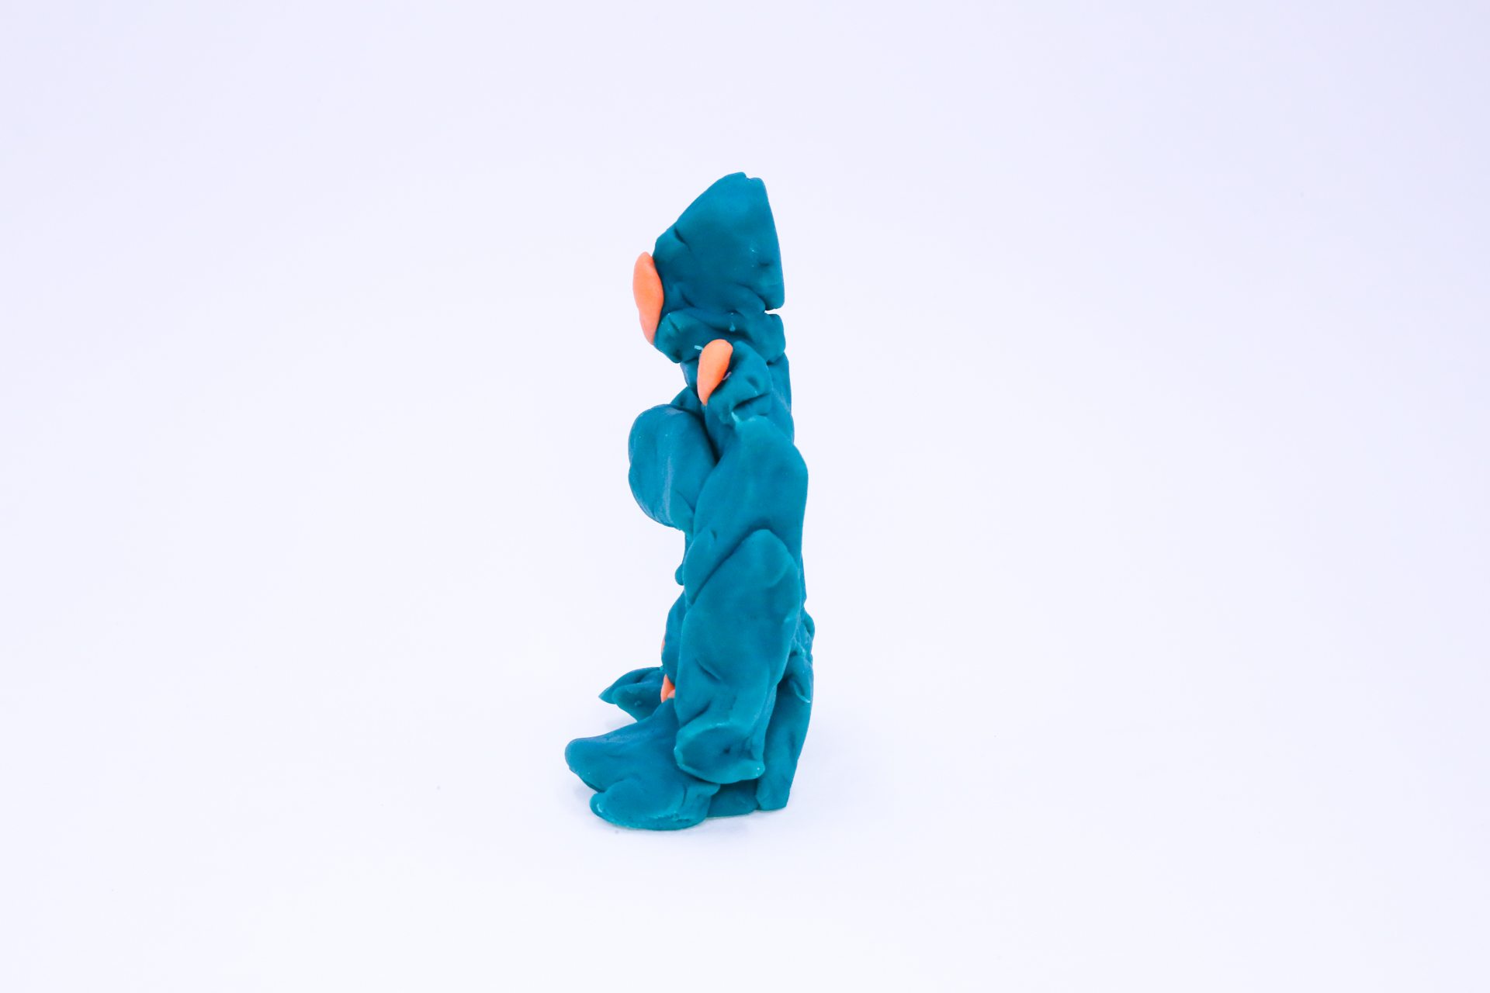400
400

A recording One Eye can be found here:
400

This is the unique QR code for this Imagined Thing. Right click it to save then share it, so you and others can find your way back to here to this point of The Well.

IT IS KNOWN! HUZZAH FOR THE GREAT & GRAND RUMPUS!

