26. Shy
HERE LIES THE ENTRY FOR AN IMAGINED THING
This is a thing imagined by Savana, aged 11, on Tuesday May 11
The full name of this thing is: Shy
It can be found in: A special imagination town.
It is known that: it's a shy hat that has toppings on top of the body. Whipped cream, icing, and sprinkles.
This thing has three important features: Body looks like a cake. , All the toppings on the body. , and Creature looks shy

An image of Shy can be found here: 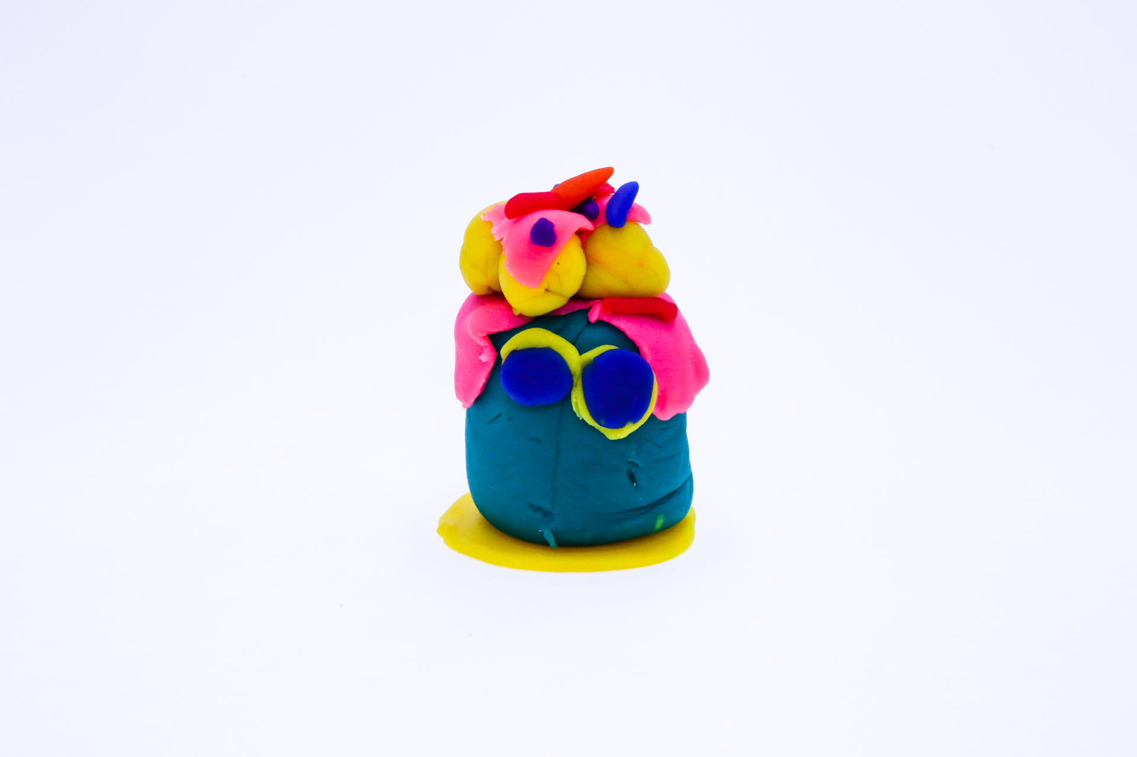 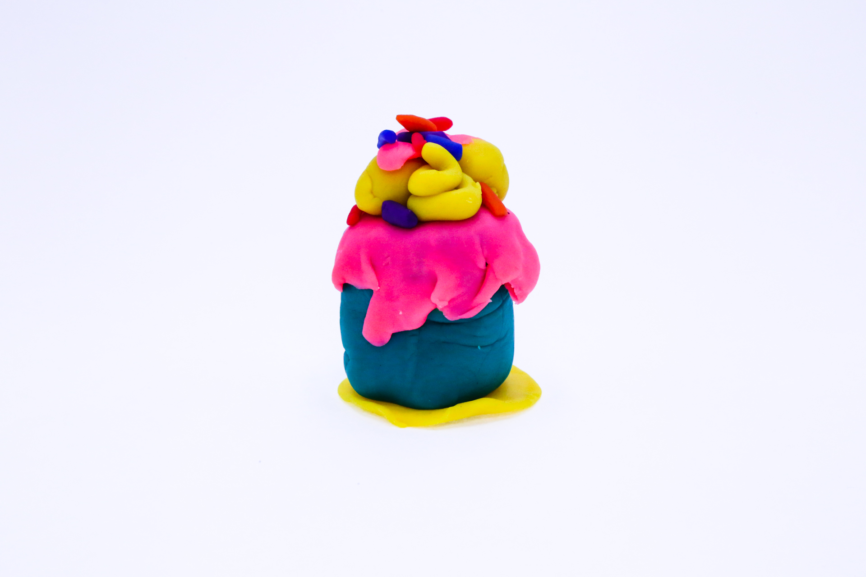 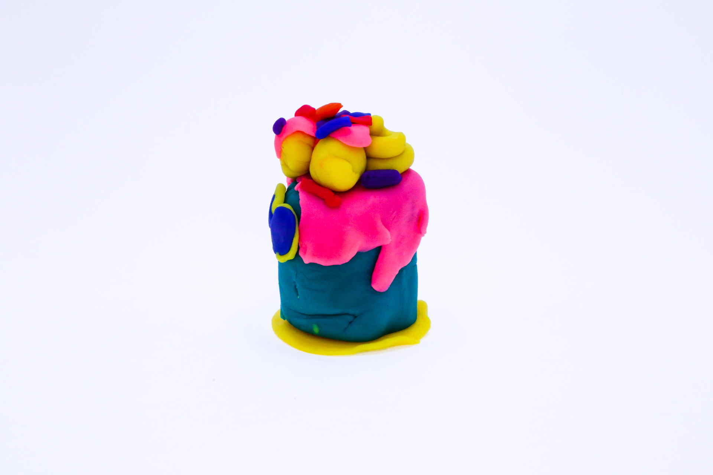 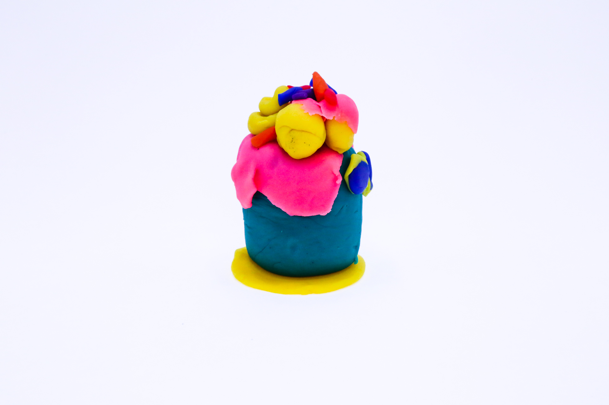 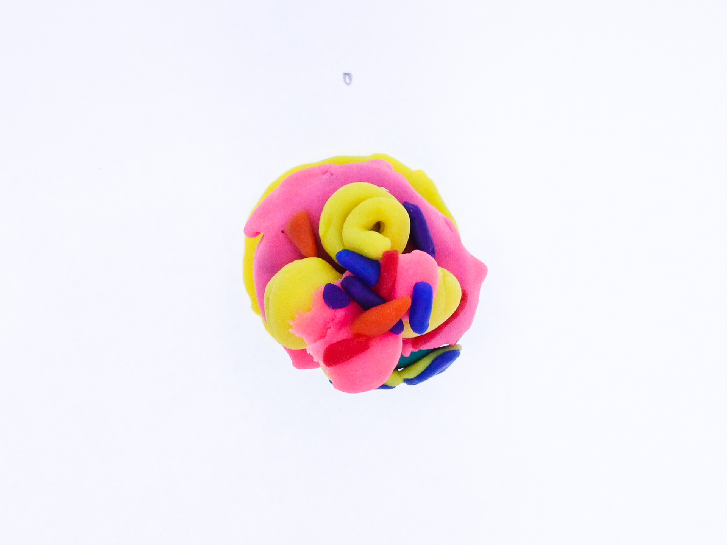

A recording Shy can be found here:
400

This is the unique QR code for this Imagined Thing. Right click it to save then share it, so you and others can find your way back to here to this point of The Well.

IT IS KNOWN! HUZZAH FOR THE GREAT & GRAND RUMPUS!

