24. The Grand Ship
HERE LIES THE ENTRY FOR AN IMAGINED THING
This is a thing imagined by Ali A., aged 7, on Thursday May 6
The full name of this thing is: The Grand Ship
It can be found in: Tree Island
It is known that: Once upon a time there was a pirate named Ali A. He left Tree Island to find treasure in the Grand Ship made out of pure chocolate. When the pirate got hungry he would take a bite and it would grow back. The pirate had to dodge the flying asteroid to survive and get to sand island to find treasure.

An image of The Grand Ship can be found here:
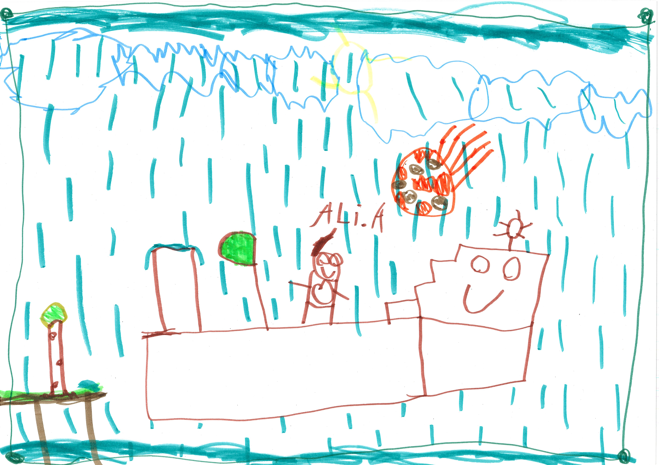400

This is the unique QR code for this Imagined Thing. Right click it to save then share it, so you and others can find your way back to here to this point of The Well.

IT IS KNOWN! HUZZAH FOR THE GREAT & GRAND RUMPUS!

