22. Rainea
HERE LIES THE ENTRY FOR AN IMAGINED THING
This is a thing imagined by Kahilla, aged 7, on Thursday May 6
The full name of this thing is: Rainea
It can be found in: Australia
It is known that: There was a rainbow and it was home and it was mine.
This thing has three important features: colour, shapes, and pretty

An image of Rainea can be found here:
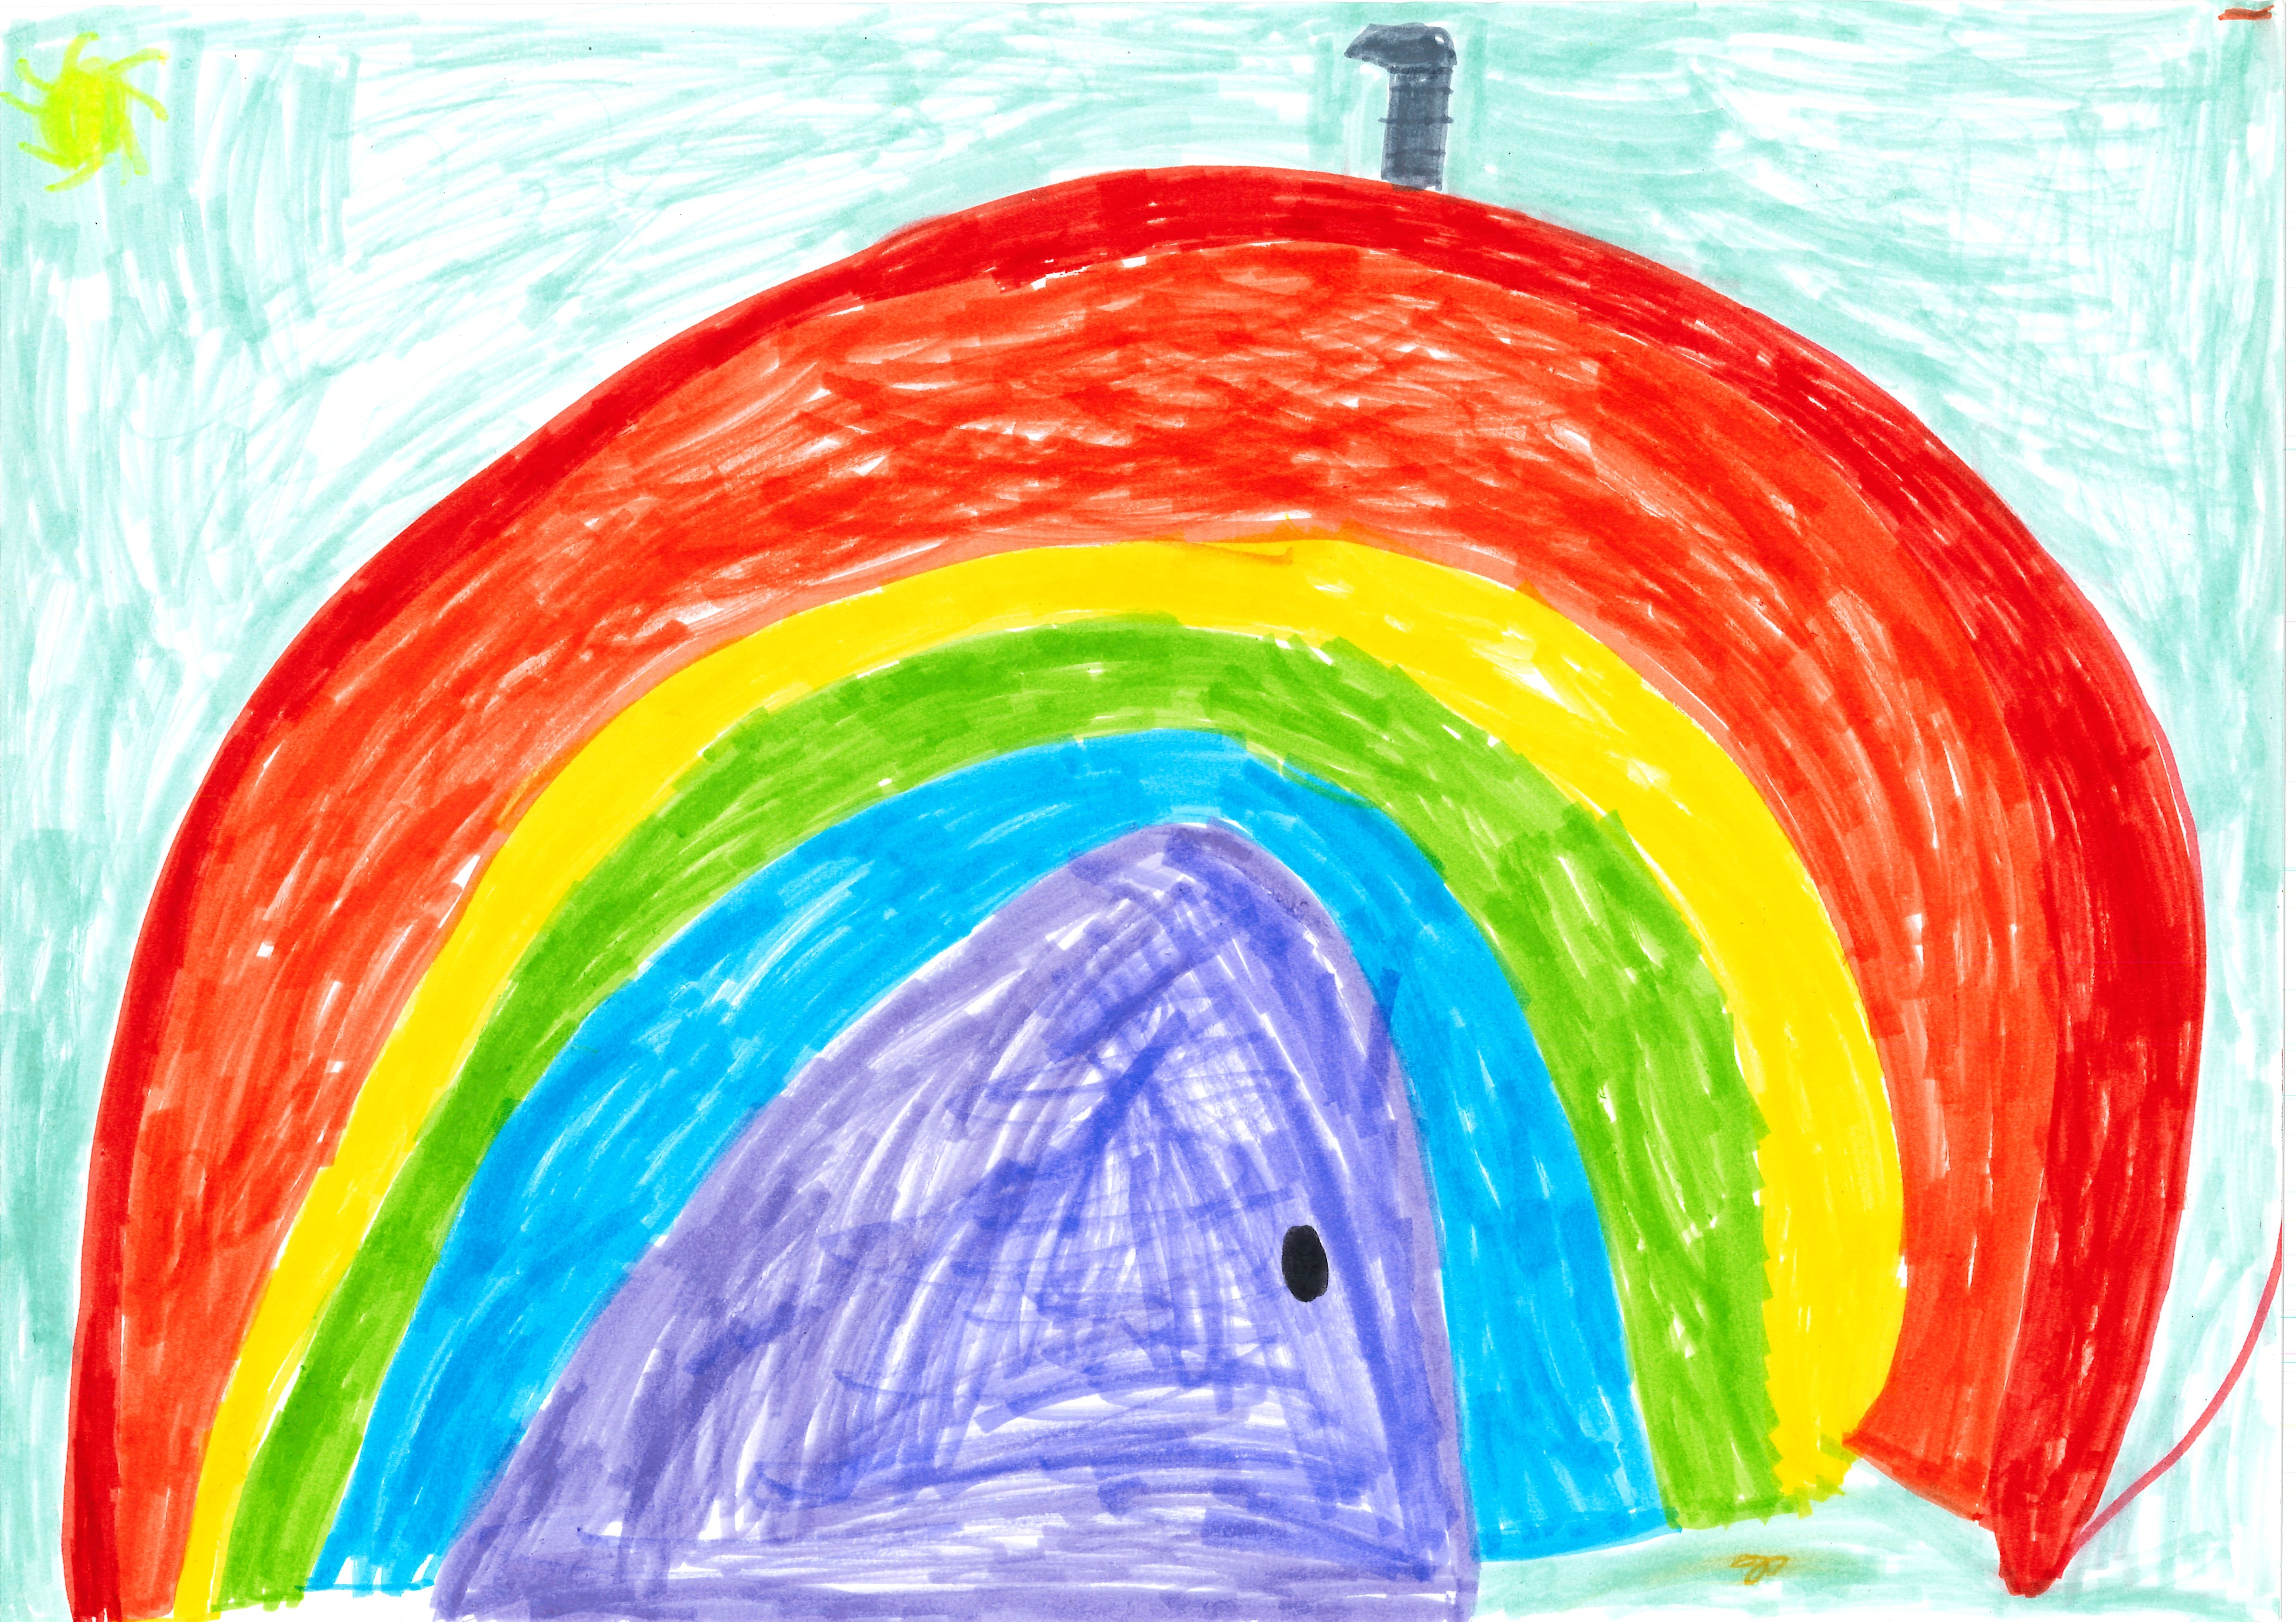400

A recording Rainea can be found here:
kahlila.mp3

This is the unique QR code for this Imagined Thing. Right click it to save then share it, so you and others can find your way back to here to this point of The Well.

IT IS KNOWN! HUZZAH FOR THE GREAT & GRAND RUMPUS!

