219. Tweedldum
HERE LIES THE ENTRY FOR AN IMAGINED THING
This is a thing imagined by Jessica, aged 10, on Monday October 11
The full name of this thing is: Tweedldum No. 219
It can be found in: The enchanted forest
It is known that: Tweedldum is ababy and got seperated from its family, it can barely fly and it is very hard to find food because the trees are too tall for tweedldum
This thing has three important features: small, fluffy, and cute

An image of Tweedldum No. 219 can be found here:
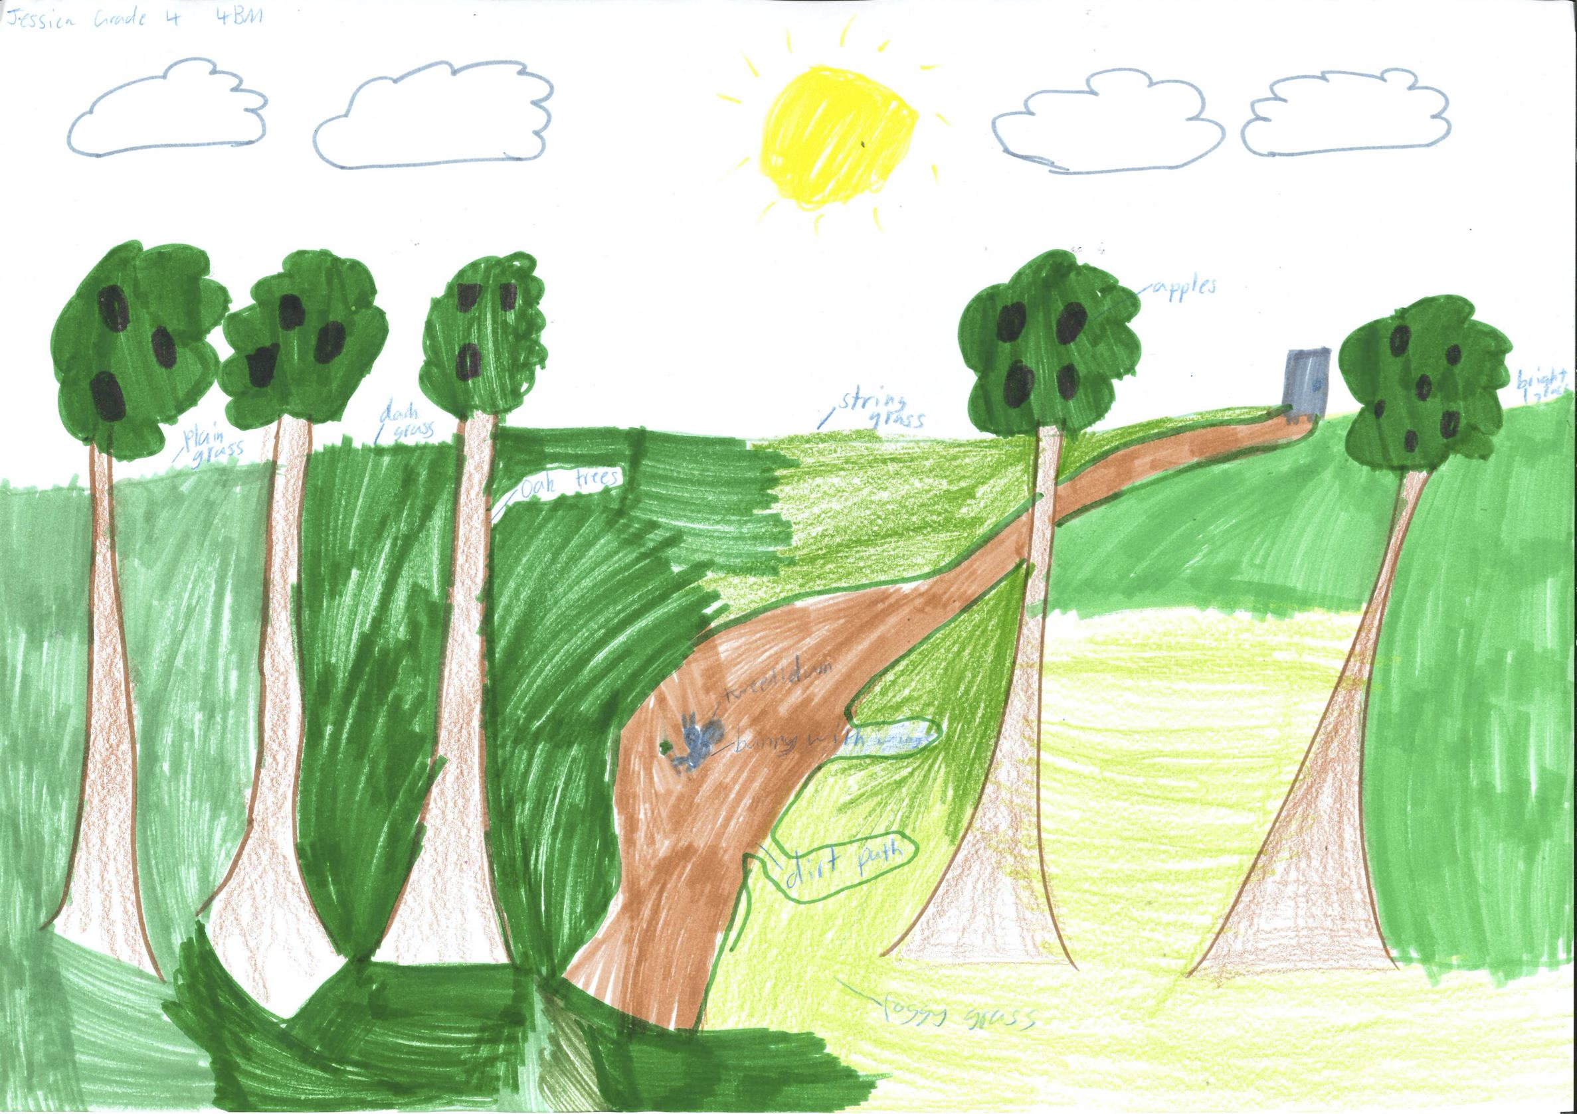

A recording Tweedldum No. 219 can be found here:
upload_your_audio_file400

This is the unique QR code for this Imagined Thing. Right click it to save then share it, so you and others can find your way back to here to this point of The Well.

IT IS KNOWN! HUZZAH FOR THE GREAT & GRAND RUMPUS!

