217. Tailneck
HERE LIES THE ENTRY FOR AN IMAGINED THING
This is a thing imagined by Thomas, aged 10, on Monday October 11
The full name of this thing is: Tailneck No. 217
It can be found in: A cold, dark and quiet environment
It is known that: Its tail is connected to its head as it has atail for its body. it came from an even colder and darker environmnet, called the darkness.
This thing has three important features: tailbodyneck combined, claws, and deadly poison

An image of Tailneck No. 217 can be found here:
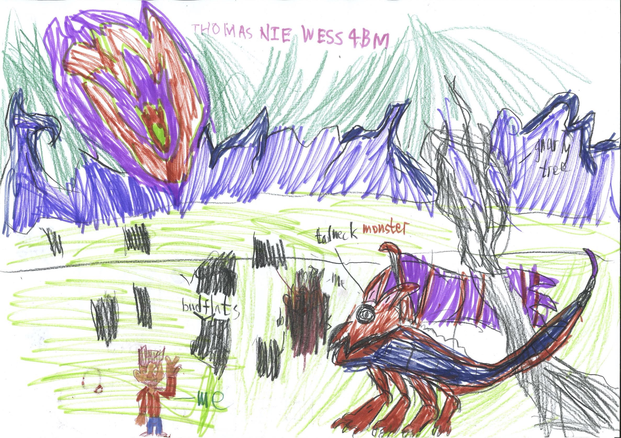

This is the unique QR code for this Imagined Thing. Right click it to save then share it, so you and others can find your way back to here to this point of The Well.

IT IS KNOWN! HUZZAH FOR THE GREAT & GRAND RUMPUS!

