21. Mask God - Chosen Thing
HERE LIES THE RECORD OF AN IMAGINED THING
This is a thing imagined by Angelina, aged 7, on Thursday May 6
The full name of this thing is: mask god
It can be found in: japan
It is known that: once all of the cou fish fought all of the cou fish when it was sunny.
This thing has three important features: @@Feature 1@@, @@Feature 2@@, and @@Feature 3@@

An image of mask god can be found here:
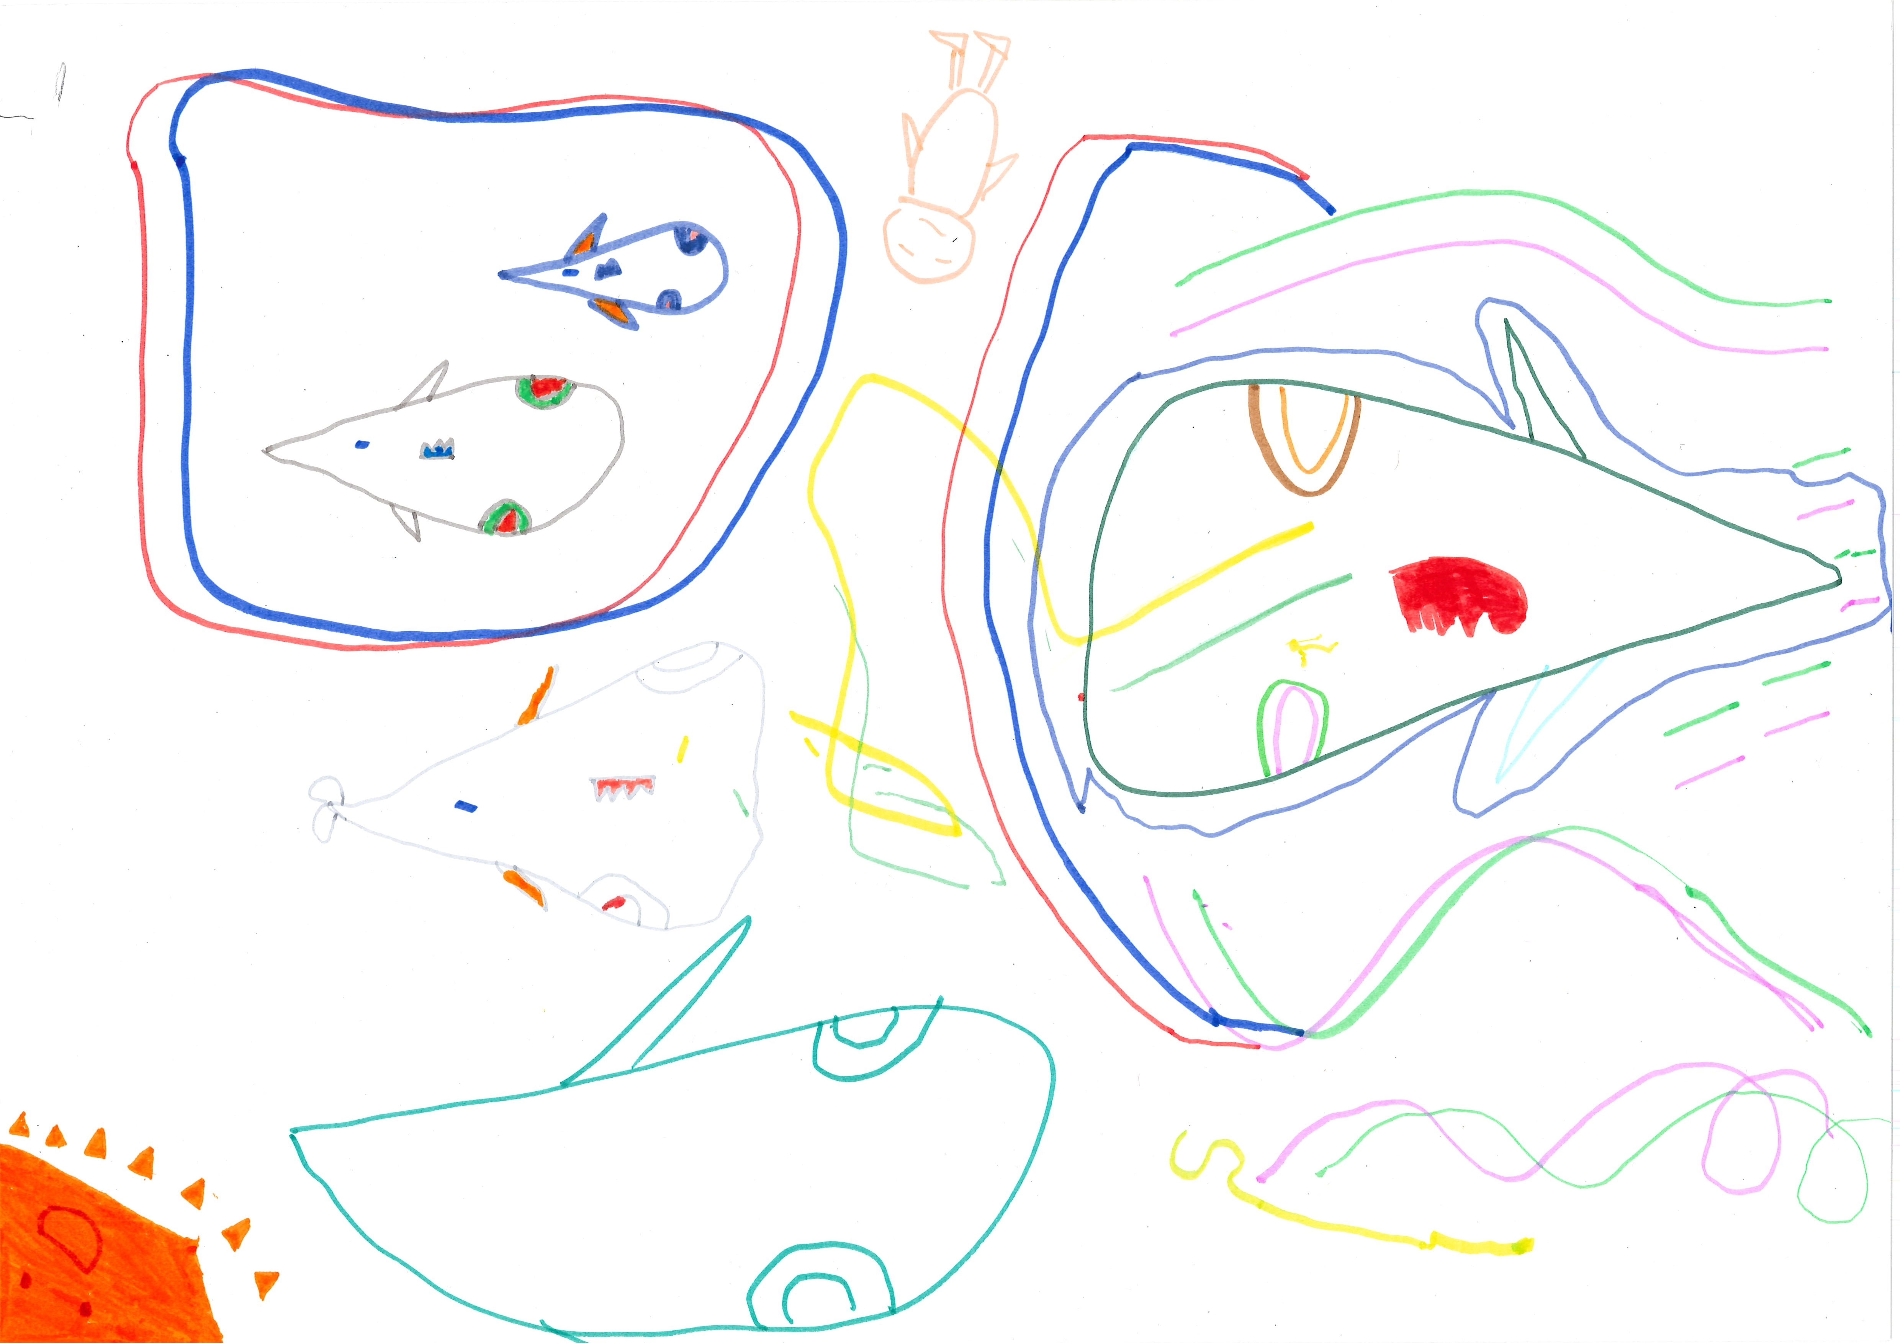400

This is the unique QR code for this Imagined Thing. Right click it to save then share it, so you and others can find your way back to here to this point of The Well.

IT IS KNOWN! HUZZAH FOR THE GREAT & GRAND RUMPUS!

