20. Fighting with blue team
HERE LIES THE ENTRY FOR AN IMAGINED THING
This is a thing imagined by Ryan, aged 7, on Thursday May 6
The full name of this thing is: fighting with blue team
It can be found in: india
It is known that: once upon a time there was a two teams they fighted each other and they all died.
This thing has three important features: cool, amazing, and beast

An image of fighting with blue team can be found here:
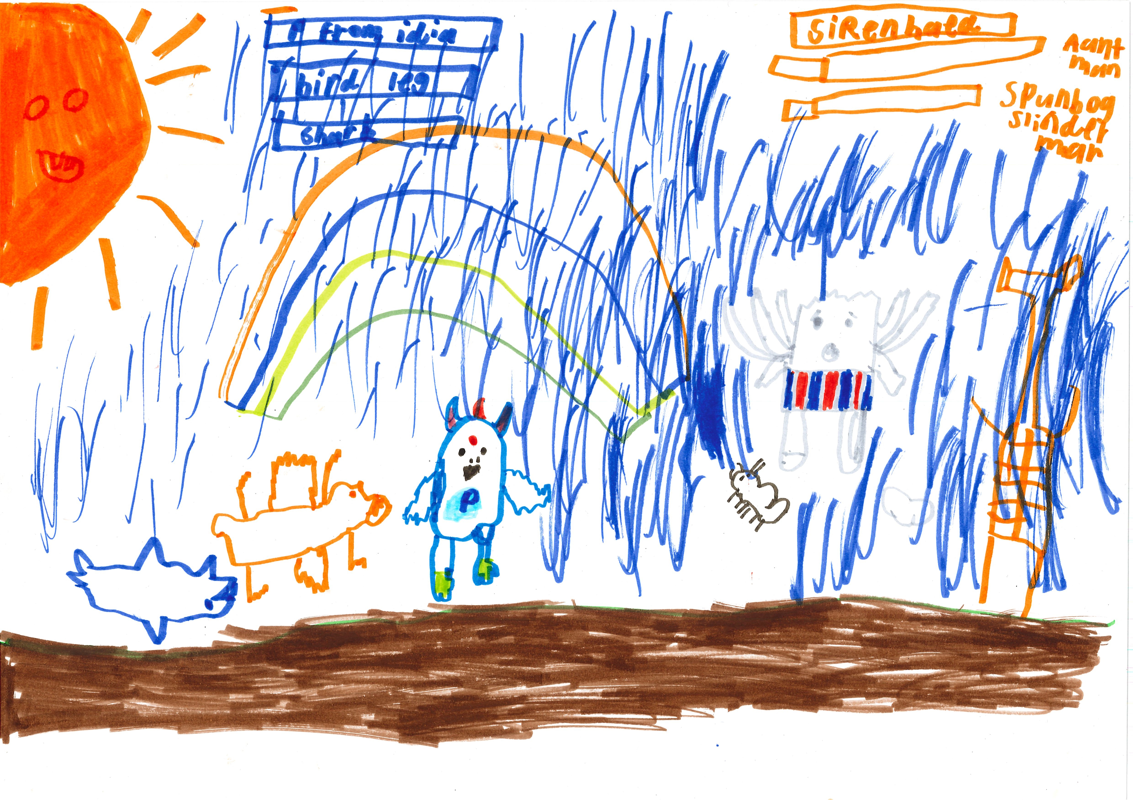

A recording fighting with blue team can be found here:
400

This is the unique QR code for this Imagined Thing. Right click it to save then share it, so you and others can find your way back to here to this point of The Well.

IT IS KNOWN! HUZZAH FOR THE GREAT & GRAND RUMPUS!

