19. Spongebobworld
HERE LIES THE ENTRY FOR AN IMAGINED THING
This is a thing imagined by DJ, aged 7, on Thursday May 6
The full name of this thing is: Spongebobworld
It can be found in: Under the sea.
It is known that: (Recorded in audio)
This thing has three important features: Sponge Bob, Patrick, and Squidward

An image of Spongebobworld can be found here:
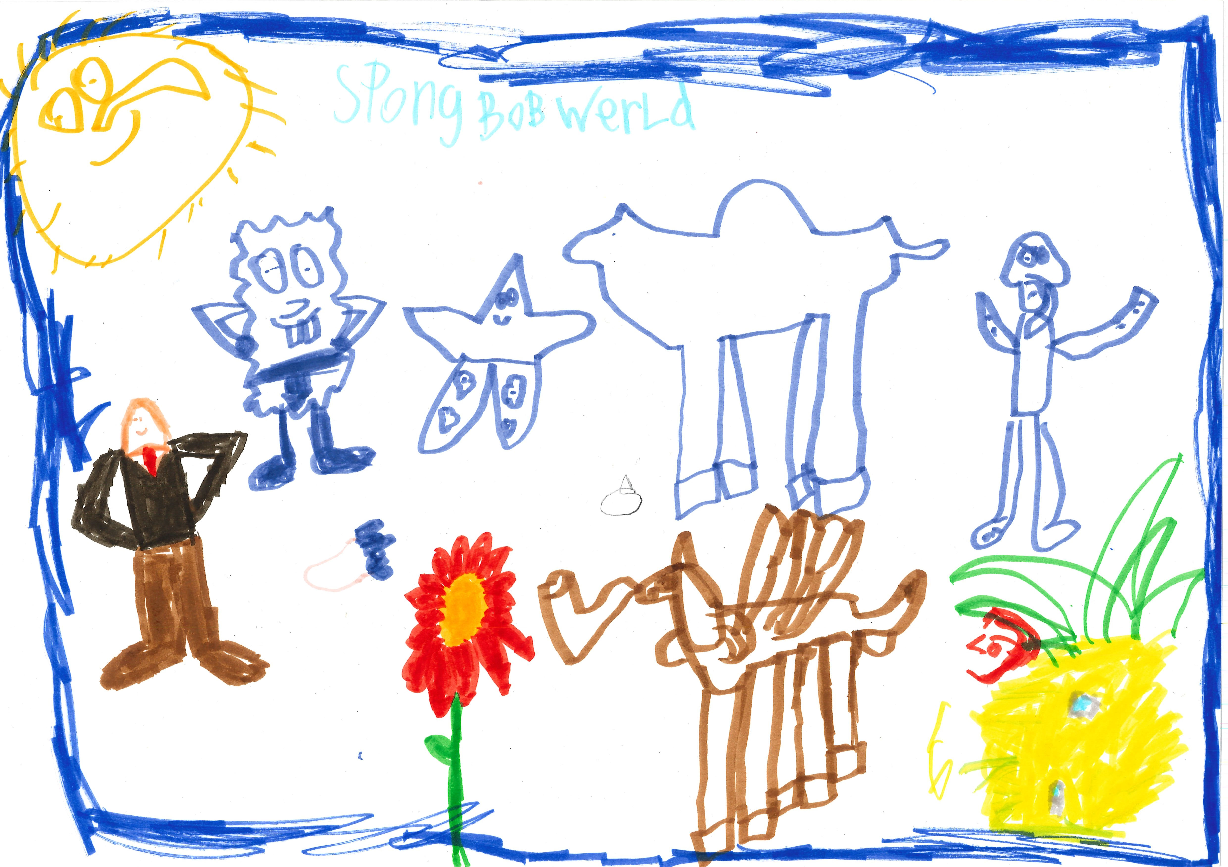400

A recording Spongebobworld can be found here:
dj_2b.mp3

This is the unique QR code for this Imagined Thing. Right click it to save then share it, so you and others can find your way back to here to this point of The Well.

IT IS KNOWN! HUZZAH FOR THE GREAT & GRAND RUMPUS!

