18. Herrylizzied
HERE LIES THE ENTRY FOR AN IMAGINED THING
This is a thing imagined by harry, aged 7, on Wednesday April 28
The full name of this thing is: herrylizzied
It can be found in: the beach at the rock pool
It is known that: once there was a rock that was dogup an there was a sckoai oof a lizzid
This thing has three important features: the lizzied, an the plas , and and the skoal

An image of herrylizzied can be found here:
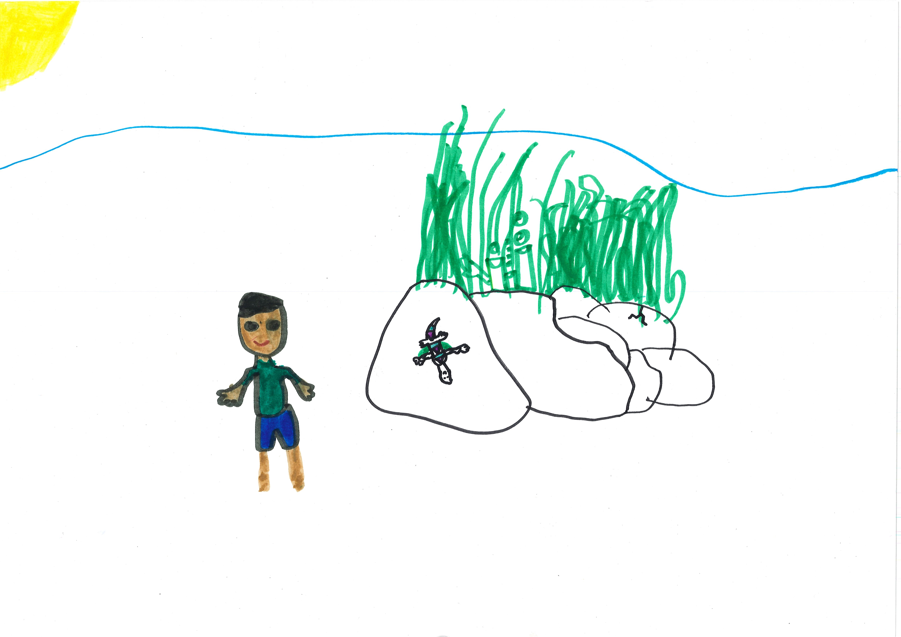600

A recording herrylizzied can be found here:
harry_2b.mp3

This is the unique QR code for this Imagined Thing. Right click it to save then share it, so you and others can find your way back to here to this point of The Well.

IT IS KNOWN! HUZZAH FOR THE GREAT & GRAND RUMPUS!

