16. Doncky
HERE LIES THE ENTRY FOR AN IMAGINED THING
This is a thing imagined by rafiq, aged 7, on Wednesday April 28
The full name of this thing is: doncky
It can be found in: it is at the sea
It is known that: Ones apond a time a boy name naroate (nar-toe) he wanted to go to the a iland sundenlee he sore a sharck and thr sharck sar a donck then the sharck stuted to eat the doncy so the conkcy ran away.
This thing has three important features: coins, donkey, and shrrck

An image of doncky can be found here:
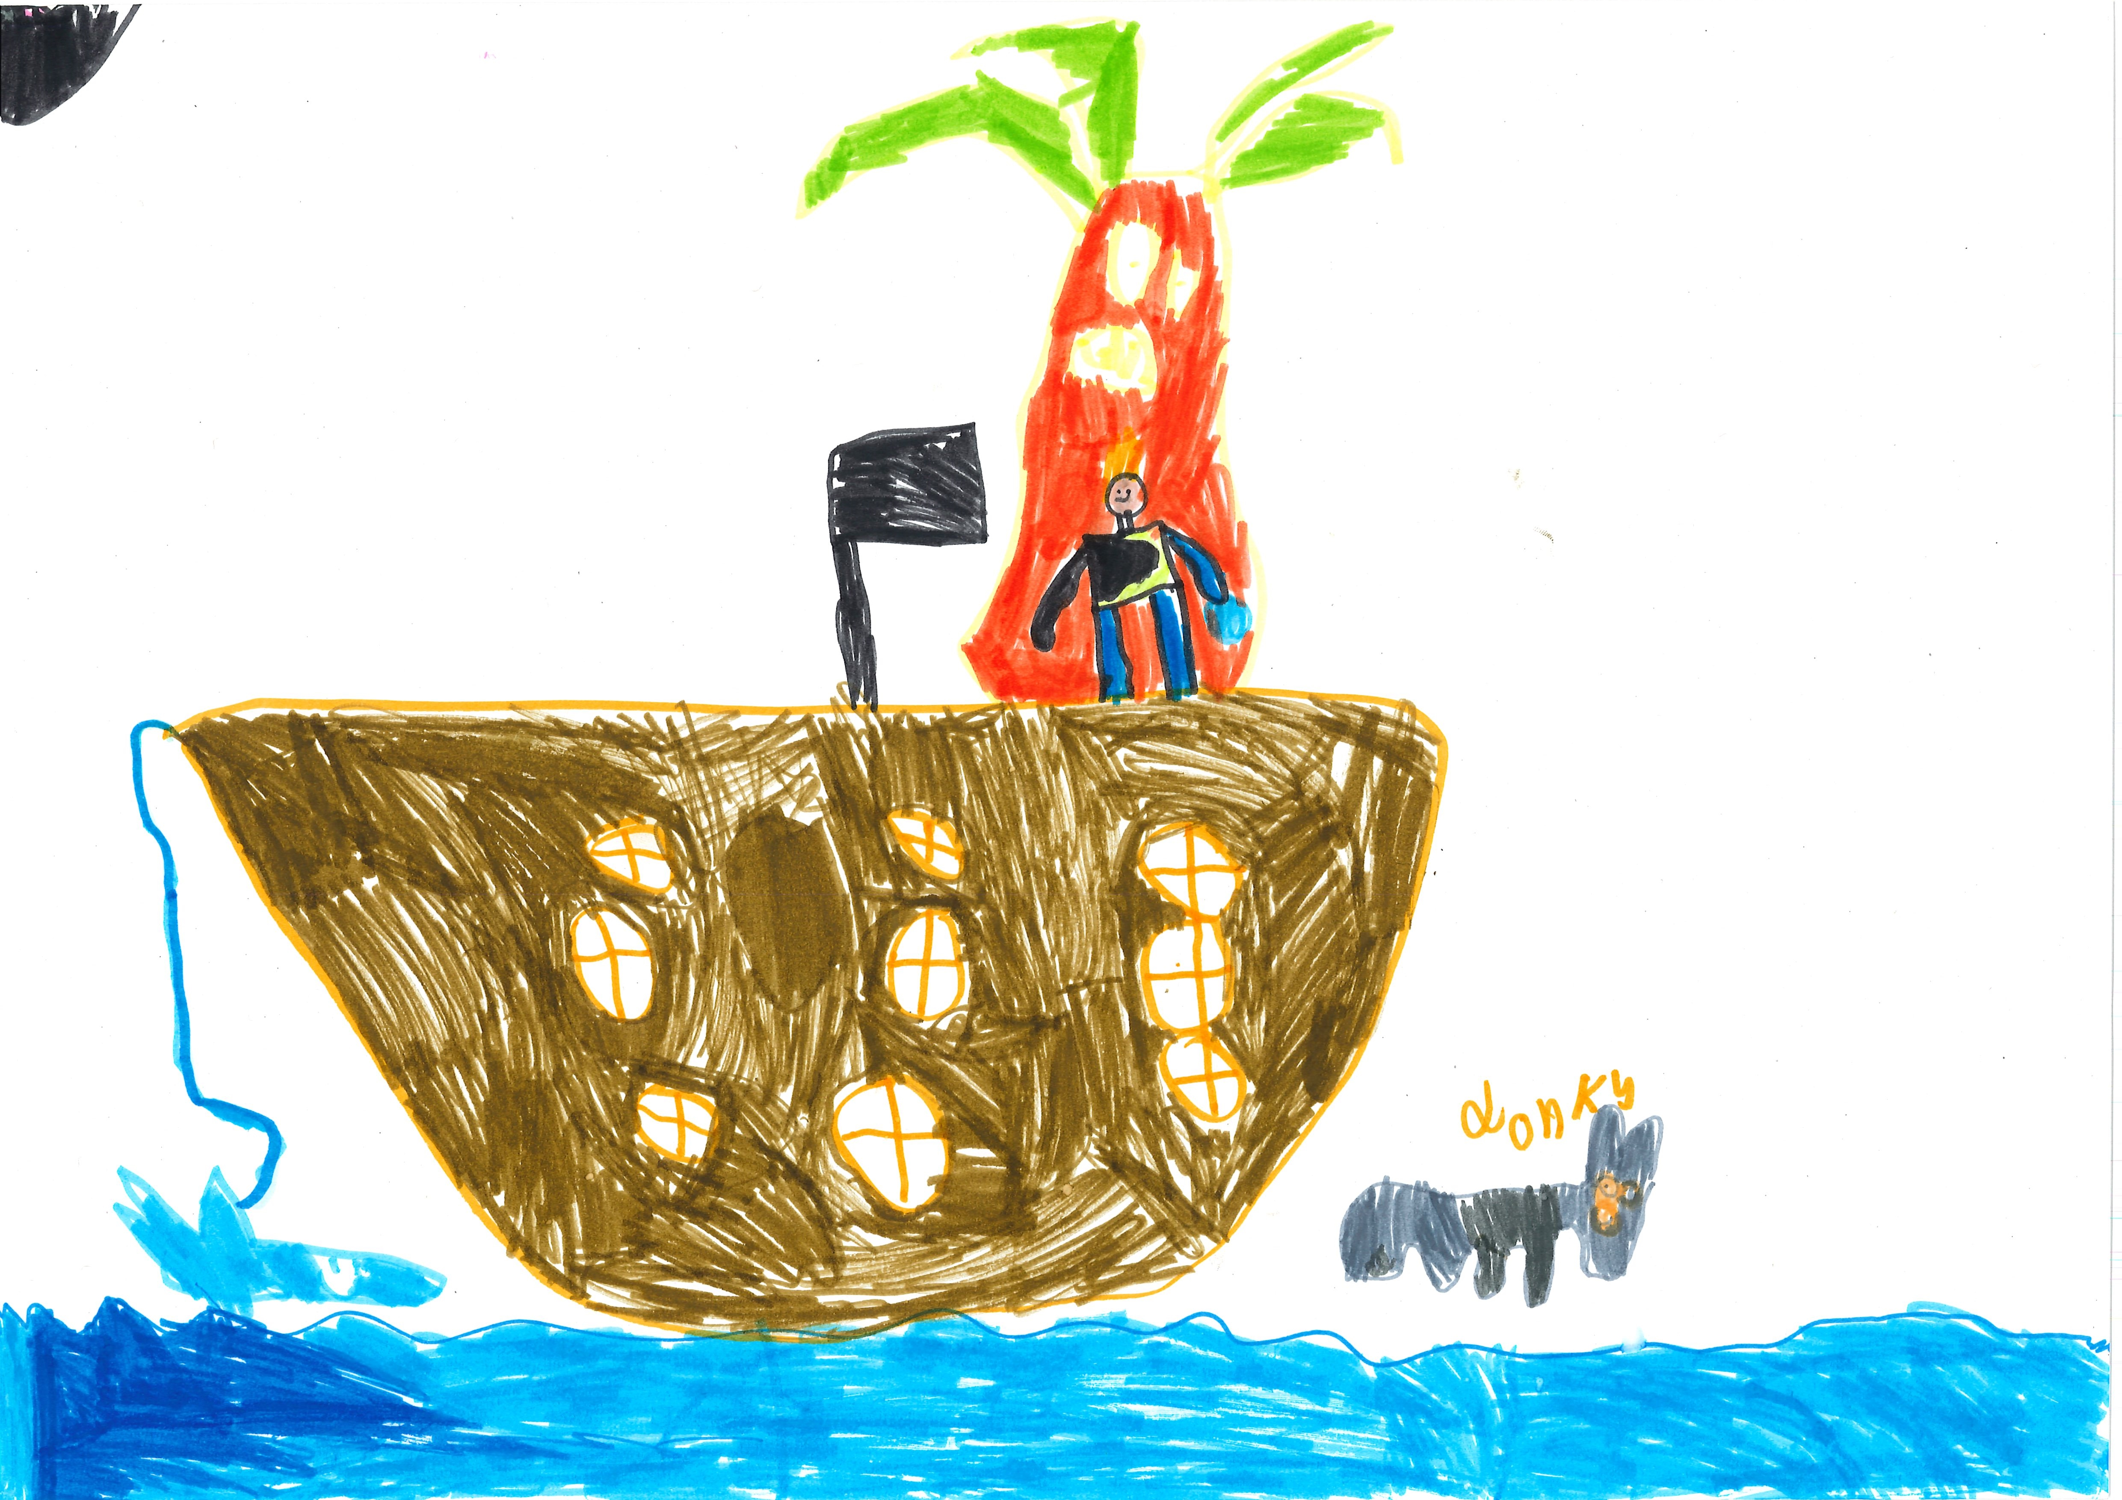400

A recording of doncky can be found here:
rafiq.mp3

This is the unique QR code for this Imagined Thing. Right click it to save then share it, so you and others can find your way back to here to this point of The Well.

IT IS KNOWN! HUZZAH FOR THE GREAT & GRAND RUMPUS!

