15. The Super Potato Island
HERE LIES THE ENTRY FOR AN IMAGINED THING
This is a thing imagined by neema, aged 7, on Wednesday April 28
The full name of this thing is: the super potato island.
It can be found in: at a very hot island.
It is known that: once upon a time there was potatos on a island there was a thousand potatos one day the potatos went to hawaii somebody saw them cooked them and ate them.
This thing has three important features: the potatos drink from the sun., the people will go to jail., and the potatos never go out again.

An image of the super potato island. can be found here:
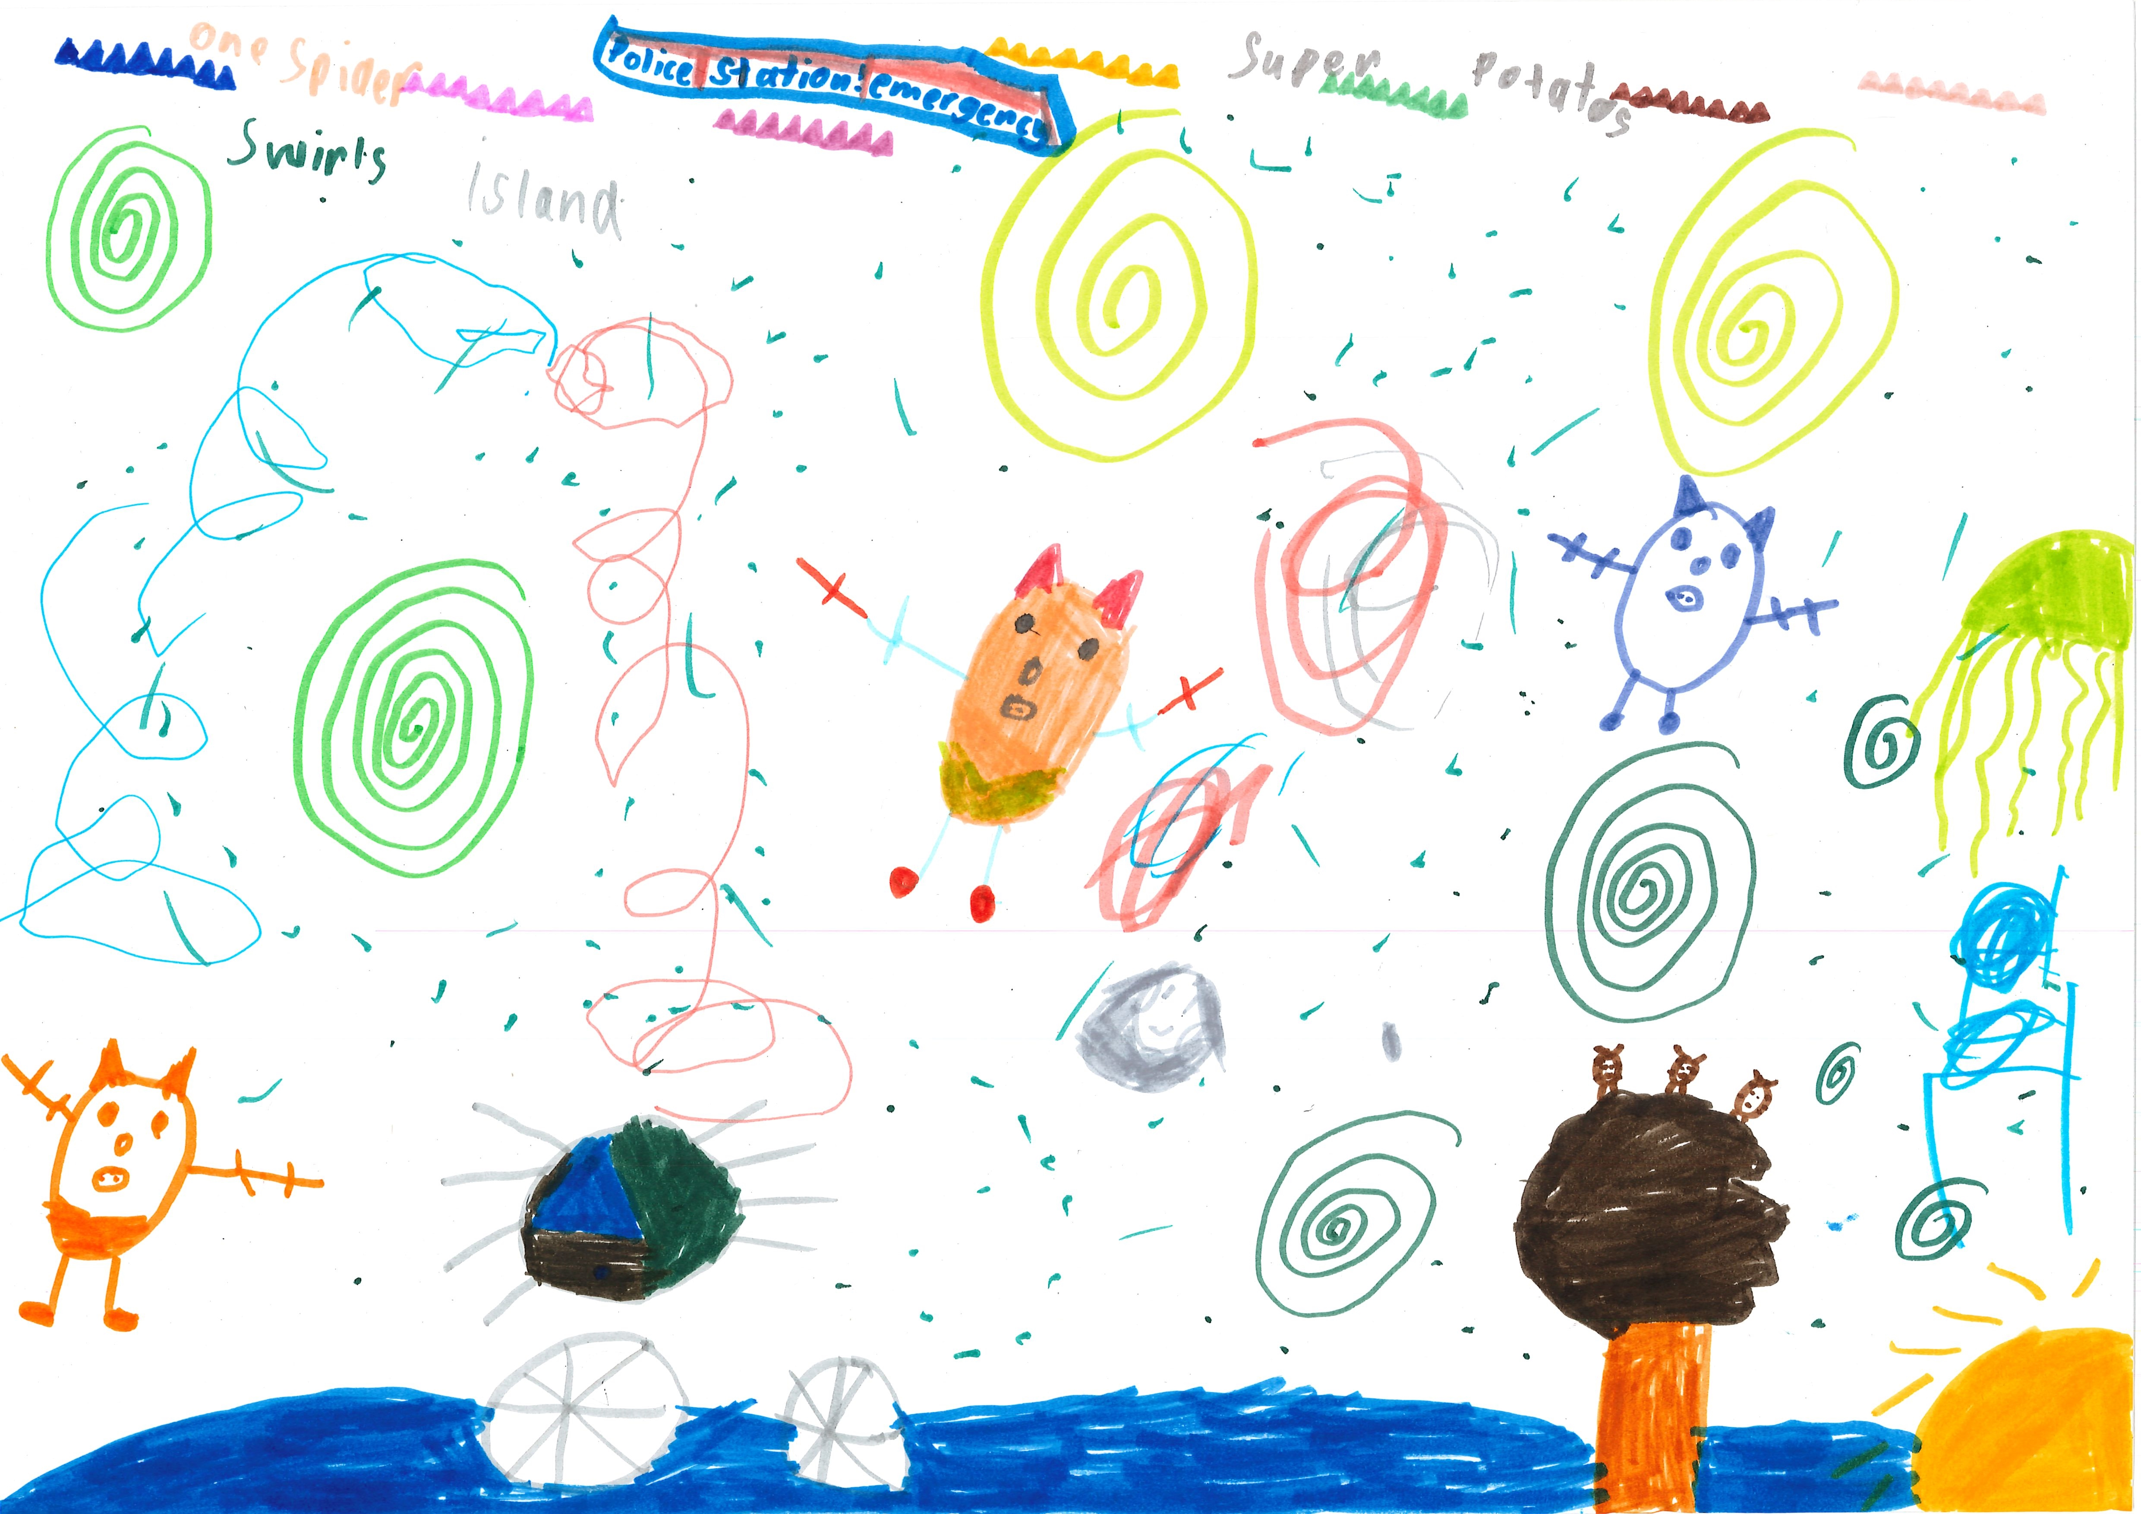400

A recording the super potato island. can be found here:
neema.mp3

This is the unique QR code for this Imagined Thing. Right click it to save then share it, so you and others can find your way back to here to this point of The Well.

IT IS KNOWN! HUZZAH FOR THE GREAT & GRAND RUMPUS!

