14. Angre Cow - Chosen Thing
HERE LIES THE ENTRY FOR AN IMAGINED THING
This is a thing imagined by samir, aged 8, on Wednesday April 28
The full name of this thing is: angre cow
It can be found in: he from amrica
It is known that: i was patting hes back and he ate me
This thing has three important features:

An image of angre cow can be found here:
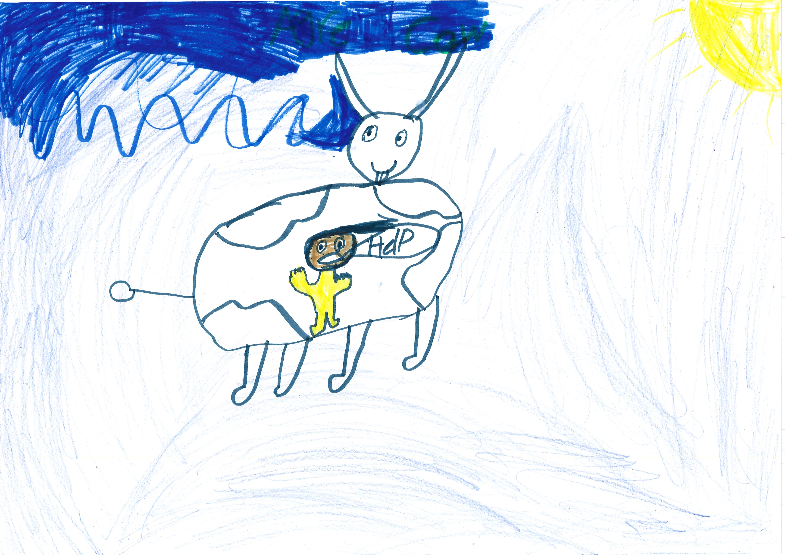400

A recording of angre cow can be found here:
samir.mp3

This is the unique QR code for this Imagined Thing. Right click it to save then share it, so you and others can find your way back to here to this point of The Well.

IT IS KNOWN! HUZZAH FOR THE GREAT & GRAND RUMPUS!

