13. Sqwigg
HERE LIES THE ENTRY FOR AN IMAGINED THING
This is a thing imagined by Riley, aged 10, on Wednesday April 21
The full name of this thing is: Sqwigg
It can be found in: From the blue sea
It is known that: There was a room with water, seal, platypus, shark and a dolphin went to the middle and touch each other and made sqwigg. He was so big he made bubbles.
This thing has three important features: Sharp long fin from shark, A platypus tail, and A seal head

An image of Sqwigg can be found here:
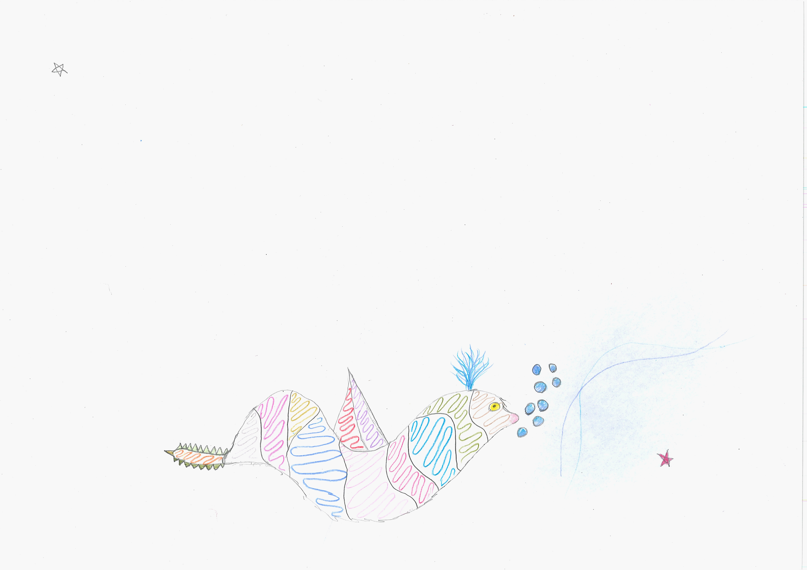400

A recording Sqwigg can be found here:
400

This is the unique QR code for this Imagined Thing. Right click it to save then share it, so you and others can find your way back to here to this point of The Well.

IT IS KNOWN! HUZZAH FOR THE GREAT & GRAND RUMPUS!

