123. John sener cat
HERE LIES THE ENTRY FOR AN IMAGINED THING
This is a thing imagined by Elliot, aged 9, on Friday September 17
The full name of this thing is: John sener cat
It can be found in: home
It is known that: She at lose lose of food and she got very fat 80.5kg
This thing has three important features: Tikeing, Me , and cat

An image of John sener cat can be found here:
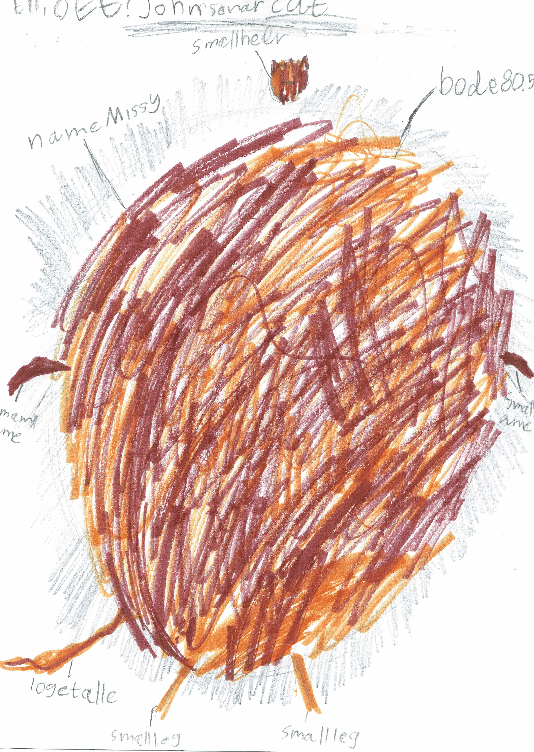

This is the unique QR code for this Imagined Thing. Right click it to save then share it, so you and others can find your way back to here to this point of The Well.

IT IS KNOWN! HUZZAH FOR THE GREAT & GRAND RUMPUS!

