122. SCP-682 AKA The Hard to destroy reptile
HERE LIES THE ENTRY FOR AN IMAGINED THING
This is a thing imagined by Oscar, aged 9, on Friday September 17
The full name of this thing is: SCP-682 AKA The Hard to destroy reptile
It can be found in: from site-19
It is known that: SCP-682 has breached containment and it is causing havoc all over the facility.
This thing has three important features: Teeth, eyes, and hair

An image of SCP-682 AKA The Hard to destroy reptile can be found here:
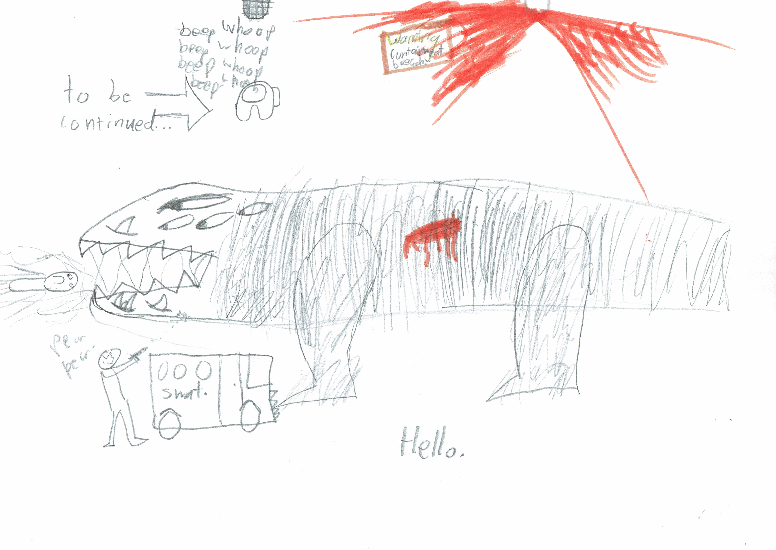

This is the unique QR code for this Imagined Thing. Right click it to save then share it, so you and others can find your way back to here to this point of The Well.

IT IS KNOWN! HUZZAH FOR THE GREAT & GRAND RUMPUS!

