121. Caluvirus
HERE LIES THE ENTRY FOR AN IMAGINED THING
This is a thing imagined by Sophia, aged 9, on Friday September 17
The full name of this thing is: Caluvirus
It can be found in: desert island
It is known that: Evreything died in desert island except gianourmaus caluvirus. He moved to the city so he could survive. He realized he loved it there.
This thing has three important features: Eye feet, floppy ears, and purple mane

An image of Caluvirus can be found here:
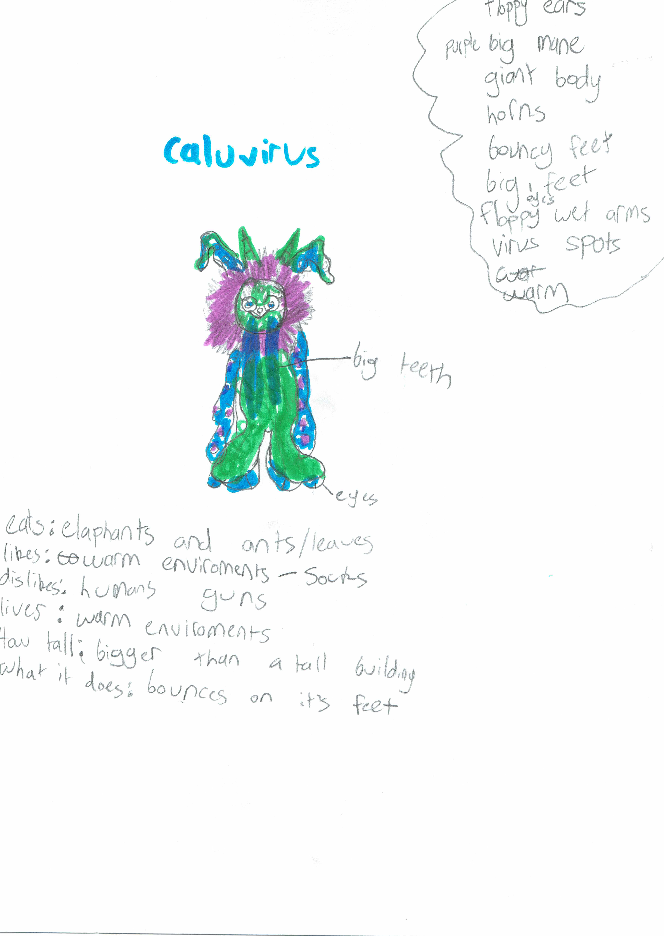

This is the unique QR code for this Imagined Thing. Right click it to save then share it, so you and others can find your way back to here to this point of The Well.

IT IS KNOWN! HUZZAH FOR THE GREAT & GRAND RUMPUS!

