120. Electro Slime
HERE LIES THE ENTRY FOR AN IMAGINED THING
This is a thing imagined by Yifei, aged 9, on Friday September 17
The full name of this thing is: Electro Slime
It can be found in: Genshin Impact
It is known that: Once upon a time, there was a big electro slime, and it died, suprise, suprise
This thing has three important features: slime condensate, Big eyes

An image of Electro Slime can be found here:
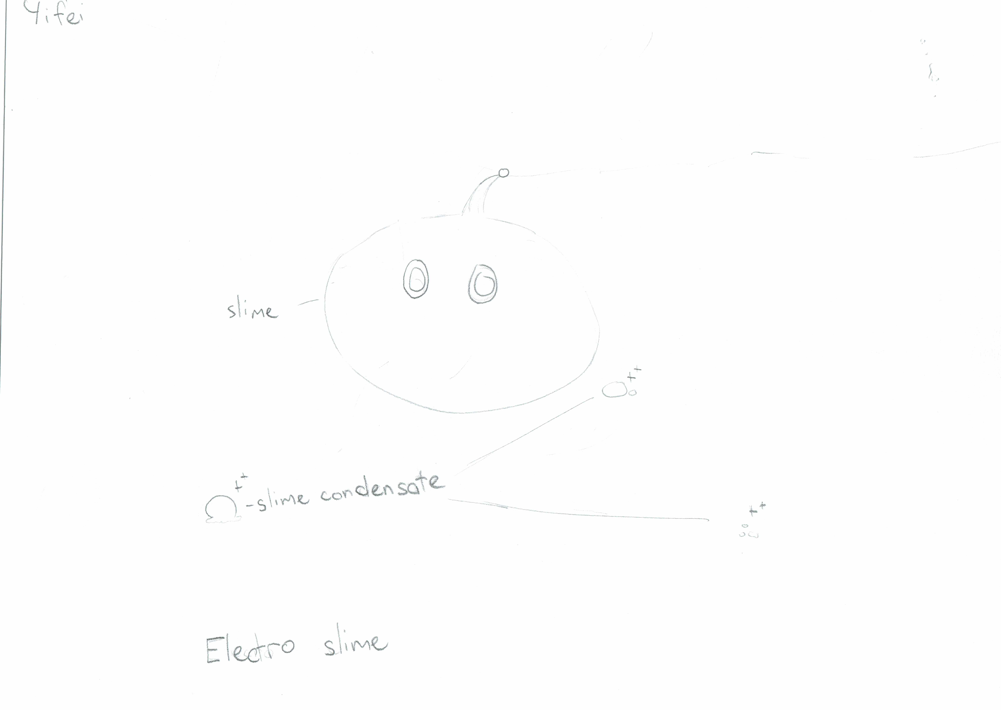

This is the unique QR code for this Imagined Thing. Right click it to save then share it, so you and others can find your way back to here to this point of The Well.

IT IS KNOWN! HUZZAH FOR THE GREAT & GRAND RUMPUS!

