117. Alirkey
HERE LIES THE ENTRY FOR AN IMAGINED THING
This is a thing imagined by Milan, aged 9, on Friday September 17
The full name of this thing is: Alirkey
It can be found in: Jungle
It is known that: He eats human's toenails to grow them on feet and wase 1000kg
This thing has three important features: wate, wings, and toe nails

An image of Alirkey can be found here:
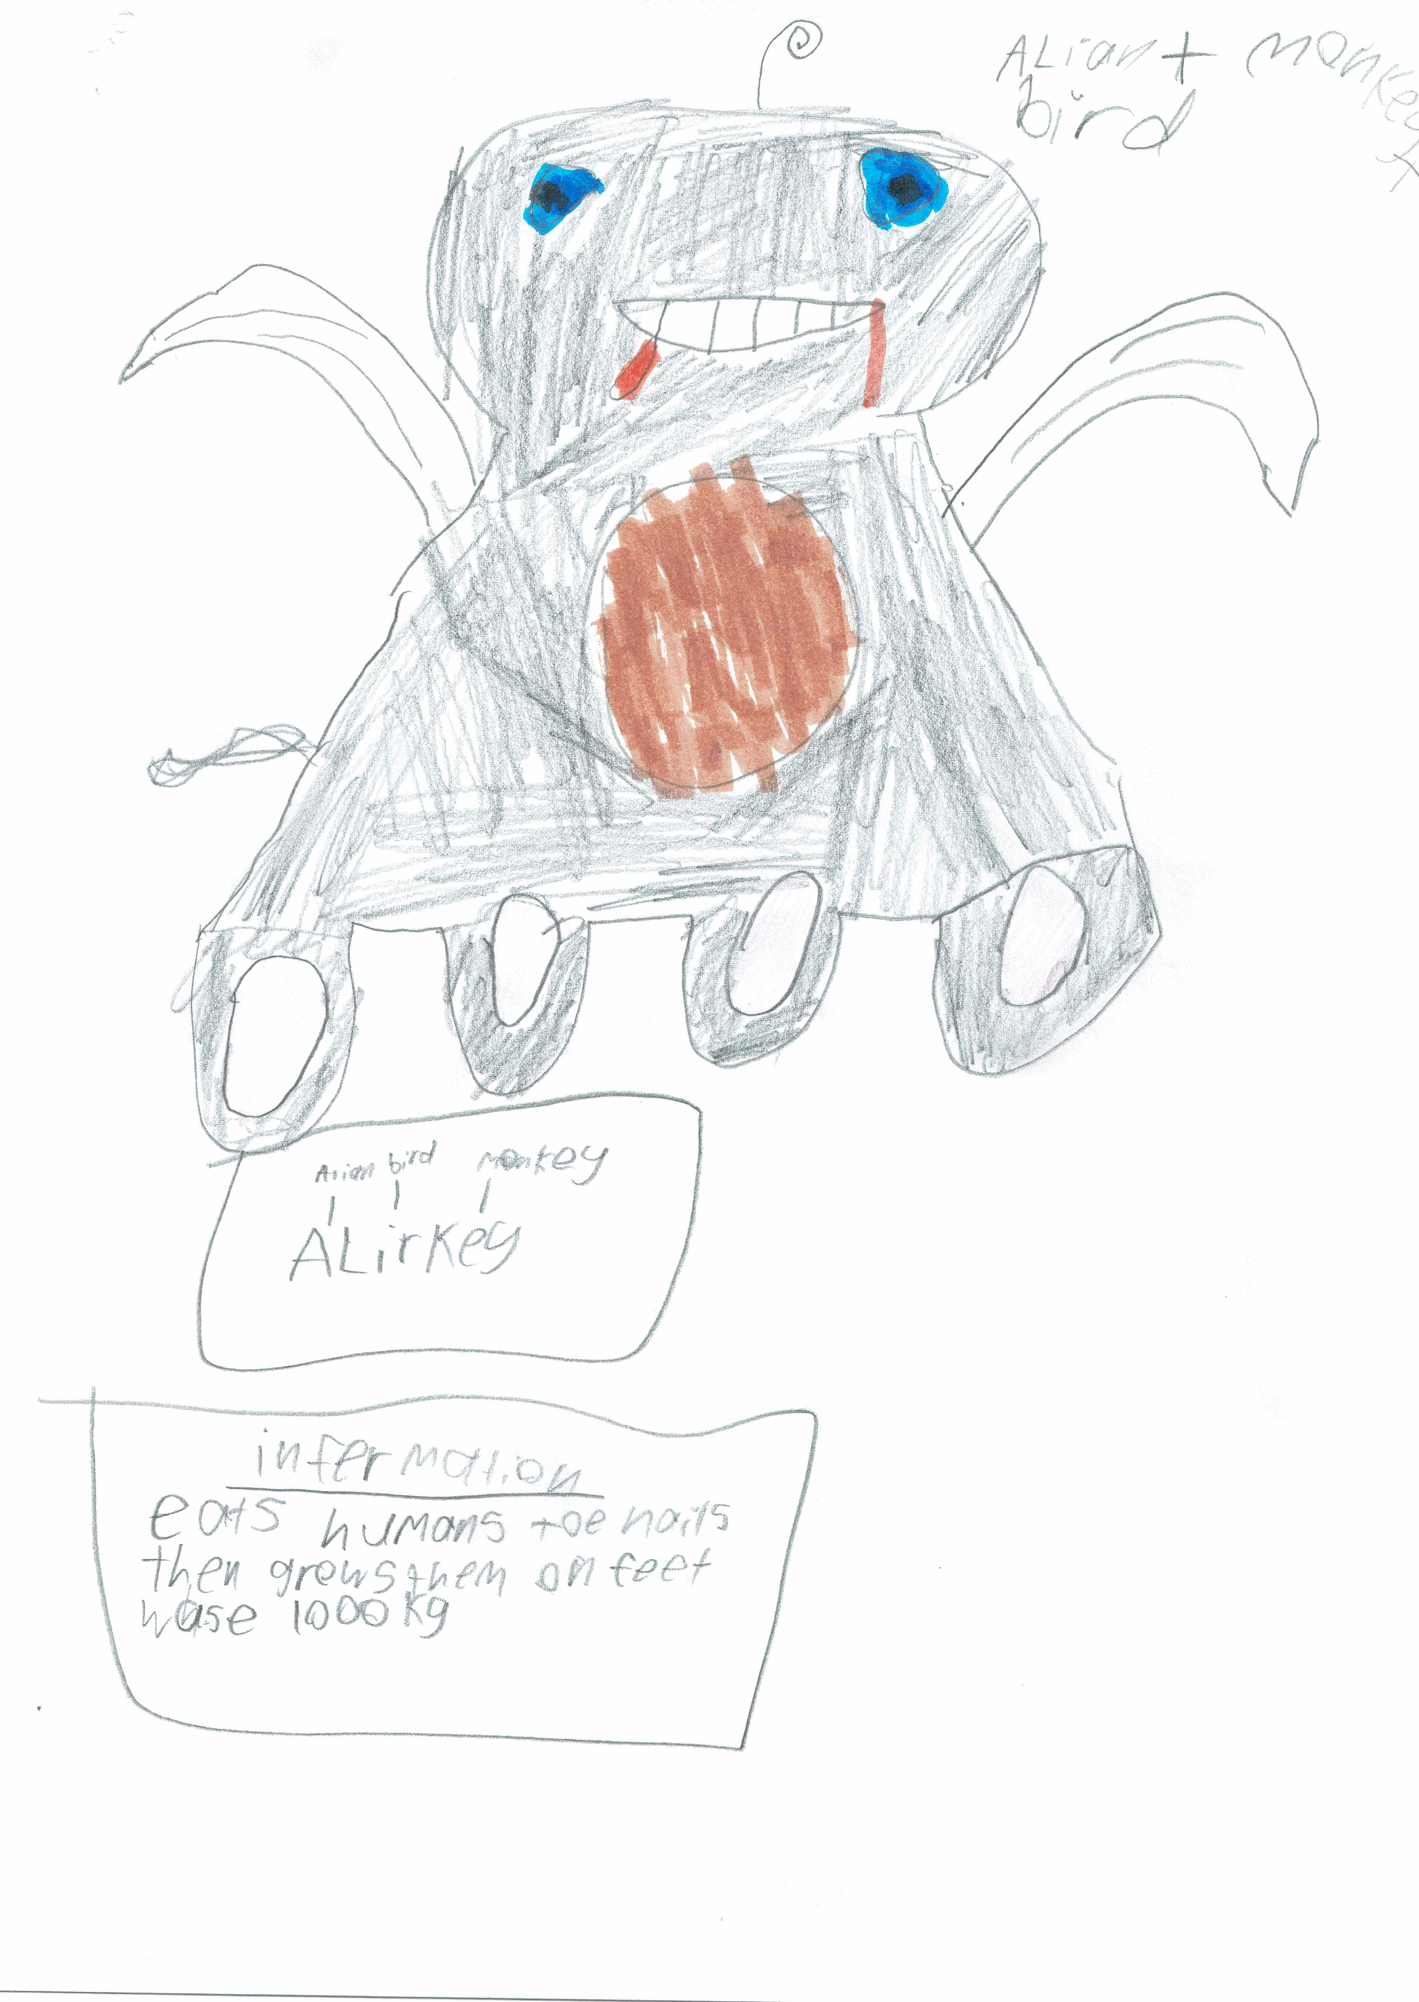

This is the unique QR code for this Imagined Thing. Right click it to save then share it, so you and others can find your way back to here to this point of The Well.

IT IS KNOWN! HUZZAH FOR THE GREAT & GRAND RUMPUS!

