116. Scales
HERE LIES THE ENTRY FOR AN IMAGINED THING
This is a thing imagined by Isabella, aged 9, on Friday September 17
The full name of this thing is: Scales
It can be found in: It is found in the sky usually above mountains
It is known that: Flys on a magic carpet in the sky usually above mountains. Has scaly skin. Eats insects in the sky.
This thing has three important features: Tenticals, clown wig, and roller skates on 'feet'

An image of Scales can be found here:
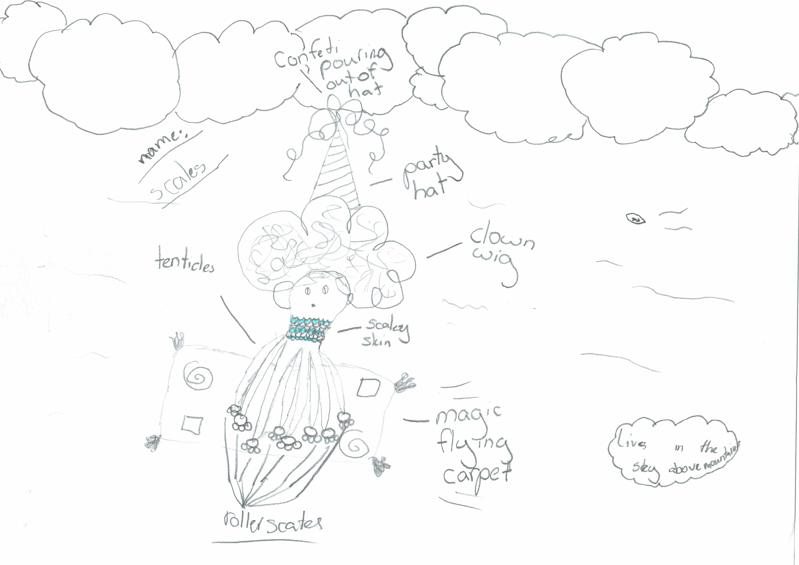

This is the unique QR code for this Imagined Thing. Right click it to save then share it, so you and others can find your way back to here to this point of The Well.

IT IS KNOWN! HUZZAH FOR THE GREAT & GRAND RUMPUS!

