115. Chicken
HERE LIES THE ENTRY FOR AN IMAGINED THING
This is a thing imagined by Inniss, aged 9, on Friday September 17
The full name of this thing is: Chicken
It can be found in: Chicken World
It is known that: Chickens from over world go to chicken protal to the chicken world
This thing has three important features: feathers, wings, and feet

An image of Chicken can be found here:
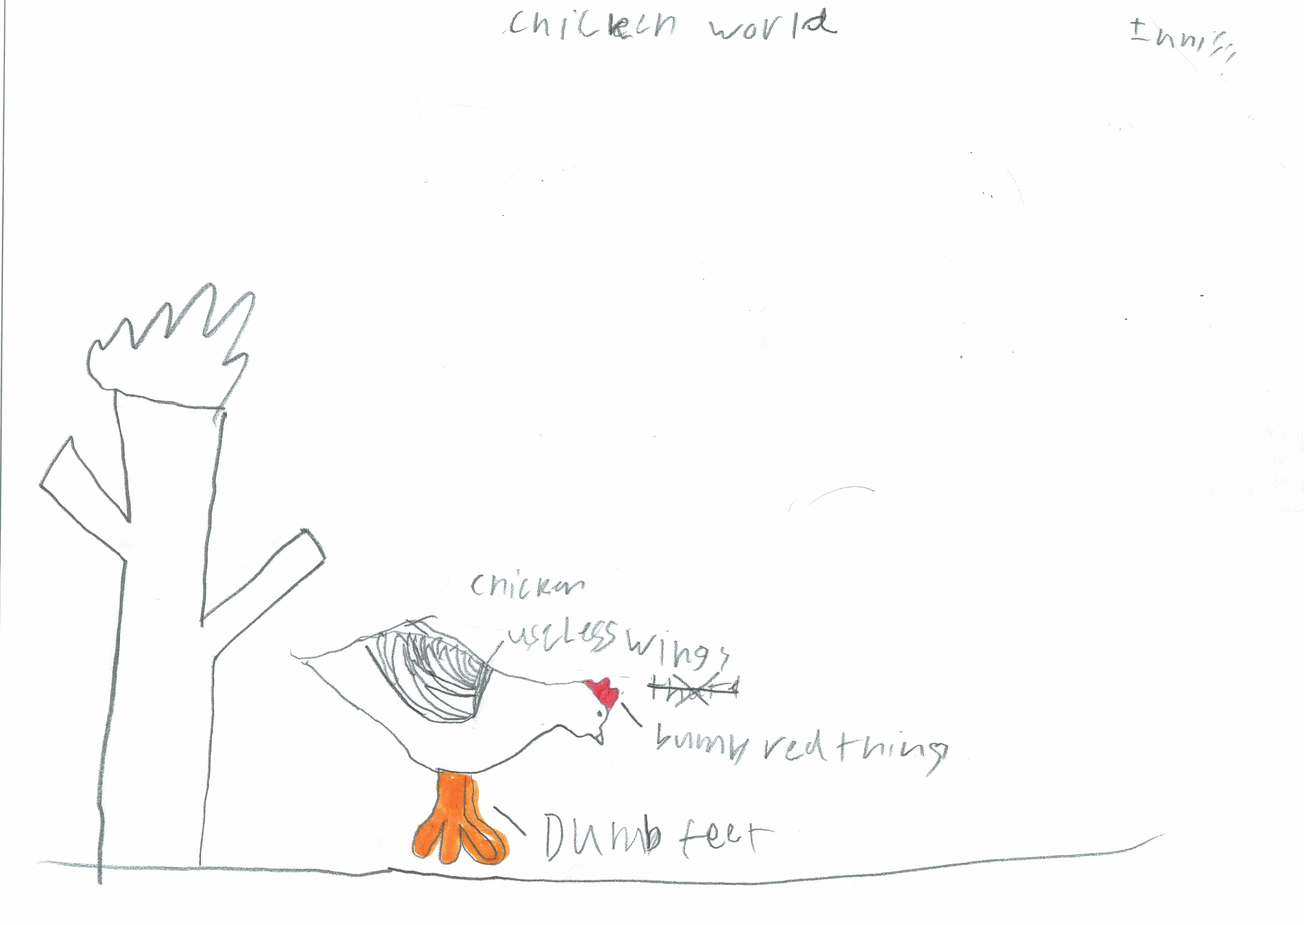

This is the unique QR code for this Imagined Thing. Right click it to save then share it, so you and others can find your way back to here to this point of The Well.

IT IS KNOWN! HUZZAH FOR THE GREAT & GRAND RUMPUS!

