114. Danger
HERE LIES THE ENTRY FOR AN IMAGINED THING
This is a thing imagined by Mia, aged 9, on Friday September 17
The full name of this thing is: Danger
It can be found in: the pet store
It is known that: Well one day I went to the pet store and I was looking for a dog and I found danger and I fell in love with him so I brought him
This thing has three important features: he will protect me, he loves me, and He will not run away

An image of Danger can be found here:
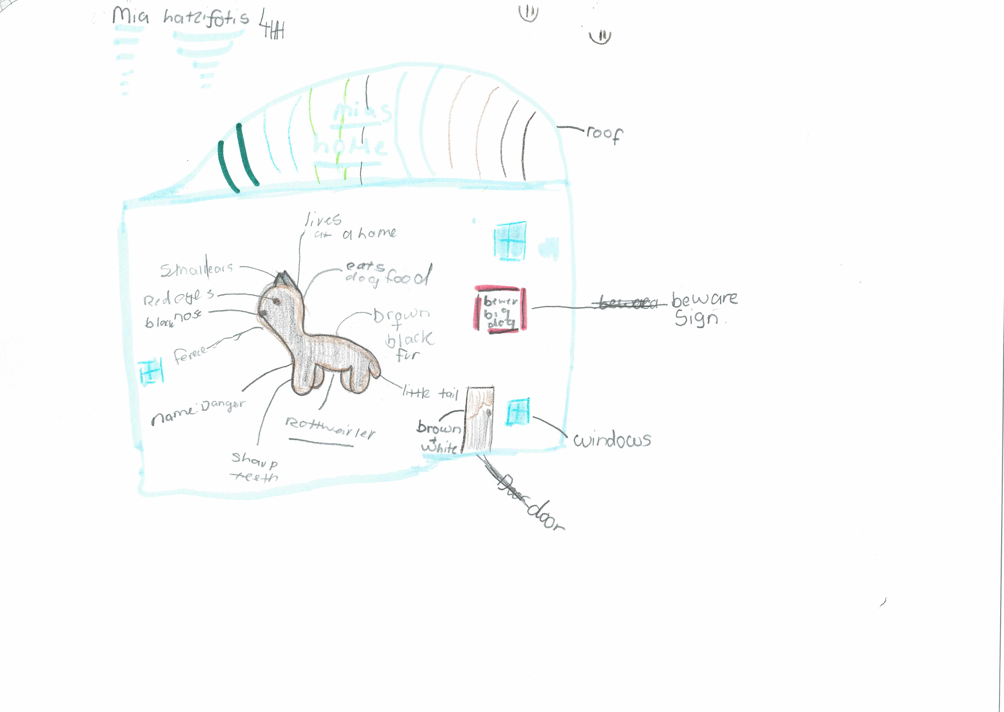

This is the unique QR code for this Imagined Thing. Right click it to save then share it, so you and others can find your way back to here to this point of The Well.

IT IS KNOWN! HUZZAH FOR THE GREAT & GRAND RUMPUS!

