113. War
HERE LIES THE ENTRY FOR AN IMAGINED THING
This is a thing imagined by Dylan, aged 9, on Friday September 17
The full name of this thing is: War
It can be found in: battelfeiled
It is known that: japan invaded amaica and so amaica when to way whith japan
This thing has three important features: Peace, anger, and resolution

An image of War can be found here:
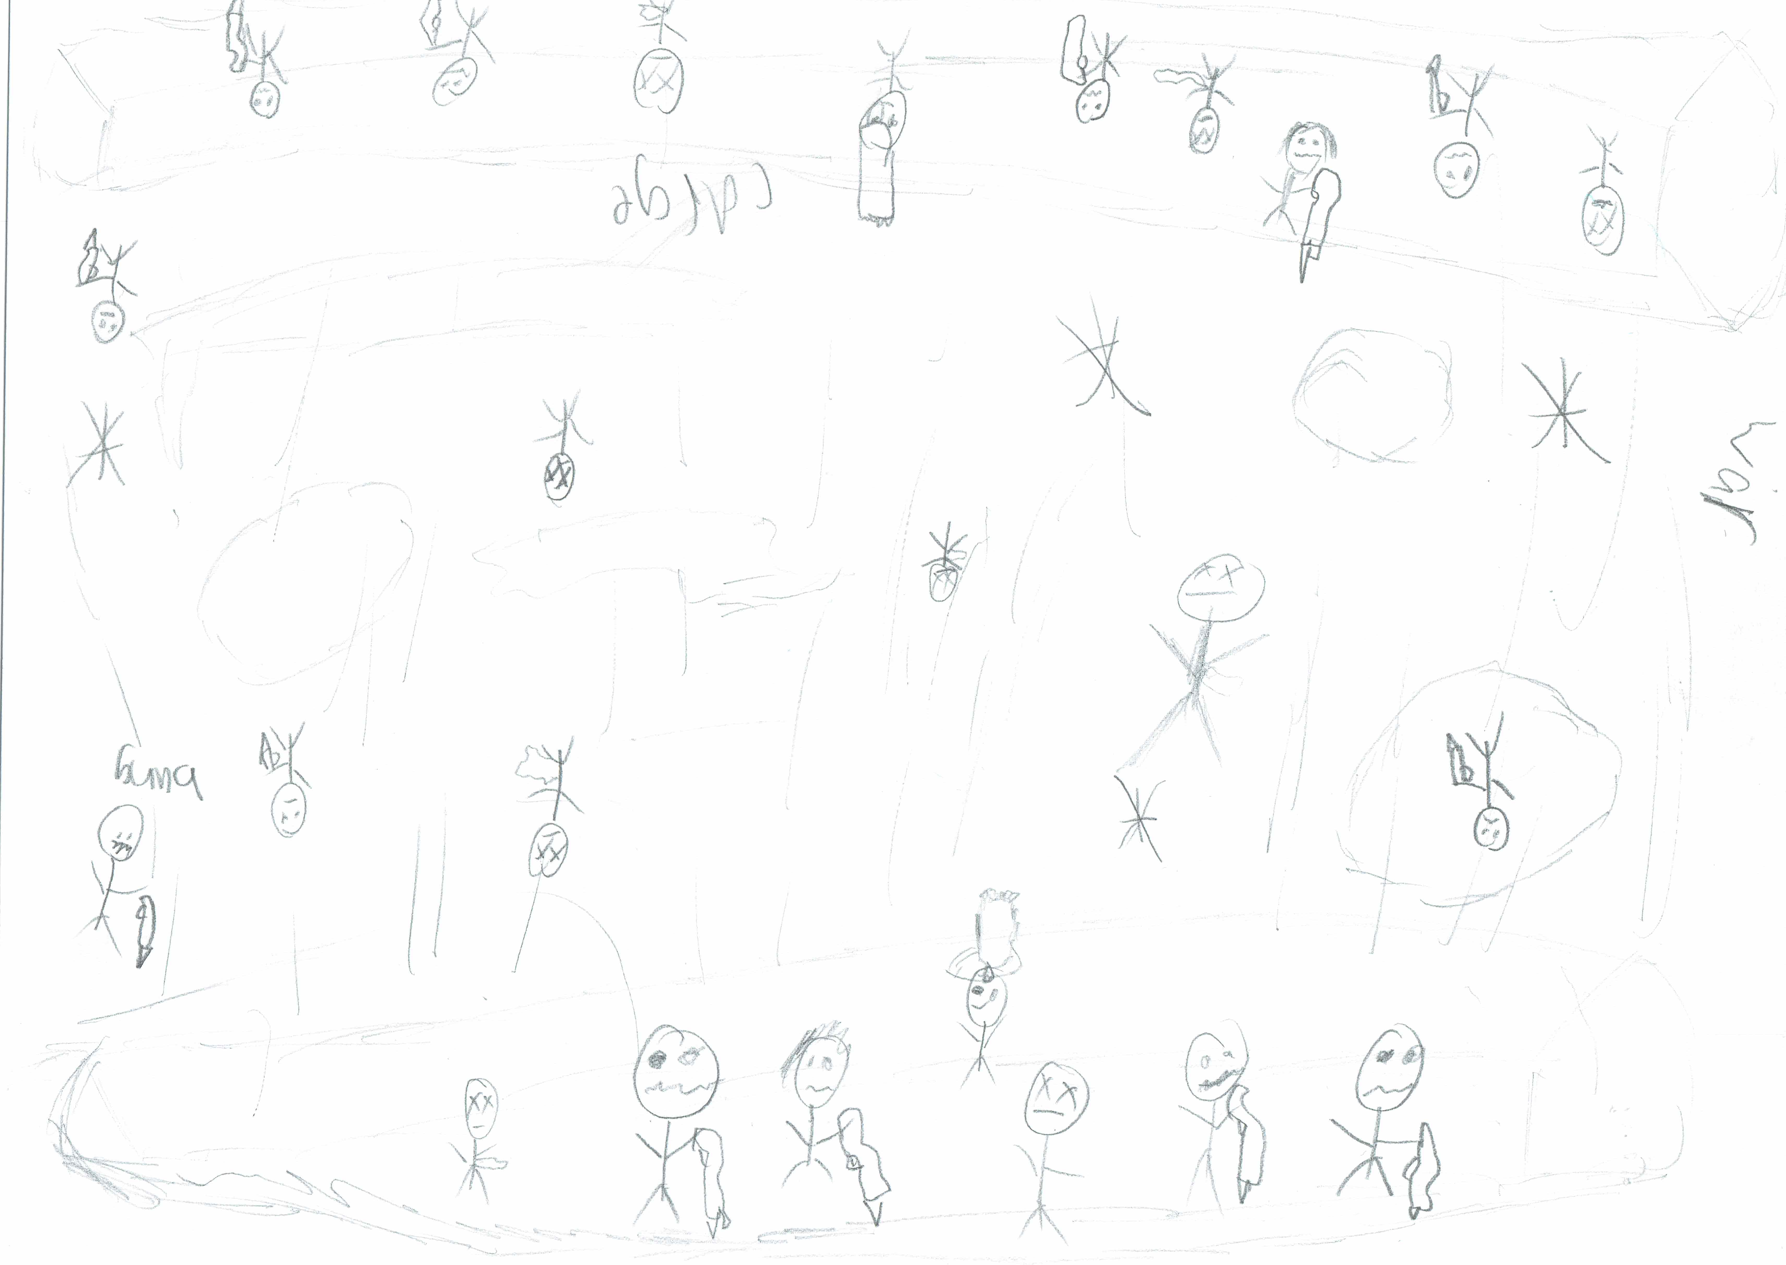

This is the unique QR code for this Imagined Thing. Right click it to save then share it, so you and others can find your way back to here to this point of The Well.

IT IS KNOWN! HUZZAH FOR THE GREAT & GRAND RUMPUS!

