112. Dogsheep
HERE LIES THE ENTRY FOR AN IMAGINED THING
This is a thing imagined by Isabela, aged 9, on Friday September 17
The full name of this thing is: Dogsheep
It can be found in: A farme
It is known that: One day it came from the farme and it was a dogsheep
This thing has three important features: Fury, cut and big

An image of Dogsheep can be found here:
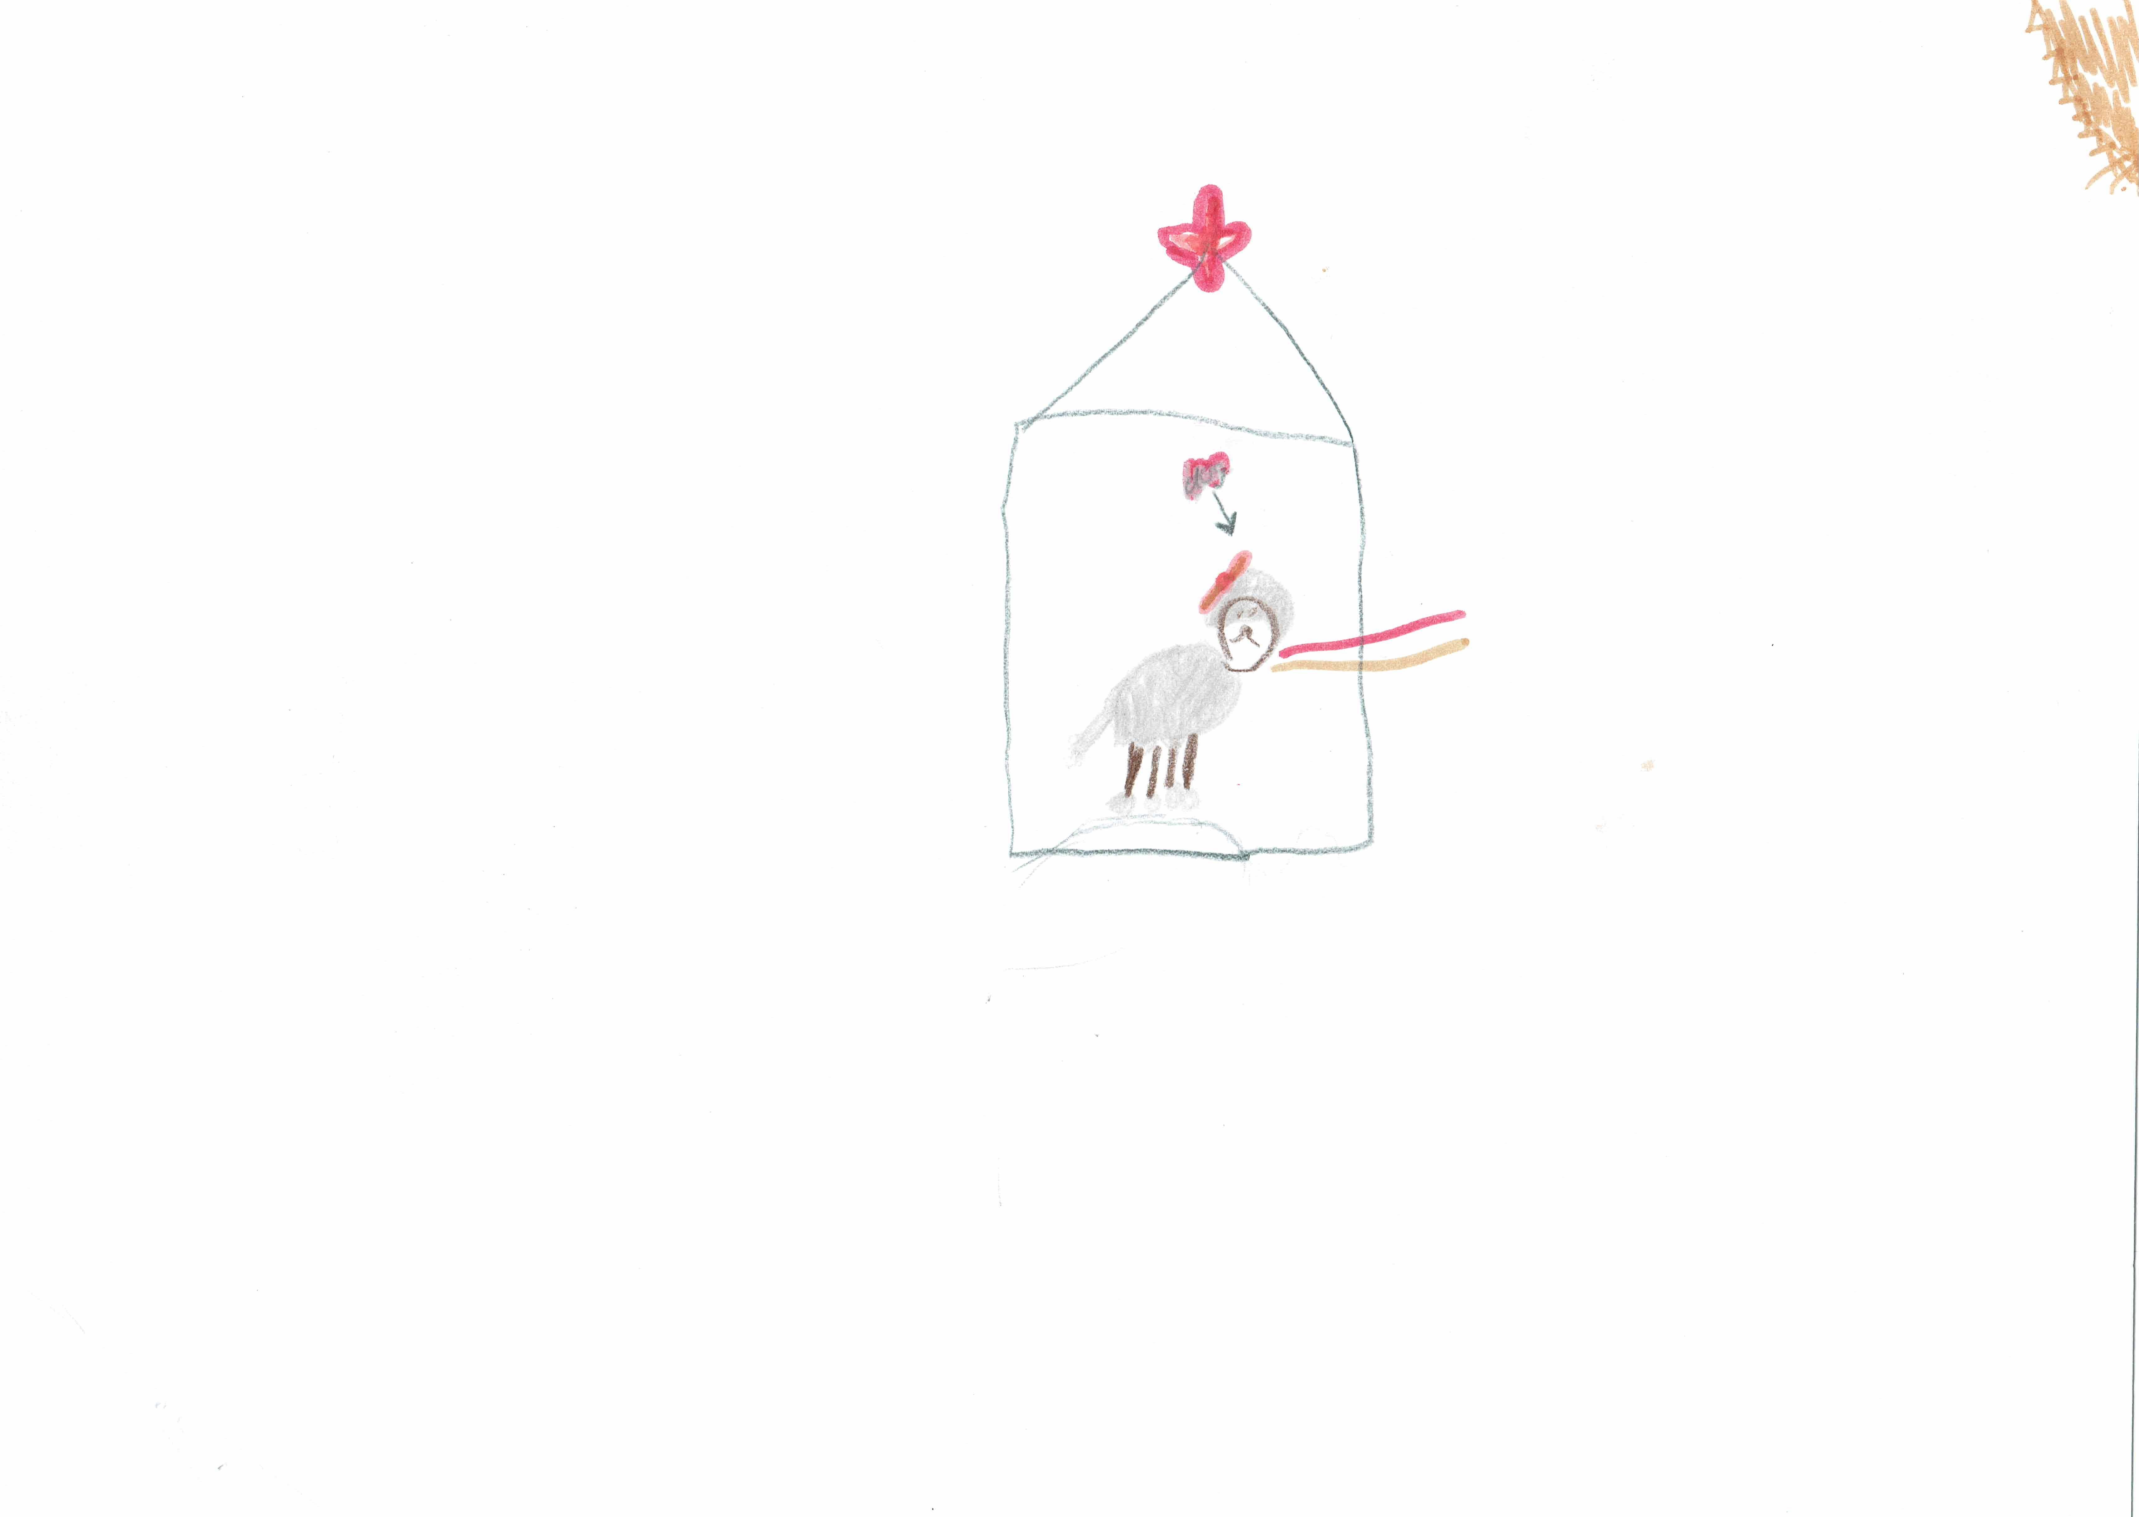

This is the unique QR code for this Imagined Thing. Right click it to save then share it, so you and others can find your way back to here to this point of The Well.

IT IS KNOWN! HUZZAH FOR THE GREAT & GRAND RUMPUS!

