110. Steve
HERE LIES THE ENTRY FOR AN IMAGINED THING
This is a thing imagined by Henry, aged 9, on Friday September 17
The full name of this thing is: Steve
It can be found in: Jungle
It is known that: It's from the jungle swamp.
This thing has three important features: head, mouth, and eyes

An image of Steve can be found here:
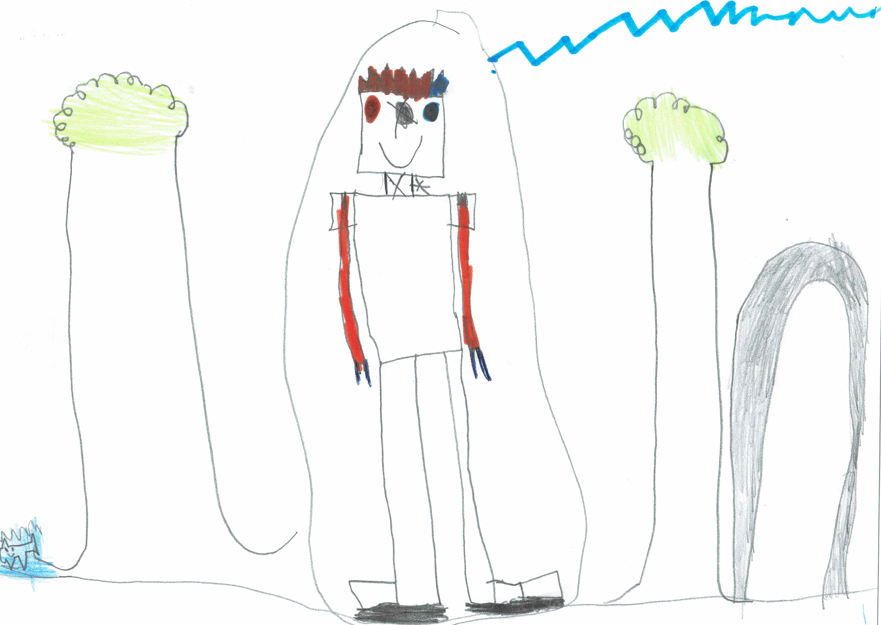

This is the unique QR code for this Imagined Thing. Right click it to save then share it, so you and others can find your way back to here to this point of The Well.

IT IS KNOWN! HUZZAH FOR THE GREAT & GRAND RUMPUS!

