108. Thing
HERE LIES THE ENTRY FOR AN IMAGINED THING
This is a thing imagined by Matilda, aged 9, on Friday September 17
The full name of this thing is: Thing
It can be found in: Under the bed
It is known that: Once there was a kid who had so many bad dreams that one day Thing appeared under his bed at first the kid was scared then he finally realised what Thing can do. Take away Bad Dreams.

An image of Thing can be found here:
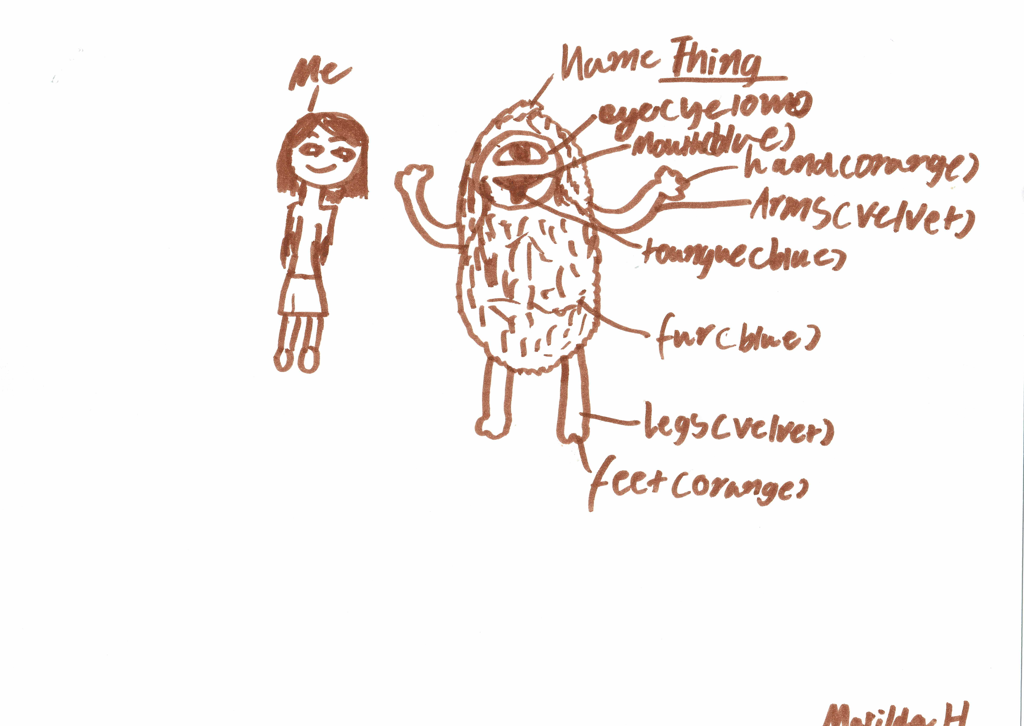

This is the unique QR code for this Imagined Thing. Right click it to save then share it, so you and others can find your way back to here to this point of The Well.

IT IS KNOWN! HUZZAH FOR THE GREAT & GRAND RUMPUS!

