106. Thing that wants to eat me!
HERE LIES THE ENTRY FOR AN IMAGINED THING
This is a thing imagined by Margot, aged 9, on Friday September 17
The full name of this thing is: Thing that wants to eat me!
It can be found in: a difront dimention
It is known that: it is a very big black cloud that kills people
This thing has three important features: very big, creapy head, and pointy feet

An image of Thing that wants to eat me! can be found here:
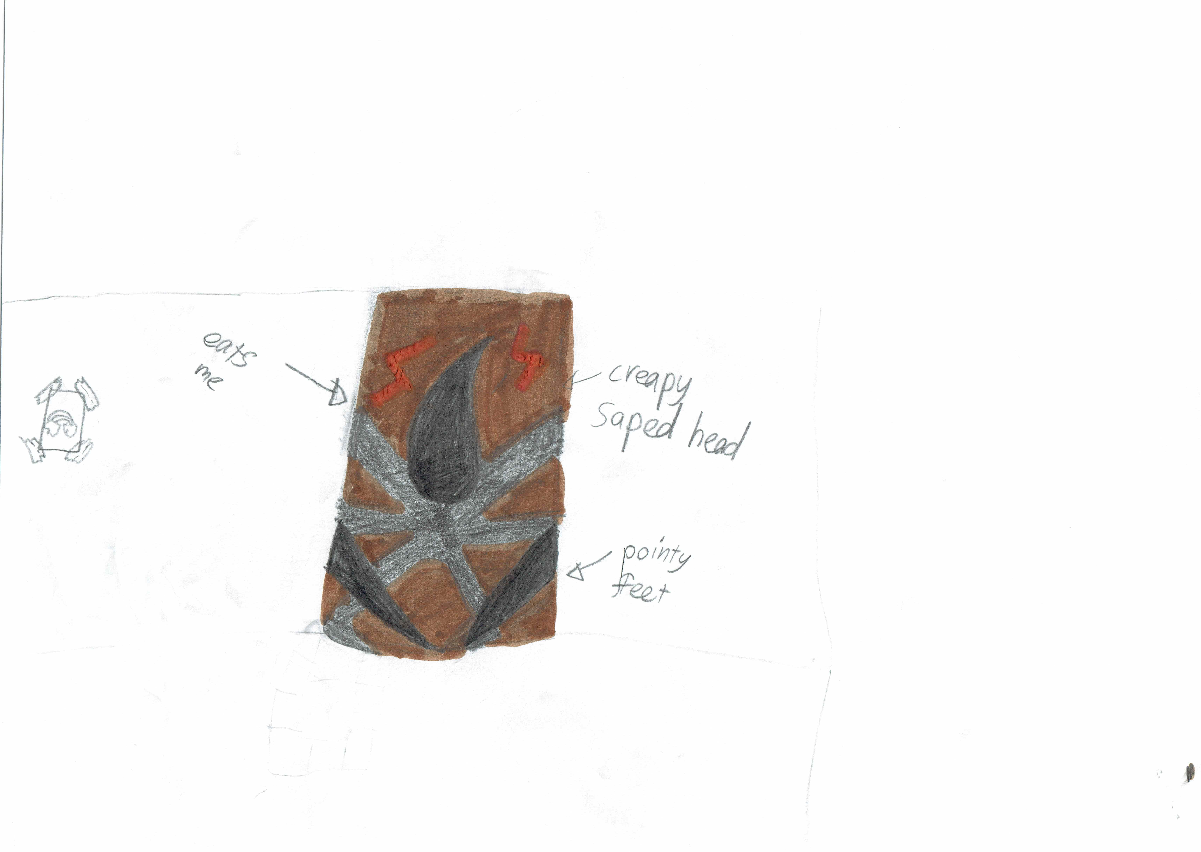

This is the unique QR code for this Imagined Thing. Right click it to save then share it, so you and others can find your way back to here to this point of The Well.

IT IS KNOWN! HUZZAH FOR THE GREAT & GRAND RUMPUS!

