105. Yakult Man
HERE LIES THE ENTRY FOR AN IMAGINED THING
This is a thing imagined by Angel, aged 9, on Friday September 17
The full name of this thing is: Yakult Man
It can be found in: Happy Yakult Place
It is known that: Yakult Man with his little Yakult bottles in Happy Yakult Place which has a biggus rainbowus.
This thing has three important features: Yakult Man, Little Yakult Bottles, and Happy Yakult Place

An image of Yakult Man can be found here:
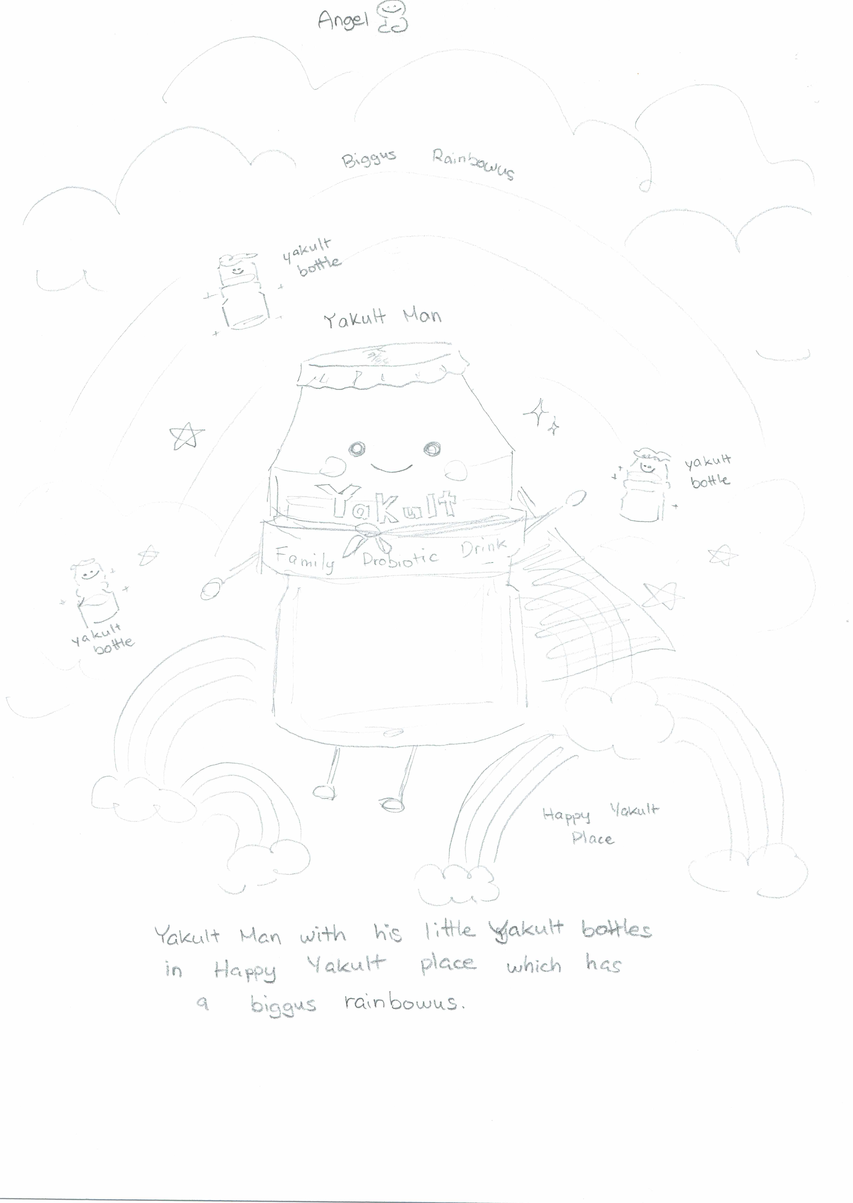

This is the unique QR code for this Imagined Thing. Right click it to save then share it, so you and others can find your way back to here to this point of The Well.

IT IS KNOWN! HUZZAH FOR THE GREAT & GRAND RUMPUS!

