104. Sun pheonix
HERE LIES THE ENTRY FOR AN IMAGINED THING
This is a thing imagined by Odilia, aged 9, on Friday September 17
The full name of this thing is: Sun pheonix
It can be found in: Sunlight ring
It is known that: My pheonix appeared in thin air and all the sunlight formed a beautiful phenoix made entirely of sunlight.

An image of Sun pheonix can be found here:
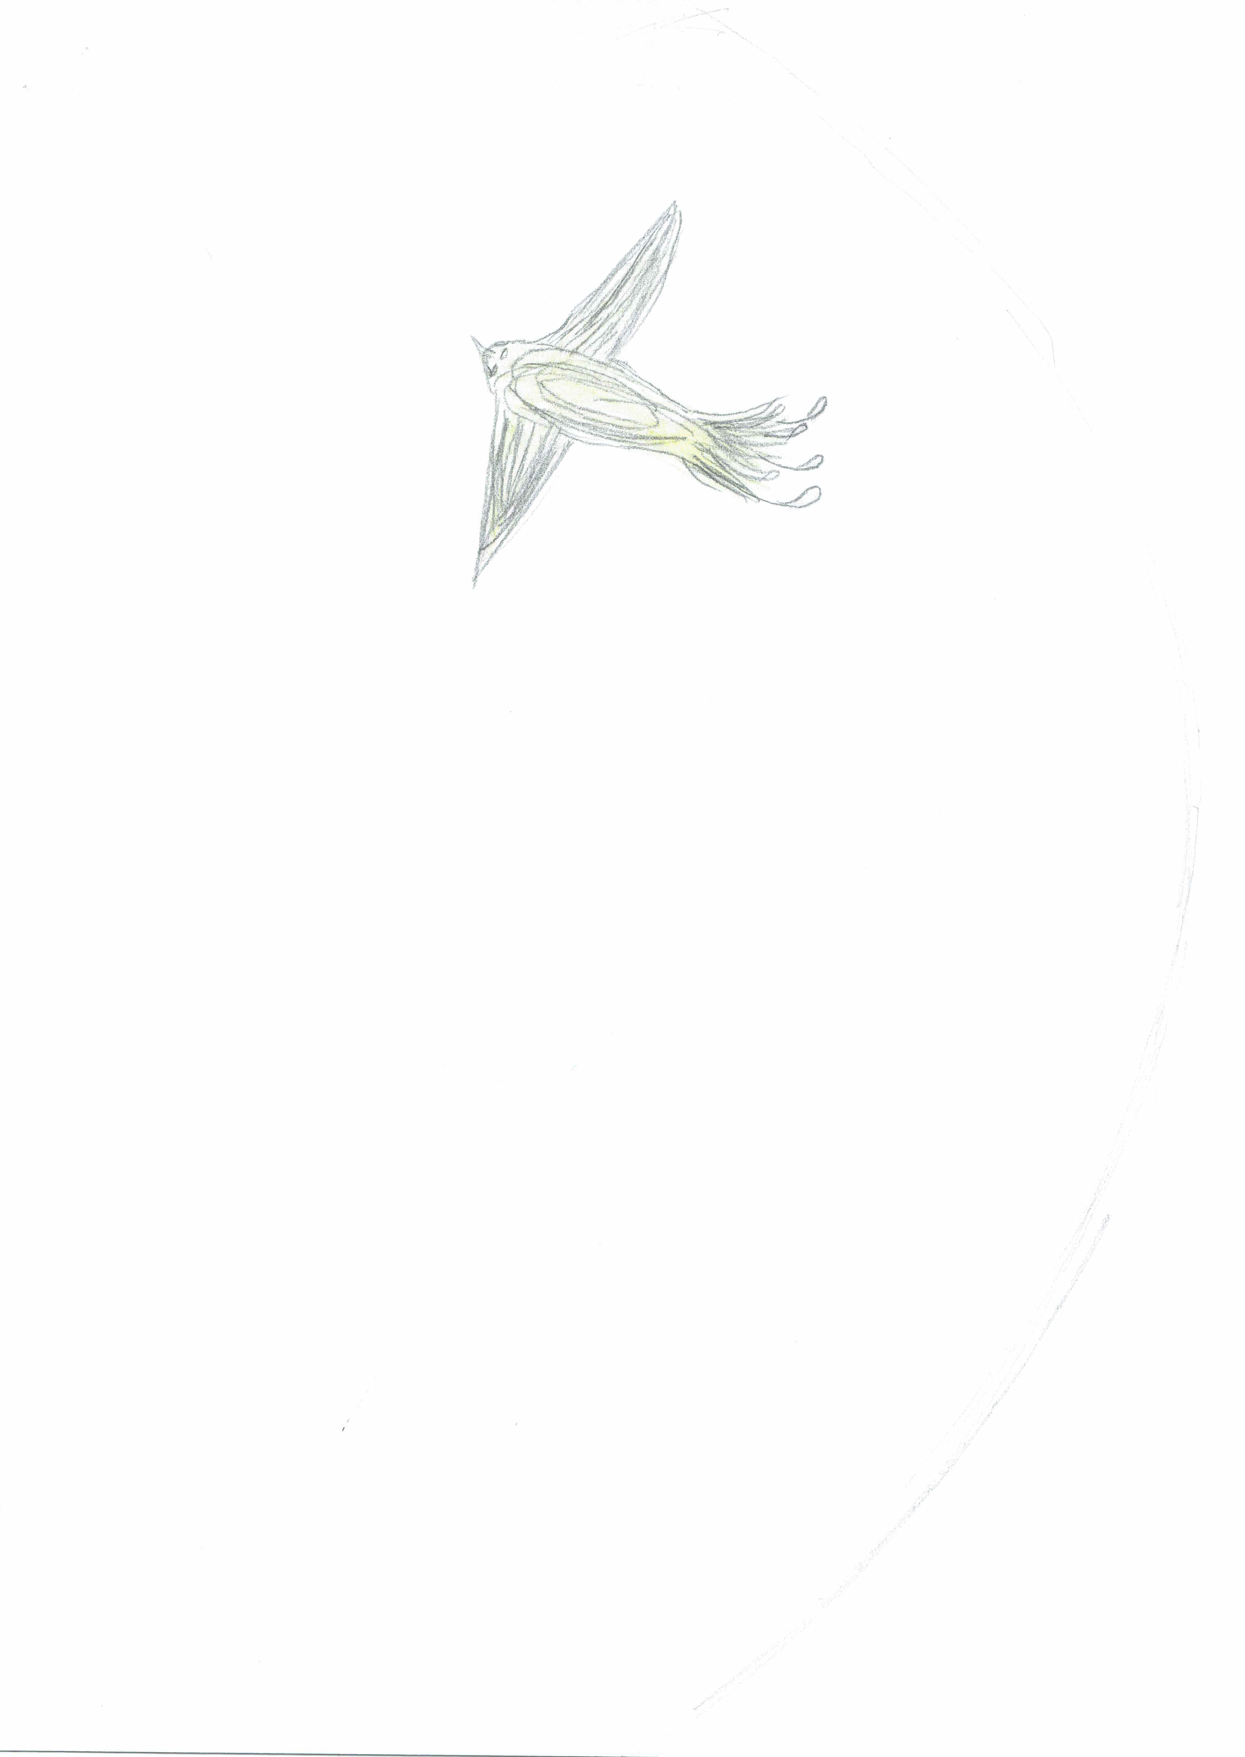

This is the unique QR code for this Imagined Thing. Right click it to save then share it, so you and others can find your way back to here to this point of The Well.

IT IS KNOWN! HUZZAH FOR THE GREAT & GRAND RUMPUS!

