102. Random thing
HERE LIES THE ENTRY FOR AN IMAGINED THING
This is a thing imagined by Kaleb, aged 9, on Friday September 17
The full name of this thing is: Random thing
It can be found in: random crazy land
It is known that: A naughty random person got angry at a woodpecker, 3 dogs and a big thumb
This thing has three important features: antlers, dogs, and woodpecker

An image of Random thing can be found here:
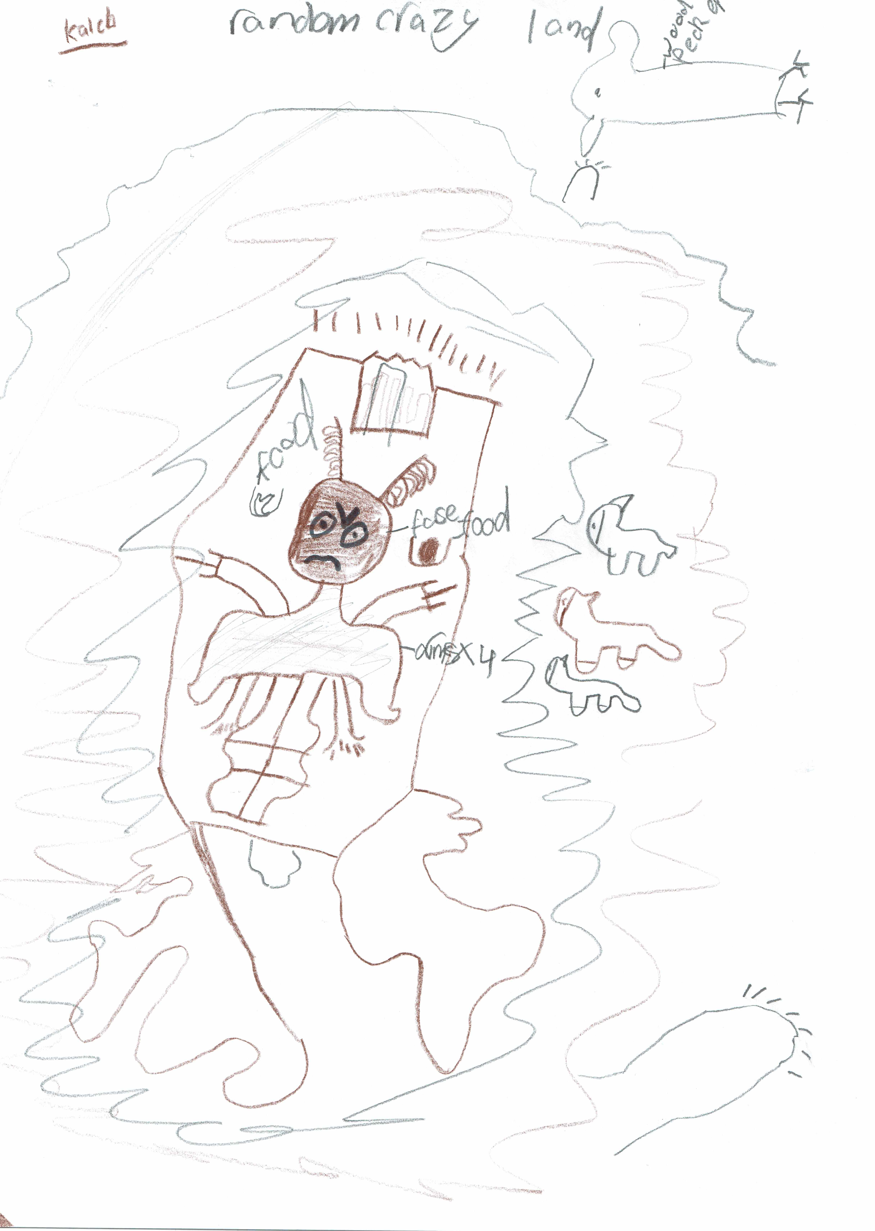

This is the unique QR code for this Imagined Thing. Right click it to save then share it, so you and others can find your way back to here to this point of The Well.

IT IS KNOWN! HUZZAH FOR THE GREAT & GRAND RUMPUS!

